**Microsoft Excel Training Tutorial: Learn in 7 Days**

### Training Summary

Excel is the most powerful tool to manage and analyze various types of Data. This tutorial covers in-depth lessons on how to use various Excel formulas, Tables and Charts for managing small to large scale business process.

### What should I know?

Nothing! This course assumes you are a beginner to Excel.

## What will you Learn?

**Introduction**

|  |  |
| --- | --- |
| [**Tutorial**](https://www.guru99.com/introduction-to-microsoft-excel.html) | Introduction to Microsoft Excel |
| [**Tutorial**](https://www.guru99.com/getting-started-with-microsoft-excel.html) | How to Add, Subtract, Multiply, Divide in Excel |
| [**Tutorial**](https://www.guru99.com/excel-validation-filters-grouping.html) | Excel Data Validation, Filters, Grouping |
| [**Tutorial**](https://www.guru99.com/introduction-to-formulas-and-functions-in-excel.html) | Introduction to formulas and functions in Excel |
| [**Tutorial**](https://www.guru99.com/logical-functions-operators-and-conditions-in-excel.html) | Logical functions (operators) and conditions in Excel |
| [**Tutorial**](https://www.guru99.com/visualizing-data-using-charts-in-excel.html) | Visualizing data using charts in Excel |
| [**Tutorial**](https://www.guru99.com/case-study-managing-personal-finance-using-microsoft-excel.html) | Case Study: Managing personal finance using Microsoft Excel |

### Advance Stuff

|  |  |
| --- | --- |
| [**Tutorial**](https://www.guru99.com/connecting-microsoft-excel-to-external-data-sources.html) | How to Import XML Data into Excel [Example] |
| [**Tutorial**](https://www.guru99.com/import-csv-data-excel.html) | How to Import CSV Data (Text) into Excel [Example] |
| [**Tutorial**](https://www.guru99.com/import-access-data-excel.html) | How to Import MS Access Data into Excel [Example] |
| [**Tutorial**](https://www.guru99.com/import-sql-data-excel.html) | How to Import SQL Database Data into Excel [Example] |
| [**Tutorial**](https://www.guru99.com/pivot-tables-in-excel-beginner-s-guide.html) | Pivot Tables in Excel: Beginner’s Guide |
| [**Tutorial**](https://www.guru99.com/creating-advanced-charts-in-excel.html) | Creating Advanced Charts in Excel |
| [**Tutorial**](https://www.guru99.com/excel-in-the-cloud-office-365.html) | Excel in the cloud: Office 365 |
| [**Tutorial**](https://www.guru99.com/excel-vs-csv.html) | CSV vs Excel (.xls) - What's the Difference? |
| [**Tutorial**](https://www.guru99.com/excel-vlookup-tutorial.html) | Excel VLOOKUP Tutorial for Beginners: Learn with Examples |
| [**Tutorial**](https://www.guru99.com/excel-isblank-function.html) | Excel ISBLANK Function: Learn with Example |
| [**Tutorial**](https://www.guru99.com/excel-sparkline-example.html) | Sparkline in Excel with EXAMPLES |
| [**Tutorial**](https://www.guru99.com/sumif-function-excel.html) | SUMIF function in Excel: Learn with EXAMPLE |
| [**Tutorial**](https://www.guru99.com/microsoft-excel-interview-questions-answers.html) | Top 40 Microsoft Excel Interview Questions & Answers |
| [**Tutorial**](https://www.guru99.com/excel-courses.html) | 20 Best Excel Courses |
| [**Tutorial**](https://www.guru99.com/excel-alternatives-free.html) | 17 BEST Excel Alternatives |
| [**Tutorial**](https://www.guru99.com/excel-pdf.html) | Excel PDF |

### Macros & VBA in Excel

|  |  |
| --- | --- |
| [**Tutorial**](https://www.guru99.com/introduction-to-macros-in-excel.html) | Introduction to Macros in Excel |
| [**Tutorial**](https://www.guru99.com/creating-your-first-visual-basic-for-applications-vba-in-excel.html) | Creating your First Visual Basic for Applications (VBA) in Excel |
| [**Tutorial**](https://www.guru99.com/vba-data-types-variables-constant.html) | VBA Data Types, Variables & Constant |
| [**Tutorial**](https://www.guru99.com/vba-arrays.html) | VBA Arrays |
| [**Tutorial**](https://www.guru99.com/vba-operators.html) | VBA Excel Form Control & Activex Control |
| [**Tutorial**](https://www.guru99.com/vba-arithmetic-operators.html) | VBA Arithmetic Operators |
| [**Tutorial**](https://www.guru99.com/vba-string-operators.html) | VBA String Operators |
| [**Tutorial**](https://www.guru99.com/vba-comparison-operators.html) | VBA Comparison Operators |
| [**Tutorial**](https://www.guru99.com/vba-logical-operators.html) | VBA Logical Operators |
| [**Tutorial**](https://www.guru99.com/vba-functions-subroutine.html) | Excel VBA Call a Subroutine |
| [**Tutorial**](https://www.guru99.com/vba-function.html) | Excel VBA Function Tutorial: Return, Call, Examples |
| [**Tutorial**](https://www.guru99.com/vba-range-objects.html) | VBA Range Objects |

# Introduction to Microsoft Excel 101

## What is Microsoft Excel?

Microsoft Excel is a spreadsheet program that is used to record and analyse numerical data. Think of a spreadsheet as a collection of columns and rows that form a table. Alphabetical letters are usually assigned to columns and numbers are usually assigned to rows. The point where a column and a row meet is called a cell. The address of a cell is given by the letter representing the column and the number representing a row. Let's illustrate this using the following image.

**Why Should I Learn Microsoft Excel?**

We all deal with numbers in one way or the other. We all have daily expenses which we pay for from the monthly income that we earn. For one to spend wisely, they will need to know their income vs. expenditure. Microsoft Excel comes in handy when we want to record, analyze and store such numeric data.

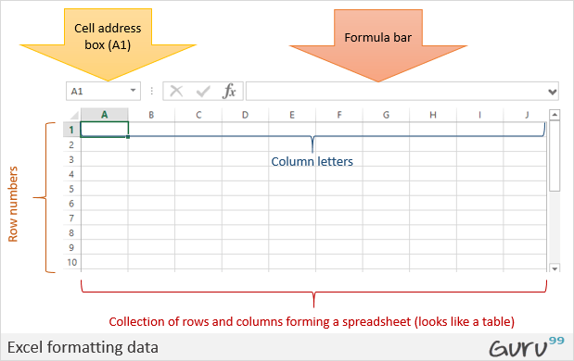

**Where can I get Microsoft Excel?**

There are number of ways in which you can get Microsoft Excel. You can buy it from a hardware computer shop that also sells software. Microsoft Excel is part of the Microsoft Office suite of programs. Alternatively, you can download it from the Microsoft website but you will have to buy the license key.

In this tutorial, we are going to cover the following topics.

* [How to Open Microsoft Excel?](https://www.guru99.com/introduction-to-microsoft-excel.html#1)
* [Understanding the Ribbon](https://www.guru99.com/introduction-to-microsoft-excel.html#2)
* [Understanding the worksheet](https://www.guru99.com/introduction-to-microsoft-excel.html#3)
* [Customization Microsoft Excel Environment](https://www.guru99.com/introduction-to-microsoft-excel.html#4)
* [Important Excel shortcuts](https://www.guru99.com/introduction-to-microsoft-excel.html#5)

## How to Open Microsoft Excel?

Running Excel is not different from running any other Windows program. If you are running Windows with a GUI like (Windows XP, Vista, and 7) follow the following steps.

* Click on start menu
* Point to all programs
* Point to Microsoft Excel
* Click on Microsoft Excel

Alternatively, you can also open it from the start menu if it has been added there. You can also open it from the desktop shortcut if you have created one.

For this tutorial, we will be working with Windows 8.1 and Microsoft Excel 2013. Follow the following steps to run Excel on Windows 8.1

* Click on start menu
* Search for Excel N.B. even before you even typing, all programs starting with what you have typed will be listed.
* Click on Microsoft Excel

The following image shows you how to do this

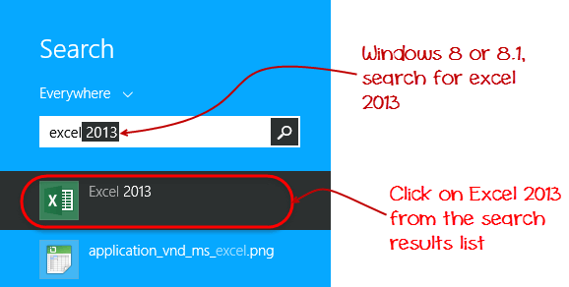

## Understanding the Ribbon

The ribbon provides shortcuts to commands in Excel. A command is an action that the user performs. An example of a command is creating a new document, printing a documenting, etc. The image below shows the ribbon used in Excel 2013.

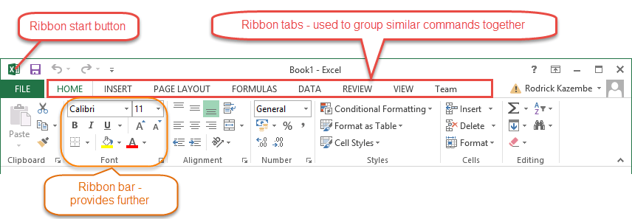

### Ribbon components explained

**Ribbon start button** - it is used to access commands i.e. creating new documents, saving existing work, printing, accessing the options for customizing Excel, etc.

**Ribbon tabs** – the tabs are used to group similar commands together. The home tab is used for basic commands such as formatting the data to make it more presentable, sorting and finding specific data within the spreadsheet.

**Ribbon bar** – the bars are used to group similar commands together. As an example, the Alignment ribbon bar is used to group all the commands that are used to align data together.

## Understanding the worksheet (Rows and Columns, Sheets, Workbooks)

**A worksheet is a collection of rows and columns**. When a row and a column meet, they form a cell. Cells are used to record data. Each cell is uniquely identified using a cell address. Columns are usually labelled with letters while rows are usually numbers.

**A workbook is a collection of worksheets**. By default, a workbook has three cells in Excel. You can delete or add more sheets to suit your requirements. By default, the sheets are named Sheet1, Sheet2 and so on and so forth. You can rename the sheet names to more meaningful names i.e. Daily Expenses, Monthly Budget, etc.

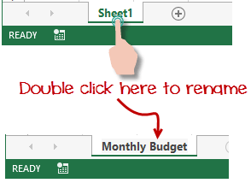

## Customization Microsoft Excel Environment

Personally I like the black colour, so my excel theme looks blackish. Your favourite colour could be blue, and you too can make your theme colour look blue-like. If you are not a programmer, you may not want to include ribbon tabs i.e. developer. All this is made possible via customizations. In this sub-section, we are going to look at;

* Customization the ribbon
* Setting the colour theme
* Settings for formulas
* Proofing settings
* Save settings

### Customization of ribbon

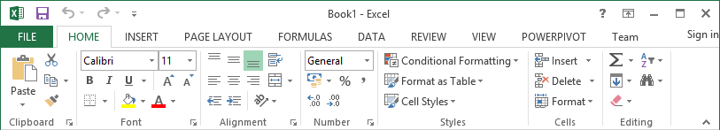

The above image shows the default ribbon in Excel 2013. Let's start with customization the ribbon, suppose you do not wish to see some of the tabs on the ribbon, or you would like to add some tabs that are missing such as the developer tab. You can use the options window to achieve this.

* Click on the ribbon start button
* Select options from the drop down menu. You should be able to see an Excel Options dialog window
* Select the customize ribbon option from the left-hand side panel as shown below

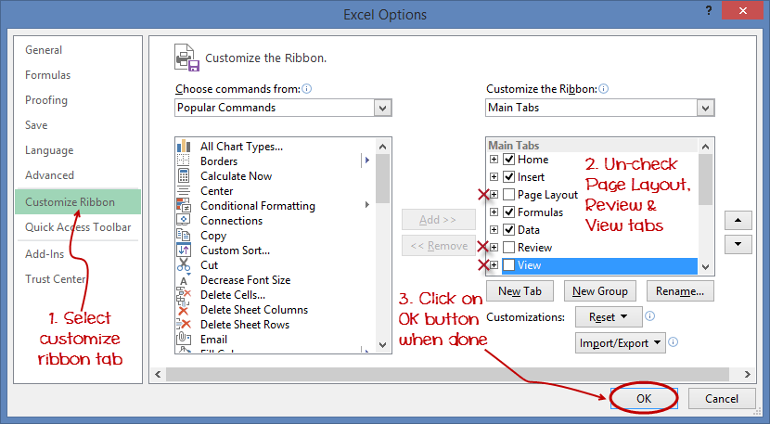

* On your right-hand side, remove the check marks from the tabs that you do not wish to see on the ribbon. For this example, we have removed Page Layout, Review, and View tab.
* Click on the "OK" button when you are done.

Your ribbon will look as follows

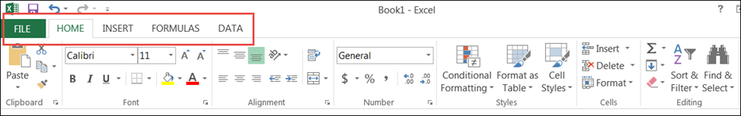

### Adding custom tabs to the ribbon

You can also add your own tab, give it a custom name and assign commands to it. Let's add a tab to the ribbon with the text Guru99



1. Right click on the ribbon and select Customize the Ribbon. The dialogue window shown above will appear
2. Click on new tab button as illustrated in the animated image below
3. Select the newly created tab
4. Click on Rename button
5. Give it a name of Guru99
6. Select the New Group (Custom) under Guru99 tab as shown in the image below
7. Click on Rename button and give it a name of My Commands
8. Let's now add commands to my ribbon bar
9. The commands are listed on the middle panel
10. Select All chart types command and click on Add button
11. Click on OK

Your ribbon will look as follows

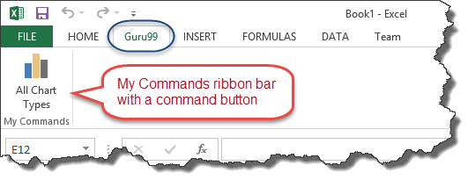

### Setting the colour theme

To set the color-theme for your Excel sheet you have to go to Excel ribbon, and click on à File àOption command. It will open a window where you have to follow the following steps.

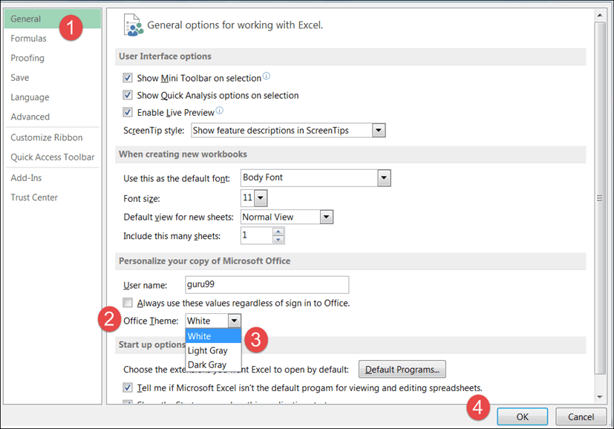

1. The general tab on the left-hand panel will be selected by default.
2. Look for colour scheme under General options for working with Excel
3. Click on the colour scheme drop-down list and select the desired colour
4. Click on OK button

### Settings for formulas

**This option allows you to define how Excel behaves when you are working with formulas**. You can use it to set options i.e. autocomplete when entering formulas, change the cell referencing style and use numbers for both columns and rows and other options.

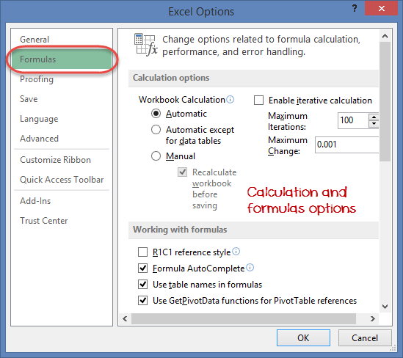

If you want to activate an option, click on its check box. If you want to deactivate an option, remove the mark from the checkbox. You can this option from the Options dialogue window under formulas tab from the left-hand side panel

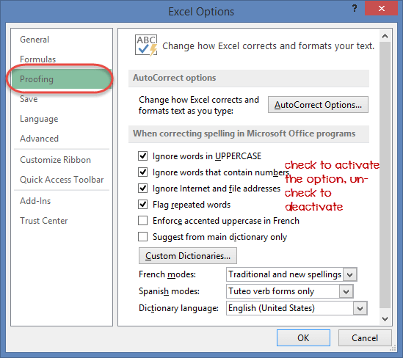

**This option manipulates the entered text entered into excel**. It allows setting options such as the dictionary language that should be used when checking for wrong spellings, suggestions from the dictionary, etc. You can this option from the options dialogue window under the proofing tab from the left-hand side panel

### Save settings

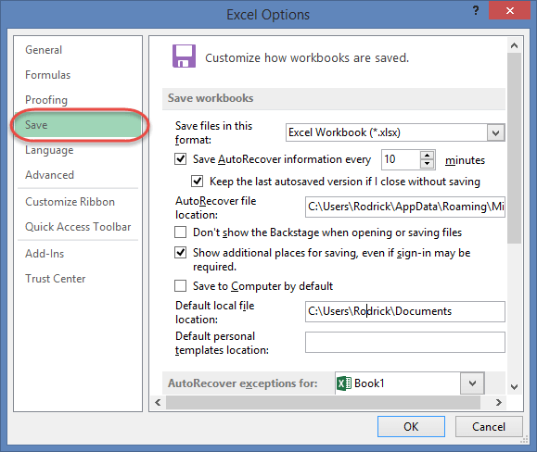

**This option allows you to define the default file format when saving files, enable auto recovery in case your computer goes off before you could save your work, etc**. You can use this option from the Options dialogue window under save tab from the left-hand side panel

Important Excel shortcuts

|  |  |
| --- | --- |
| **Ctrl + P** | used to open the print dialogue window |
| **Ctrl + N** | creates a new workbook |
| **Ctrl + S** | saves the current workbook |
| **Ctrl + C** | copy contents of current select |
| **Ctrl + V** | paste data from the clipboard |
| **SHIFT + F3** | displays the function insert dialog window |
| **SHIFT + F11** | Creates a new worksheet |
| **F2** | Check formula and cell range covered |

## Best Practices when working with Microsoft Excel

1. Save workbooks with backward compatibility in mind. If you are not using the latest features in higher versions of Excel, you should save your files in 2003 *.xls format for backwards compatibility
2. **Use description names for columns and worksheets in a workbook**
3. **Avoid working with complex formulas with many variables**. Try to break them down into small managed results that you can use to build on
4. **Use built-in functions whenever you can instead of writing your own formulas**

## Summary

* Microsoft Excel is a powerful spreadsheet program used to record, manipulate, store numeric data and it can be customized to match your preferences
* The ribbon is used to access various commands in Excel
* The options dialogue window allows you to customize a number of items i.e. the ribbon, formulas, proofing, save, etc.

# How to Add, Subtract, Multiply, Divide in Excel

In this tutorial, we are going to perform basic arithmetic operations i.e. addition, subtraction, division and multiplication. The following table shows the data that we will work with and the results that we should expect.

|  |  |  |  |  |
| --- | --- | --- | --- | --- |
| **S/N** | **ARITHMETIC OPERATOR** | **FIRST NUMBER** | **SECOND NUMBER** | **RESULT** |
| 1 | Addition (+) | 13 | 3 | 16 |
| 2 | Subtraction (-) | 21 | 9 | 12 |
| 3 | Division (/) | 33 | 12 | 2.75 |
| 4 | Multiplication (*) | 7 | 3 | 21 |

Let's now use Microsoft excel to achieve the above results

Create a folder on your computer in my documents folder and name it **Guru99**Excel Tutorials

For this tutorial, we will be using Microsoft Excel 2013. The good news is even if you have Microsoft Excel 2007 or 2010, you will still be able to follow the tutorial and get the same result.

Open Excel. You will get a window similar to the one shown below. The outlook of Excel will depend on your version.

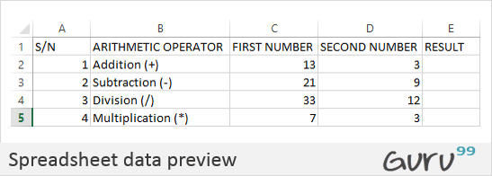

* Enter the data in your worksheet as shown in the image above.
* We will now perform the calculations using the respective arithmetic operators. When performing calculations in Excel, you should always start with the equal (=) sign.
* Let's start with the one for addition. Write the following formula in E2 Excel (Result column)
* =C2+D2

**HERE,**

* **"="** tells Excel to evaluate whatever follows after the equal sign
* **"C2"** is the cell address of the first number given by C representing the column letter and 2 representing the row number
* **"D2"** is the cell address of the second number given by D representing the column letter and 2 representing the row number

Press enter key on the keyboard when done. You should get 16 as the result.

### Tutorial exercise 1

Using the knowledge gained in the above example, try to write the formulas for subtraction, division, and multiplication.

## Formatting data in Microsoft Excel

We all love beautiful things don't we? Formatting in Excel helps us achieve exactly that. We can make our spreadsheets more presentable. We will use the data in the arithmetic operations table. We will make the column names;

* Bold
* Align serial numbers to the left
* Enclose the data in boxes.

### Make column names bold

* Highlight the cells that have the column names by dragging them.
* Click on the bold button represented by **B**command.
* Your workbook should now appear as follows

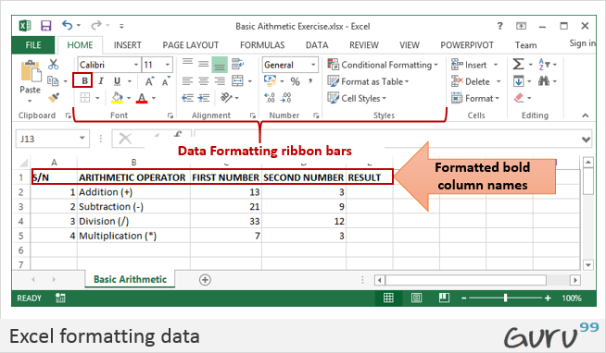

### Align data to the left

* We will align the serial numbers to the left
* Highlight all the data in the S/N column
* Click on align left as shown below

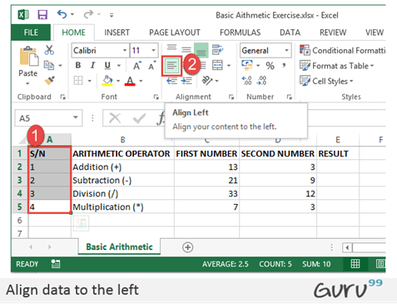

### Enclose data in boxes

Highlight all the columns and rows with data

On the font ribbon bar, click on borders command as shown below.

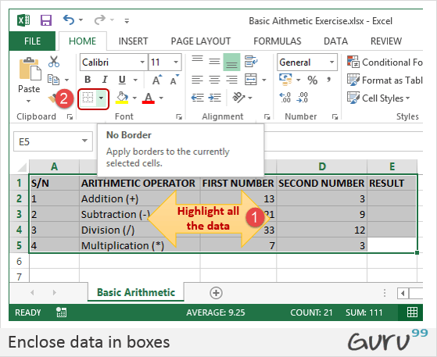

You will get the following drop down menu

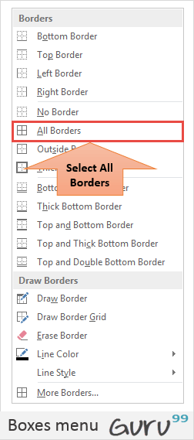

Select the option "All Borders".

Your data should now look as follows

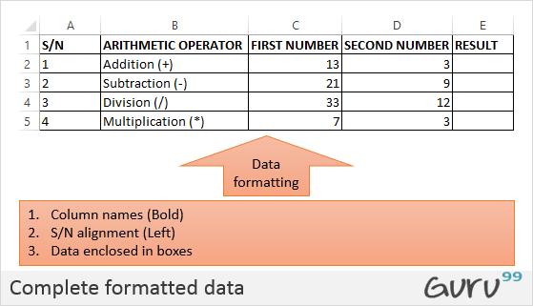

### Tutorial Exercise 2

Using the knowledge gained above, try to change the font colour and try out other options available on the Home tab.

## Setting the print area and printing (Print View) & Page Layout

The print area is the part of the worksheet that you would like to print out on paper. The quick and easy way of doing it is by using the following shortcut commands

Ctrl + P

You will get the following print preview.

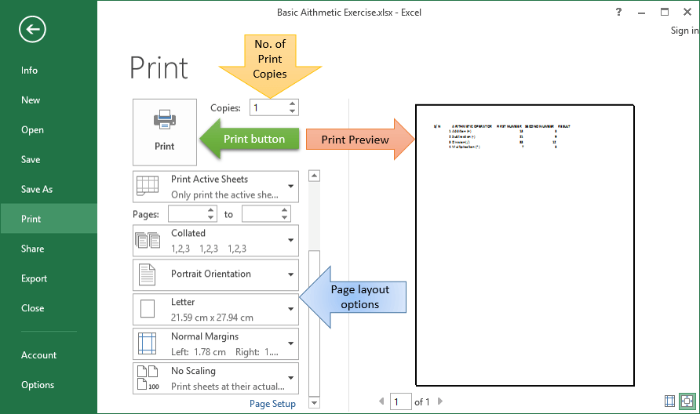

Press Esc button to exit print preview mode

### Tutorial exercise 3

The page setup ribbon bar has a number of options i.e. orientation, size, etc. Try to apply the different settings and use Ctrl + P shortcut to preview the effects on the worksheet.

## Summary

In this article, we have learnt how to perform basic arithmetic operations using Excel, Formatting data, How to Setting the print area and printing (Print View).

# Excel Data Validation, Filters, Grouping

In this tutorial, we are going to cover the following topics.

* [Data validation](https://www.guru99.com/excel-validation-filters-grouping.html#5)
* [Data filters](https://www.guru99.com/excel-validation-filters-grouping.html#6)
* [Group and Ungroup](https://www.guru99.com/excel-validation-filters-grouping.html#7)
* [Adding images to spreadsheets](https://www.guru99.com/excel-validation-filters-grouping.html#4)

## Data validation

**Data validation is very important in the sense that it helps us avoid mistakes that can be avoided**. Let's assume you are recording student exam marks and you know the minimum is 0 and the maximum is 100. You can take advantage of validation features to ensure that only values between 0 and 100 are entered.

Add a new sheet in your workbook by clicking on the plus button at the bottom of the worksheet.

Add a column for S/N, Name and Score. Your sheet should look as follows

|  |  |  |
| --- | --- | --- |
| **S/N** | **Name** | **Score** |
| 1 | Jane |  |
| 2 | James |  |
| 3 | Jones |  |
| 4 | Jonathan |  |
| 5 | John |  |

* Click on the DATA tab
* Select the cells C2 to C6 (The cells that will be used to record the scores)

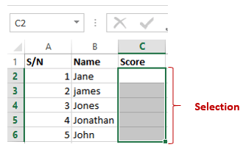

* Click on Data validation drop down list.
* Click on Data validation.

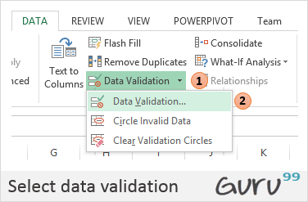

* You will get the following dialogue window

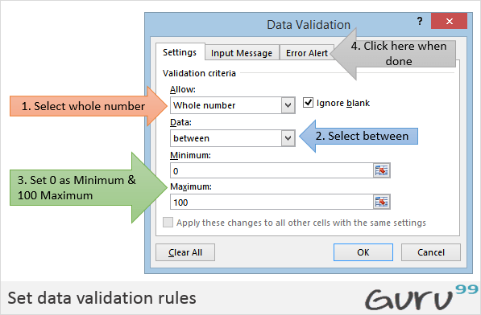

* Click on Error Alert tab
* Enter the alert title and message as shown in the diagram below.

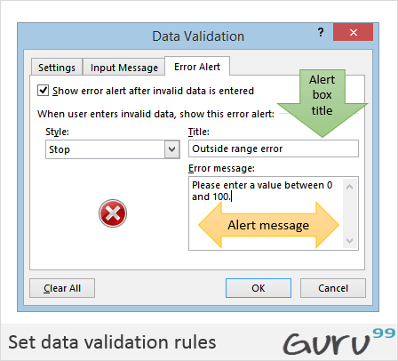

* Click on OK button
* Try to enter a score greater than 200. You will get the following error message

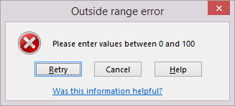

## Data filters

Data filters allow us to get data that matches our desired criteria. Let's say we want to show the results of all the students whose names start with "ja" or get scores that are less than, greater than or equal to a certain value, we can use filters to get such data.

Select the name and scores columns as shown below

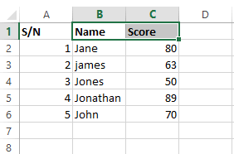

* Click on DATA tab on the ribbon
* Click on Sort & Filter drop down list as shown in the image below

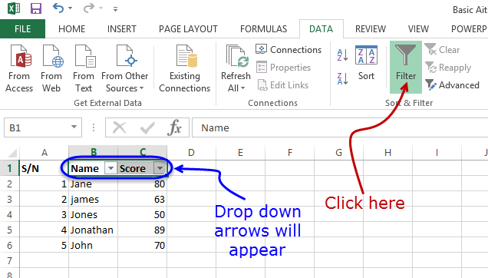

* Click on the Name Filter
* Select text filters
* Select begins with
* You will get the following window.

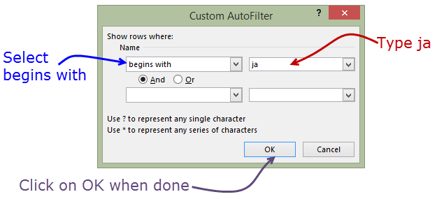

* Enter "ja" and click on "OK" button
* You should be able to see only the results for Jane and James.

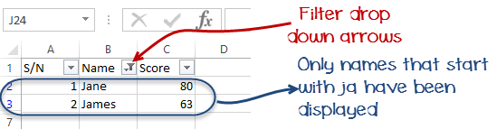

## Group and Ungroup

Groups allow us to view easily and hide unnecessary details from either columns or rows. In addition to that, we can also use groups to analyse data that belongs to a common category. Let's illustrate this with an example. We will use the student scores example above.



* Right click on the score and select insert column. Name the name column gender.
* Change James to Juanita. Put female for Janet and Juanita. Put male for the rest of the students. You sheet should look as follows.

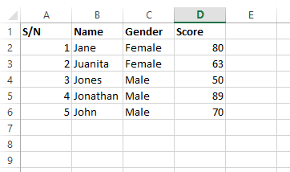

We will now group the females together and display their average score and do the same for the males.

* Click on DATA tab on the ribbon
* Select all the columns and rows with data
* Click on Group drop down button as shown in the image below

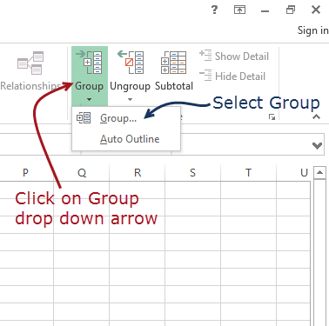

You will get the following window

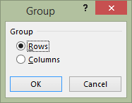

* Make sure Rows options is selected
* Click on OK button
* You will get the following preview

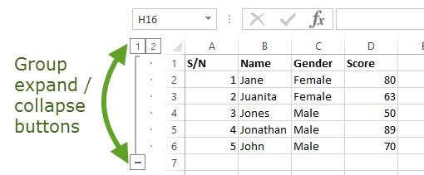

* We will now calculate the average scores for females and males
* Select the whole data as shown below

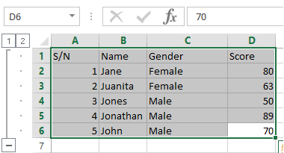

Click on Subtotal drop down button under DATA tab

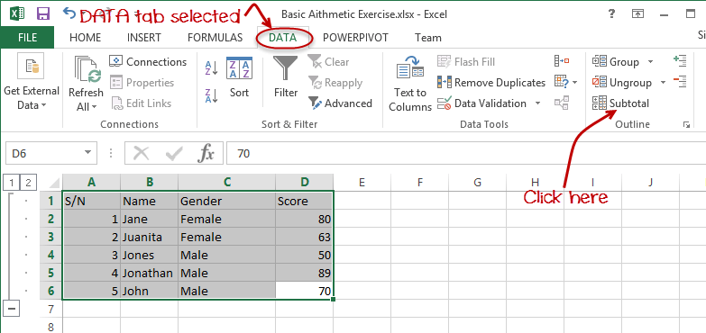

You will get the following window

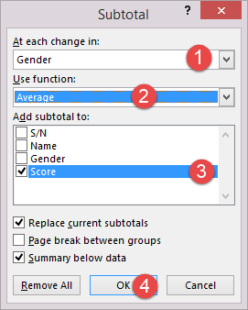

* Set "At each change" into gender
* Set "Use function" to average
* Select "Add subtotal" to Score
* Click on "OK" button

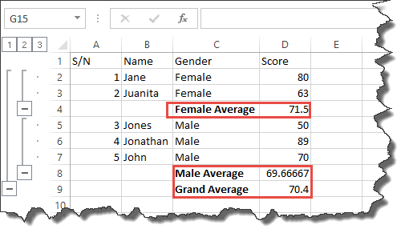

## Adding images to spreadsheets

At times, you would like to brand the documents printed in excel with letterhead information and print with the company logo, etc. Excel has features that allow you to import images into Excel. The command for adding images is found under the INSERT tab on the ribbon.

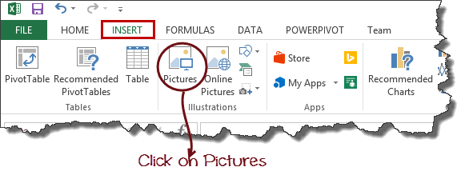

You will get the following dialogue window

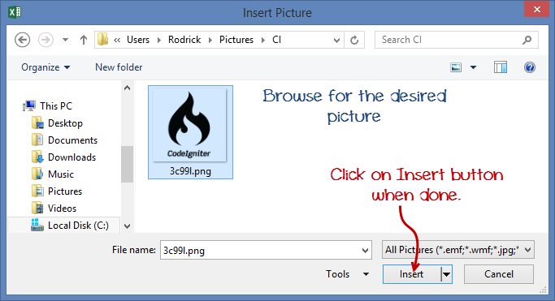

* You can browse to any folder on your computer that has pictures, and you can select any picture of your choice.
* You will get results similar to the ones shown below

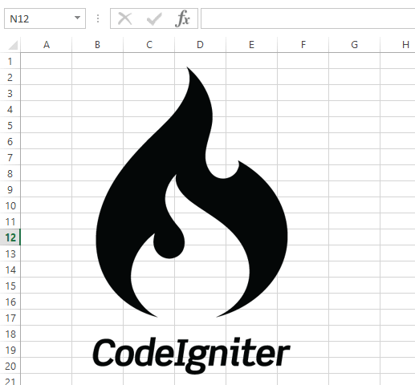

### Tutorial exercise 4

Use the INSERT tab pictures command to add a picture of your choice to the worksheet.

## Summary

In this article, we have learnt how to perform basic arithmetic operations using Excel, format the data, and apply validation rules, filter data and how to take advantage of groups to further analyse data and improve presentation.

# Best Excel Formulas & Functions: You Need to Know Now

Formulas and functions are the building blocks of working with numeric data in Excel. This article introduces you to formulas and functions.

In this article, we will cover the following topics.

* [What is a formula?](https://www.guru99.com/introduction-to-formulas-and-functions-in-excel.html#1)
* [Mistakes to avoid when working with formulas in Excel](https://www.guru99.com/introduction-to-formulas-and-functions-in-excel.html#2)
* [What is a function? (Function Wizard)](https://www.guru99.com/introduction-to-formulas-and-functions-in-excel.html#3)
* [The importance of functions](https://www.guru99.com/introduction-to-formulas-and-functions-in-excel.html#4)
* [Common functions](https://www.guru99.com/introduction-to-formulas-and-functions-in-excel.html#5)
* [Numeric Functions](https://www.guru99.com/introduction-to-formulas-and-functions-in-excel.html#6)
* [String functions](https://www.guru99.com/introduction-to-formulas-and-functions-in-excel.html#7)
* [Date Time functions](https://www.guru99.com/introduction-to-formulas-and-functions-in-excel.html#8)
* [V Lookup function](https://www.guru99.com/introduction-to-formulas-and-functions-in-excel.html#9)

## Tutorials Data

For this tutorial, we will work with the following datasets.

**Home supplies budget**

|  |  |  |  |  |  |
| --- | --- | --- | --- | --- | --- |
| **S/N** | **ITEM** | **QTY** | **PRICE** | **SUBTOTAL** | **Is it Affordable?** |
| 1 | Mangoes | 9 | 600 |  |  |
| 2 | Oranges | 3 | 1200 |  |  |
| 3 | Tomatoes | 1 | 2500 |  |  |
| 4 | Cooking Oil | 5 | 6500 |  |  |
| 5 | Tonic Water | 13 | 3900 |  |  |

**House Building Project Schedule**

|  |  |  |  |  |
| --- | --- | --- | --- | --- |
| **S/N** | **ITEM** | **START DATE** | **END DATE** | **DURATION (DAYS)** |
| 1 | Survey land | 04/02/2015 | 07/02/2015 |  |
| 2 | Lay Foundation | 10/02/2015 | 15/02/2015 |  |
| 3 | Roofing | 27/02/2015 | 03/03/2015 |  |
| 4 | Painting | 09/03/2015 | 21/03/2015 |  |

## What is a formula?

It is the simplest form, a formula is an expression made up of cell addresses and arithmetic operators. Formulas can also be made up of discrete values i.e. =6*3. Excel evaluates the formula to a value. An example of a formula looks as follows.

=A2 * D2 / 2

**HERE,**

* **"="** tells Excel that this is a formula, and it should evaluate it.
* **"A2" * D2"** makes reference to cell addresses A2 and D2 then multiplies the values found in these cell addresses.
* **"/"** is the division arithmetic operator
* **"2"** is a discrete value

### Formulas practical exercise

We will work with the sample data for the home budget to calculate the subtotal.

* Create a new workbook in Excel
* Enter the data shown in the home supplies budget above.
* Your worksheet should look as follows.

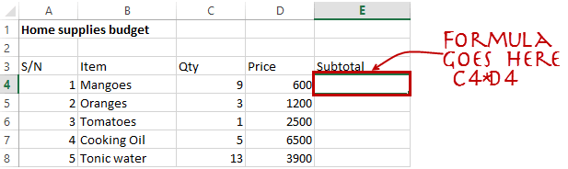

We will now write the formula that calculates the subtotal

Set the focus to cell E4

Enter the following formula.

=C4*D4

**HERE,**

* **"C4*D4"** uses the arithmetic operator multiplication (*) to multiply the value of the cell address C4 and D4.

Press enter key

You will get the following result

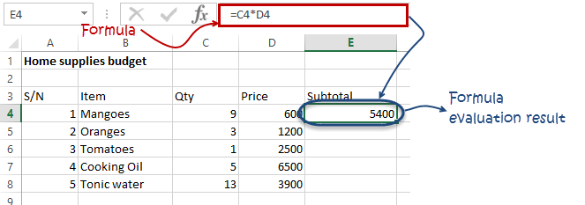

The following animated image shows you how to auto select cell address and apply the same formula to other rows. 

## Mistakes to avoid when working with formulas in Excel

1. Remember the rules of Brackets of Division, Multiplication, Addition, & Subtraction **(BODMAS).** This means expressions are brackets are evaluated first. For arithmetic operators, the division is evaluated first followed by multiplication then addition and subtraction is the last one to be evaluated. Using this rule, we can rewrite the above formula as =(A2 * D2) / 2. This will ensure that A2 and D2 are first evaluated then divided by two.
2. Formulas usually work with numeric data; you can take advantage of data validation to specify the type of data that should be accepted by a cell i.e. numbers only.
3. To ensure that you are working with the correct cell addresses referenced in the formulas, you can press F2 on the keyboard. This will highlight the cell addresses used in the formula, and you can cross check to ensure they are the desired cell addresses.
4. When you are working with many rows, you can use serial numbers for all the rows and have a record count at the bottom of the sheet. You should compare the serial number count with the record total to ensure that your formulas included all the rows.

Check Out [Top 10 Excel Formulas](https://career.guru99.com/top-10-excel-formulas-asked-in-an-interview/)

## What is a function? (Function Wizard)

A function is a predefined formula. Functions allow you to use descriptive names to automatically apply formulas for you. Examples of functions include;

* **SUM** for summation of a range of numbers
* **AVERAGE** for calculating the average of a given range of numbers
* **COUNT** for counting the number of items in a given range

## The importance of functions

**Functions increase user productivity when working with excel**. Let's say you would like to get the grand total for the above home supplies budget. To make it simpler, you can use a formula to get the grand total. Using a formula, you would have to reference the cells E4 through to E8 one by one. You would have to use the following formula.

= E4 + E5 + E6 + E7 + E8

With a function, you would write the above formula as

**=SUM (E4:E8)**

As you can see from the above function used to get the sum of a range of cells, it is much more efficient to use a function to get the sum than using the formula which will have to reference a lot of cells.

## Common functions

Let's look at some of the most commonly used functions in Excel. We will start with statistical functions.

|  |  |  |  |  |
| --- | --- | --- | --- | --- |
| **S/N** | **FUNCTION** | **CATEGORY** | **DESCRIPTION** | **USAGE** |
| 01 | SUM | Math & Trig | Adds all the values in a range of cells | =SUM(E4:E8) |
| 02 | MIN | Statistical | Finds the minimum value in a range of cells | =MIN(E4:E8) |
| 03 | MAX | Statistical | Finds the maximum value in a range of cells | =MAX(E4:E8) |
| 04 | AVERAGE | Statistical | Calculates the average value in a range of cells | =AVERAGE(E4:E8) |
| 05 | COUNT | Statistical | Counts the number of cells in a range of cells | =COUNT(E4:E8) |
| 06 | LEN | Text | Returns the number of characters in a string text | =LEN(B7) |
| 07 | SUMIF | Math & Trig | Adds all the values in a range of cells that meet a specified criteria. =SUMIF(range,criteria,[sum_range]) | =SUMIF(D4:D8,">=1000",C4:C8) |
| 08 | AVERAGEIF | Statistical | Calculates the average value in a range of cells that meet the specified criteria. =AVERAGEIF(range,criteria,[average_range]) | =AVERAGEIF(F4:F8,"Yes",E4:E8) |
| 09 | DAYS | Date & Time | Returns the number of days between two dates | =DAYS(D4,C4) |
| 10 | NOW | Date & Time | Returns the current system date and time | =NOW() |

## Numeric Functions

As the name suggests, these functions operate on numeric data. The following table shows some of the common numeric functions.

|  |  |  |  |  |
| --- | --- | --- | --- | --- |
| **S/N** | **FUNCTION** | **CATEGORY** | **DESCRIPTION** | **USAGE** |
| 1 | ISNUMBER | Information | Returns True if the supplied value is numeric and False if it is not numeric | =ISNUMBER(A3) |
| 2 | RAND | Math & Trig | Generates a random number between 0 and 1 | =RAND() |
| 3 | ROUND | Math & Trig | Rounds off a decimal value to the specified number of decimal points | =ROUND(3.14455,2) |
| 4 | MEDIAN | Statistical | Returns the number in the middle of the set of given numbers | =MEDIAN(3,4,5,2,5) |
| 5 | PI | Math & Trig | Returns the value of Math Function PI(π) | =PI() |
| 6 | POWER | Math & Trig | Returns the result of a number raised to a power. **POWER( number, power )** | =POWER(2,4) |
| 7 | MOD | Math & Trig | Returns the Remainder when you divide two numbers | =MOD(10,3) |
| 8 | ROMAN | Math & Trig | Converts a number to roman numerals | =ROMAN(1984) |

## String functions

These functions are used to manipulate text data. The following table shows some of the common string functions.

|  |  |  |  |  |  |
| --- | --- | --- | --- | --- | --- |
| **S/N** | **FUNCTION** | **CATEGORY** | **DESCRIPTION** | **USAGE** | **COMMENT** |
| 1 | LEFT | Text | Returns a number of specified characters from the start (left-hand side) of a string | =LEFT("GURU99",4) | Left 4 Characters of "GURU99" |
| 2 | RIGHT | Text | Returns a number of specified characters from the end (right-hand side) of a string | =RIGHT("GURU99",2) | Right 2 Characters of "GURU99" |
| 3 | MID | Text | Retrieves a number of characters from the middle of a string from a specified start position and length. **=MID (text, start_num, num_chars)** | =MID("GURU99",2,3) | Retrieving Characters 2 to 5 |
| 4 | ISTEXT | Information | Returns True if the supplied parameter is Text | =ISTEXT(value) | value - The value to check. |
| 5 | FIND | Text | Returns the starting position of a text string within another text string. This function is case-sensitive. **=FIND(find_text, within_text, [start_num])** | =FIND("oo","Roofing",1) | Find oo in "Roofing", Result is 2 |
| 6 | REPLACE | Text | Replaces part of a string with another specified string. **=REPLACE (old_text, start_num, num_chars, new_text)** | =REPLACE("Roofing",2,2,"xx") | Replace "oo" with "xx" |

## Date Time Functions

These functions are used to manipulate date values. The following table shows some of the common date functions

|  |  |  |  |  |
| --- | --- | --- | --- | --- |
| **S/N** | **FUNCTION** | **CATEGORY** | **DESCRIPTION** | **USAGE** |
| 1 | DATE | Date & Time | Returns the number that represents the date in excel code | =DATE(2015,2,4) |
| 2 | DAYS | Date & Time | Find the number of days between two dates | =DAYS(D6,C6) |
| 3 | MONTH | Date & Time | Returns the month from a date value | =MONTH("4/2/2015") |
| 4 | MINUTE | Date & Time | Returns the minutes from a time value | =MINUTE("12:31") |
| 5 | YEAR | Date & Time | Returns the year from a date value | =YEAR("04/02/2015") |

## VLOOKUP function

The VLOOKUP function is used to perform a vertical look up in the left most column and return a value in the same row from a column that you specify. Let's explain this in a layman's language. The home supplies budget has a serial number column that uniquely identifies each item in the budget. Suppose you have the item serial number, and you would like to know the item description, you can use the VLOOKUP function. Here is how the VLOOKUP function would work.

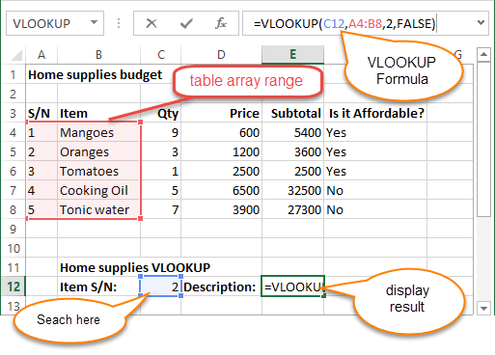

=VLOOKUP (C12, A4:B8, 2, FALSE)

**HERE,**

* **"=VLOOKUP"** calls the vertical lookup function
* **"C12"** specifies the value to be looked up in the left most column
* **"A4:B8"** specifies the table array with the data
* **"2"** specifies the column number with the row value to be returned by the VLOOKUP function
* **"FALSE,"** tells the VLOOKUP function that we are looking for an exact match of the supplied look up value

The animated image below shows this in action



## Summary

Excel allows you to manipulate the data using formulas and/or functions. Functions are generally more productive compared to writing formulas. Functions are also more accurate compared to formulas because the margin of making mistakes is very minimum.

# IF, AND, OR, Nested IF & NOT Logical Functions in Excel

Things will not always be the way we want them to be. The unexpected can happen. For example, let's say you have to divide numbers. Trying to divide any number by zero (0) gives an error. Logical functions come in handy such cases. In this tutorial, we are going to cover the following topics.

In this tutorial, we are going to cover the following topics.

* [What is a Logical Function?](https://www.guru99.com/logical-functions-operators-and-conditions-in-excel.html#1)
* [IF function example](https://www.guru99.com/logical-functions-operators-and-conditions-in-excel.html#3)
* [Excel Logic functions explained](https://www.guru99.com/logical-functions-operators-and-conditions-in-excel.html#4)
* [Nested IF functions](https://www.guru99.com/logical-functions-operators-and-conditions-in-excel.html#5)

## What is a Logical Function?

It is a feature that allows us to introduce decision-making when executing formulas and functions. Functions are used to;

* Check if a condition is true or false
* Combine multiple conditions together

**What is a condition and why does it matter?**

A condition is an expression that either evaluates to true or false. The expression could be a function that determines if the value entered in a cell is of numeric or text data type, if a value is greater than, equal to or less than a specified value, etc.

## IF Function example

We will work with the home supplies budget from this tutorial. We will use the IF function to determine if an item is expensive or not. We will assume that items with a value greater than 6,000 are expensive. Those that are less than 6,000 are less expensive. The following image shows us the dataset that we will work with.

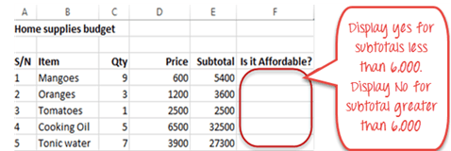

* Put the cursor focus in cell F4
* Enter the following formula that uses the IF function

=IF(E4<6000,"Yes","No")

**HERE,**

* **"=IF(…)"** calls the IF functions
* **"E4<6000"** is the condition that the IF function evaluates. It checks the value of cell address E4 (subtotal) is less than 6,000
* **"Yes"** this is the value that the function will display if the value of E4 is less than 6,000
* **"No"** this is the value that the function will display if the value of E4 is greater than 6,000

When you are done press the enter key

You will get the following results

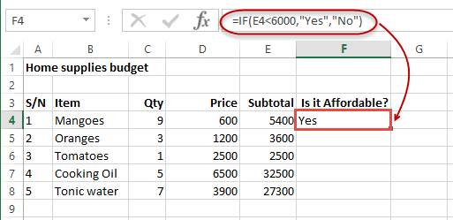

## Excel Logic functions explained

The following table shows all of the logical functions in Excel

|  |  |  |  |  |
| --- | --- | --- | --- | --- |
| **S/N** | **FUNCTION** | **CATEGORY** | **DESCRIPTION** | **USAGE** |
| 01 | AND | Logical | Checks multiple conditions and returns true if they all the conditions evaluate to true. | =AND(1 > 0,ISNUMBER(1)) The above function returns TRUE because both Condition is True. |
| 02 | FALSE | Logical | Returns the logical value FALSE. It is used to compare the results of a condition or function that either returns true or false | FALSE() |
| 03 | IF | Logical | Verifies whether a condition is met or not. If the condition is met, it returns true. If the condition is not met, it returns false. **=IF(logical_test,[value_if_true],[value_if_false])** | =IF(ISNUMBER(22),"Yes", "No") 22 is Number so that it return Yes. |
| 04 | IFERROR | Logical | Returns the expression value if no error occurs. If an error occurs, it returns the error value | =IFERROR(5/0,"Divide by zero error") |
| 05 | IFNA | Logical | Returns value if #N/A error does not occur. If #N/A error occurs, it returns NA value. #N/A error means a value if not available to a formula or function. | =IFNA(D6*E6,0) N.B the above formula returns zero if both or either D6 or E6 is/are empty |
| 06 | NOT | Logical | Returns true if the condition is false and returns false if condition is true | =NOT(ISTEXT(0)) N.B. the above function returns true. This is because ISTEXT(0) returns false and NOT function converts false to TRUE |
| 07 | OR | Logical | Used when evaluating multiple conditions. Returns true if any or all of the conditions are true. Returns false if all of the conditions are false | =OR(D8="admin",E8="cashier") N.B. the above function returns true if either or both D8 and E8 admin or cashier |
| 08 | TRUE | Logical | Returns the logical value TRUE. It is used to compare the results of a condition or function that either returns true or false | TRUE() |

## Nested IF functions

**A nested IF function is an IF function within another IF function**. Nested if statements come in handy when we have to work with more than two conditions. Let's say we want to develop a simple program that checks the day of the week. If the day is Saturday we want to display "party well", if it's Sunday we want to display "time to rest", and if it's any day from Monday to Friday we want to display, remember to complete your to do list.

A nested if function can help us to implement the above example. The following flowchart shows how the nested IF function will be implemented.

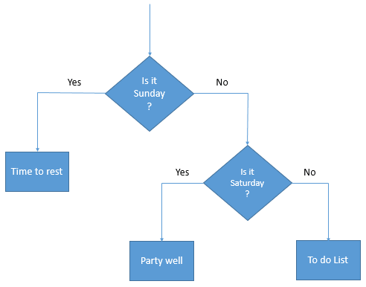

The formula for the above flowchart is as follows

=IF(B1="Sunday","time to rest",IF(B1="Saturday","party well","to do list"))

**HERE,**

* **"=IF(….)"** is the main if function
* **"=IF(…,IF(….))"**the second IF function is the nested one. It provides further evaluation if the main IF function returned false.

## Practical example



Create a new workbook and enter the data as shown below

[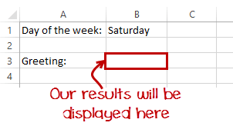](https://www.guru99.com/images/5-2015/050215_0844_Logicalfunc4.png)

* Enter the following formula

=IF(B1="Sunday","time to rest",IF(B1="Saturday","party well","to do list"))

* Enter Saturday in cell address B1
* You will get the following results

[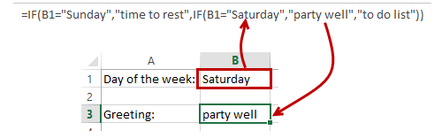](https://www.guru99.com/images/5-2015/050215_0844_Logicalfunc5.png)

## Summary

Logical functions are used to introduce decision-making when evaluating formulas and functions in Excel.

**How to Create Charts in Excel: Types & Examples**

A picture is worth of thousand words; a chart is worth of thousand sets of data. In this tutorial, we are going to learn how we can use graph in Excel to visualize our data.

## What is a chart?

**A chart is a visual representative of data in both columns and rows**. Charts are usually used to analyse trends and patterns in data sets. Let's say you have been recording the sales figures in Excel for the past three years. Using charts, you can easily tell which year had the most sales and which year had the least. You can also draw charts to compare set targets against actual achievements.

We will use the following data for this tutorial.

**Note**: we will be using Excel 2013. If you have a lower version, then some of the more advanced features may not be available to you.

|  |  |  |  |  |
| --- | --- | --- | --- | --- |
| **Item** | **2012** | **2013** | **2014** | **2015** |
| Desktop Computers | 20 | 12 | 13 | 12 |
| Laptops | 34 | 45 | 40 | 39 |
| Monitors | 12 | 10 | 17 | 15 |
| Printers | 78 | 13 | 90 | 14 |

## Types of charts

Different scenarios require different types of charts. Towards this end, Excel provides a number of chart types that you can work with. **The type of chart that you choose depends on the type of data that you want to visualize**. To help simplify things for the users, Excel 2013 and above has an option that analyses your data and makes a recommendation of the chart type that you should use.

The following table shows some of the most commonly used charts and when you should consider using them.

|  |  |  |  |
| --- | --- | --- | --- |
| **S/N** | **CHART TYPE** | **WHEN SHOULD I USE IT?** | EXAMPLE |
| 1 | Pie Chart | When you want to quantify items and show them as percentages. | [Visualizing data using charts in Excel](https://www.guru99.com/images/5-2015/050215_0900_Visualizing1.png) |
| 2 | Bar Chart | When you want to compare values across a few categories. The values run horizontally | [Visualizing data using charts in Excel](https://www.guru99.com/images/5-2015/050215_0900_Visualizing2.png) |
| 3 | Column chart | When you want to compare values across a few categories. The values run vertically | [Visualizing data using charts in Excel](https://www.guru99.com/images/5-2015/050215_0900_Visualizing3.png) |
| 4 | Line chart | When you want to visualize trends over a period of time i.e. months, days, years, etc. | [Visualizing data using charts in Excel](https://www.guru99.com/images/5-2015/050215_0900_Visualizing4.png) |
| 5 | Combo Chart | When you want to highlight different types of information | [Visualizing data using charts in Excel](https://www.guru99.com/images/5-2015/050215_0900_Visualizing5.png) |

## The importance of charts

* Allows you to visualize data graphically
* It's easier to analyse trends and patterns in the charts
* Easy to interpret compared to data in cells

## Step by step example of creating charts in Excel

In this tutorial, we are going to plot a simple column chart that will display the sold quantities against the sales year.

* Open Excel
* Enter the data from the sample data table above
* Your workbook should now look as follows

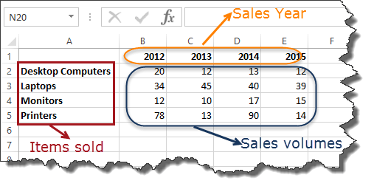

To get the desired chart you have to follow the following steps

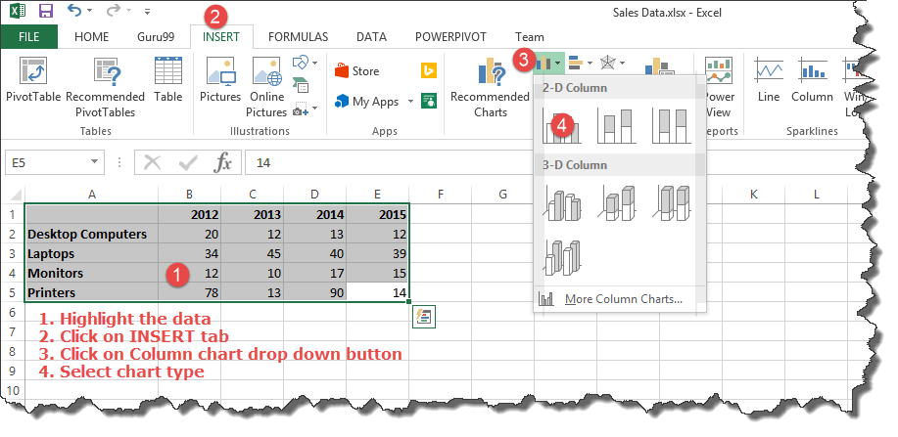

* Select the data you want to represent in graph
* Click on INSERT tab from the ribbon
* Click on the Column chart drop down button
* Select the chart type you want

You should be able to see the following chart



### Tutorial Exercise

When you select the chart, the ribbon activates the following tab

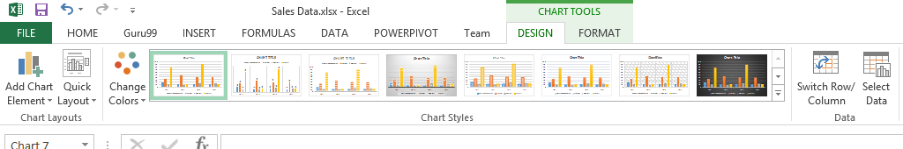

Try to apply the different chart styles, and other options presented in your chart.

## Summary

Charts are a powerful way of graphically visualizing your data. Excel has many types of charts that you can use depending on your needs.

Conditional formatting is also another power formatting feature of Excel that helps us easily see the data that meets a specified condition

# How to make Budget in Excel: Personal Finance Tutorial

"Money is a tool. Used properly it makes something beautiful- used wrong, it makes a mess!" - Bradley Vinson

It takes discipline to use money properly. In this tutorial, we are going to look at how we can use Excel to properly manage our personal finances. We will cover the following topics.

* [Why manage Budget?](https://www.guru99.com/case-study-managing-personal-finance-using-microsoft-excel.html#1)
* [Major components of a personal finance system](https://www.guru99.com/case-study-managing-personal-finance-using-microsoft-excel.html#2)
* [Using Excel to set personal budgets, record income and expenses](https://www.guru99.com/case-study-managing-personal-finance-using-microsoft-excel.html#3)
* [Visualizing the data using charts](https://www.guru99.com/case-study-managing-personal-finance-using-microsoft-excel.html#4)

## Why manage Budget?

Let's face it, the world we live in is fuelled by money. We go to school to get a good job, engage in business and other related activities with the main goal of making money. If we do not manage our personal finances properly, then all of our efforts go to waste.

Most people spend more than they earn. In order to be financially successful, one needs to develop a habit of spending less than they earn and invest the surplus in business ventures that will multiply the invested money

## Major components of a personal finance system

This is a basic personal finance system so we will consider the following components;

1. **Projected income** – this is the money that you expect to earn now and in the future.
2. **Budget** – this is a list of the items that you expect to buy, quantities and their respective prices
3. **Actual income** – this is the actual money that you earn as time progresses
4. **Actual expenditure** – this is the money that you actually spend buying things

The variance between the projected income and actual income gives us the performance indicator of how accurate our estimates are or how hard we are working.

The variance between the budget and the actual expenditure give us the performance indicator of how disciplined we are when it comes to sticking to a budget.

Since saving is a part of the goal of having a personal finance system, the actual income vs. the actual expenditure say on a monthly basis gives us an idea of how much we would save over a year.

## Using Excel to set personal budgets, and record income and expenses

We have looked at the components of a personal finance system, and we will now use what we have learnt so far to implement the above. We will create two workbooks for this tutorial, one for income and the other for budgets.

When you are done with this tutorial, your workbooks should look as follows

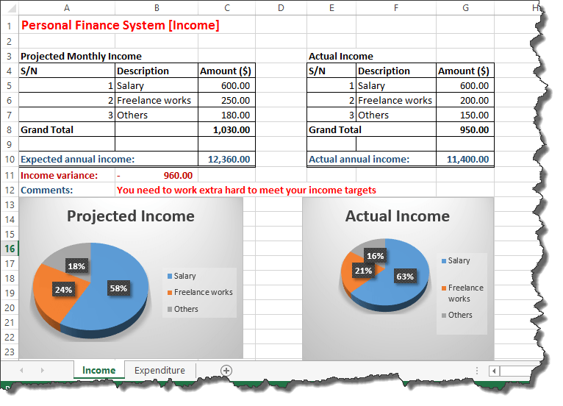

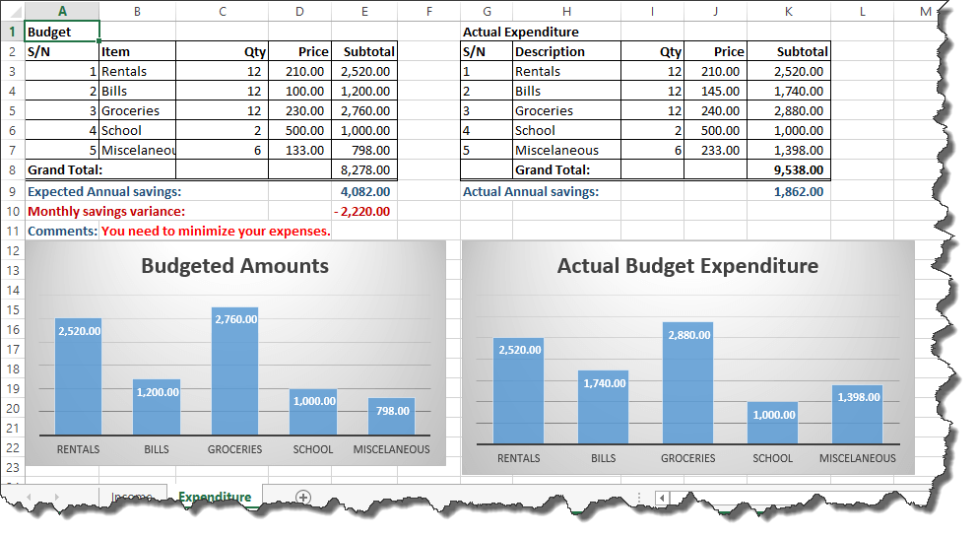

Open Excel and create a new workbook

### Income sheet

* Rename the Sheet1 to Income
* Enter the data shown below
* Projected Monthly Income

|  |  |  |
| --- | --- | --- |
| **S/N** | **Description** | **Amount ($)** |
| 1 | Salary | 600.00 |
| 2 | Freelance works | 250.00 |
| 3 | Others | 180.00 |
| **Grand Total** |  |  |
|  |  |  |
| **Expected annual income:** |  |  |

**Actual Income**

|  |  |  |
| --- | --- | --- |
| **S/N** | **Description** | **Amount ($)** |
| 1 | Salary | 600.00 |
| 2 | Freelance works | 200.00 |
| 3 | Others | 150.00 |
| **Grand Total** |  |  |
|  |  |  |
| **Actual annual income:** |  |  |

### Formulas for Income sheet

We will now need to;

1. Calculate the monthly income for both projected and actual income.
2. Compute the projected annual income and actual annual income based on the monthly total.
3. Find the variance between the actual and project annual income
4. Show tips on how we are doing using logical functions
5. Use conditional formatting to highlight how well we are managing our finances

### Tutorial Exercise 1

1. Find the sum of all monthly income sources. Use the **SUM** function. Do this for both projected and actual monthly income.
2. Find the annual projected and actual income by multiplying your answer in question 1 by 12.
3. Find the income variance by subtracting the projected annual income from the actual annual income.
4. Add a comments row just below the tables. Use the IF functions to display "You need to work extra hard to meet your income targets" if the variance is less than zero (0) else display "Great job working smart and harder".
5. Use conditional formatting to change the text colour to red if the variance is less than 0 else change the text colour to green.

If you are stuck on what to do, read the articles on formulas and functions, and Visualizing data using charts in Excel.

### Expenditure sheet

Add a new sheet and rename it to Expenditure

Enter the data as shown below

**Budget**

|  |  |  |  |  |
| --- | --- | --- | --- | --- |
| **S/N** | **Item** | **Qty** | **Price** | **Subtotal** |
| 1 | Rentals | 12 | 210.00 |  |
| 2 | Bills | 12 | 100.00 |  |
| 3 | Groceries | 12 | 230.00 |  |
| 4 | School | 2 | 500.00 |  |
| 5 | Miscellaneous | 6 | 133.00 |  |
| **Grand Total:** |  |  |  |  |
| **Expected Annual savings:** |  |  |  |  |

**Actual income**

|  |  |  |  |  |
| --- | --- | --- | --- | --- |
| **S/N** | **Description** | **Qty** | **Price** | **Subtotal** |
| 1 | Rentals | 12 | 210.00 |  |
| 2 | Bills | 12 | 145.00 |  |
| 3 | Groceries | 12 | 240.00 |  |
| 4 | School | 2 | 500.00 |  |
| 5 | Miscellaneous | 6 | 233.00 |  |
|  | **Grand Total:** |  |  |  |
| **Actual Annual Savings:** |  |  |  |  |

### Formulas for Expenditure sheet

We will need to;

1. Calculate the subtotal
2. Calculate the grand total based on sub totals
3. Compute the expected annual savings. The expected annual savings is the difference between the projected annual income and the budget total amount. This will be done for the actual income and actual expenditure too.
4. Compute the monthly savings variance
5. Add a comments row just below the tables. Use the IF functions to display "You need to minimize your expenses." if the variance is less than zero (0) else display" Great job sticking to the budget".
6. Use conditional formatting to change the text colour to red if the variance is less than 0 else change the text colour to green.

**Tutorial exercise 2**

Write formulas that implement the above scenarios.

## Visualizing the data using charts

Charts are a great way of visualizing our data. We will now add a pie chart to our income sheet for the projected monthly income. The image below shows our data

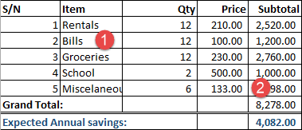

As marked in the above image our chart should only show the data for

1. Item column
2. Subtotal column

Highlight items **1 to 5 in Item column**

Hold Ctrl button on the keyboard and highlight the subtotals from **1 to 5 in subtotals column**.

Your selection should look as shown in the image below

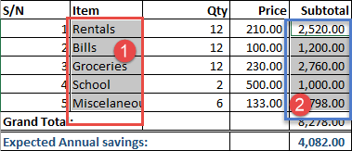

Click on INSERT tab from main menu

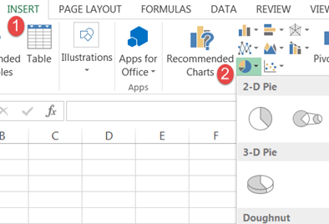

* Use the charts ribbon bar, click on the pie chart drop down and select a pie chart of your choice.
* Your pie chart should now look similar to the one shown below

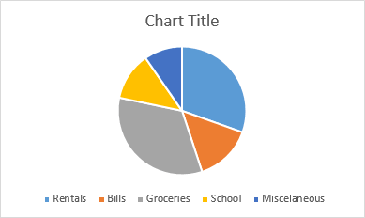

### Tutorial exercise three

Create charts for the actual expenditure, projected income, and actual income

## Summary

In this tutorial, we have learnt and applied the knowledge gained in the previous tutorials. We have also been able to visualize our data using charts.

**How to Import XML Data into Excel [Example]**

Data is the bloodstream of any business entity. Businesses use different programs and formats to save the data depending on the business data storage requirements. **You could have a payroll program powered by a database engine, you could have data in a CSV file or even from a website that you would like to analyse in Excel**. This article shows you how you can achieve the above.

## What is external data source?

External data is data that you link/import into excel from a source that resides outside excel.

Examples of external include the following

* Data stored in a Microsoft Access database. This could the information from a custom application i.e. **Payroll, Point of Sale, Inventory,** etc.
* Data from[SQL](https://www.guru99.com/sql.html)Server or other database engines i.e. MySQL, Oracle, etc. – This could be information from a custom application
* From a web site/web service – this could be information from a[Web services](https://www.guru99.com/web-services-tutorial.html)i.e. currency exchange rates from the internet, stock prices, etc.
* Text file i.e. CSV, tab separated, etc. – this could be information from a third party application that does not provide direct links. Such data could include bank payments exported to comma separated file CSV, etc.
* Other types i.e. HTML data, Windows Azure Market Place, etc.

## Website(XML data) external data source example

In this example, we will assume we are trading the Euro currency and would like to get the exchange rates from the European Central Bank web service. The currency exchange rate API link is <http://www.ecb.europa.eu/stats/eurofxref/eurofxref-daily.xml>

* Open a new workbook
* Click on the DATA tab on the ribbon bar
* Click on "From Web" button
* You will get the following window

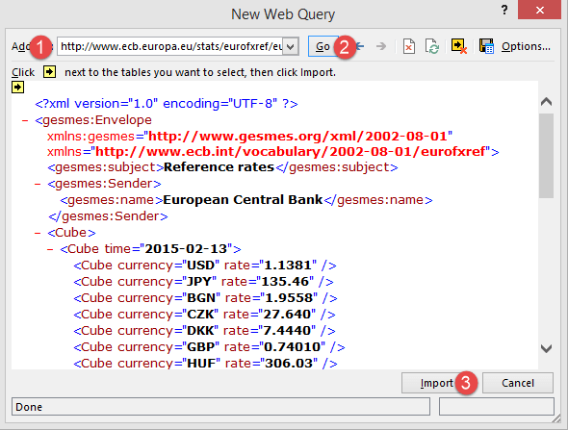

1. Enter <http://www.ecb.europa.eu/stats/eurofxref/eurofxref-daily.xml> in the address
2. Click on Go button, you will get the XML data preview
3. Click on Import button when done

You will get the following options dialogue window

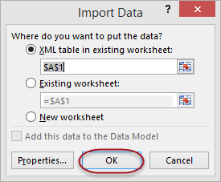

* Click on OK button
* You will get the following data

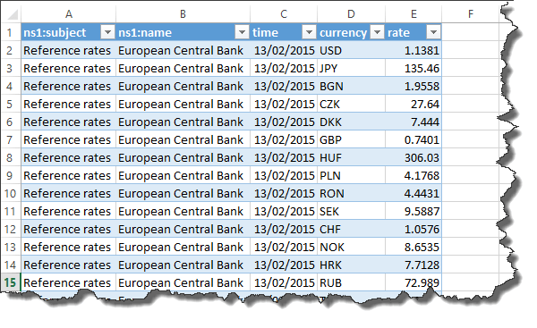

Let's take another example, this time you have local xml not in form of web link. You can download XML File below.

* Open a new workbook
* Click on the DATA tab on the ribbon bar
* Click on "From Other Source"

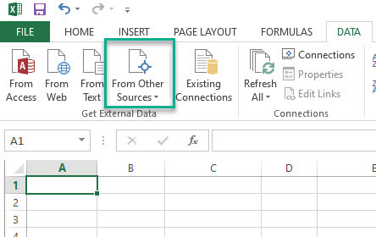

Then click on "From XML Data Import"

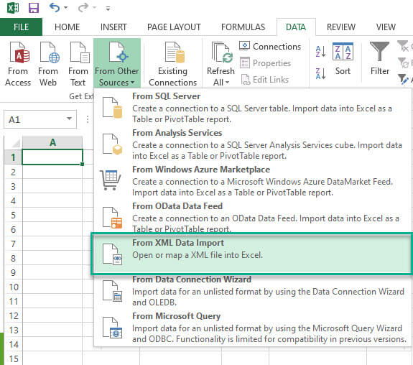

* Now select the XML File

You will get the options dialogue window as above example

* Click on OK button
* You will get the following data

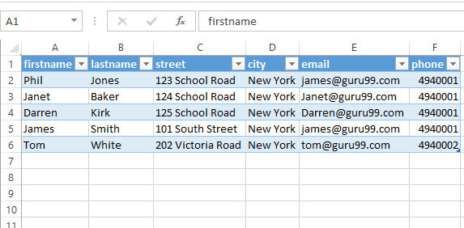

## Summary

Excel has powerful features that allow us to analyse numeric data and create visual reports such as charts. You can take advantage of external data importation to create your own custom reports that meet your business reporting requirements.

**How to Import CSV Data (Text) into Excel [Example]**

In this tutorial, We will import external data from a simple CSV file containing customer payments. You can download the CSV file for this exercise.

* Open a new workbook
* Click on DATA tab on the ribbon
* Click on From Text button
* You will get the following window

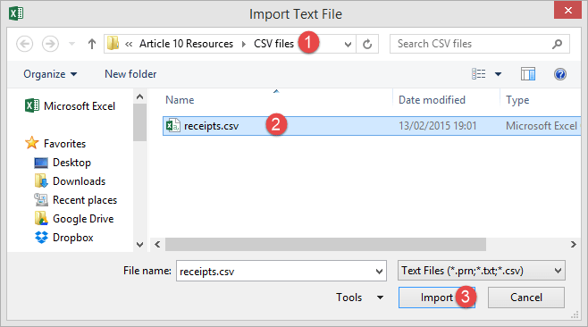

* Browse to the folder where you downloaded the CSV file
* Select da.csv file
* Click on Import button
* You will get the following import text file wizard

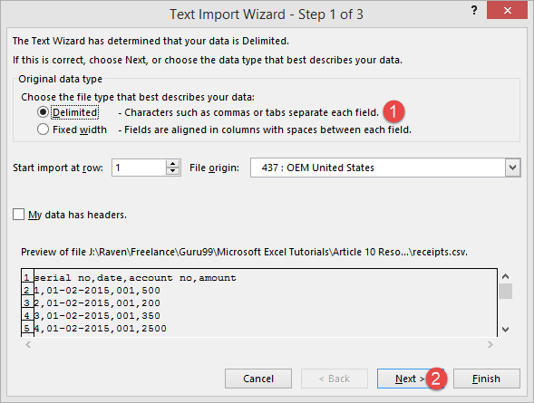

Click on Next button

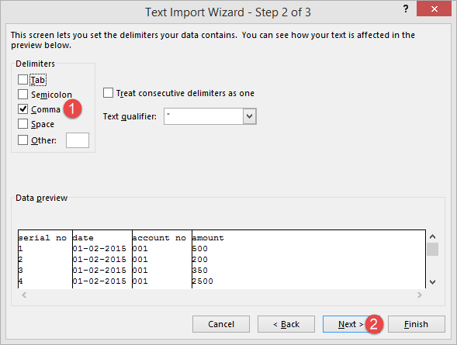

* Select Comma on the Delimiters panel
* Click on Next button

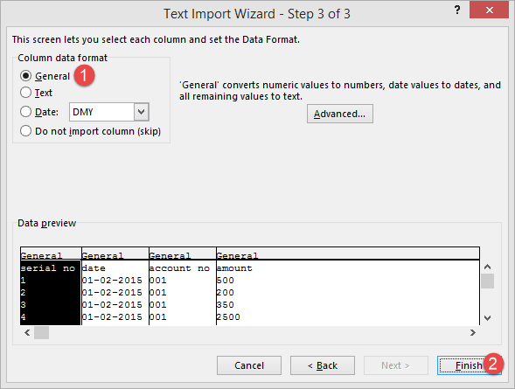

Click on Finish button

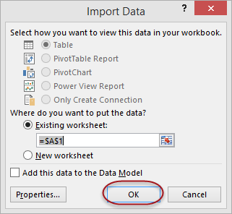

* Click on OK button
* You will get the following data

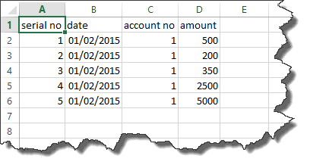

In some cases you may not get comma separated file, it could be Slash (\), Pipe (|) or other delimiter separated files. Let's take a look at how to deal with them.

Here is sample Slash (\) separated value file that you can download.

* Open a new workbook
* Click on DATA tab on the ribbon
* Click on From Text button
* Browse to the folder where you downloaded the file and Import it
* You will get the following import text file wizard

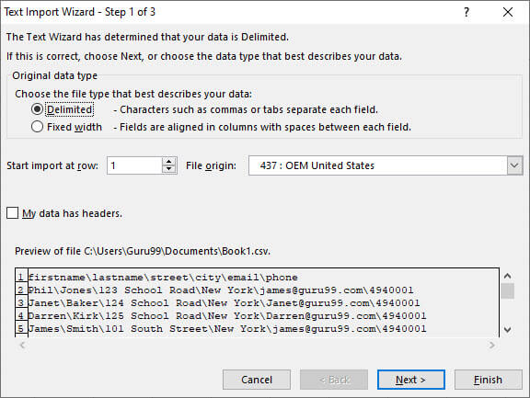

* Click on Next button

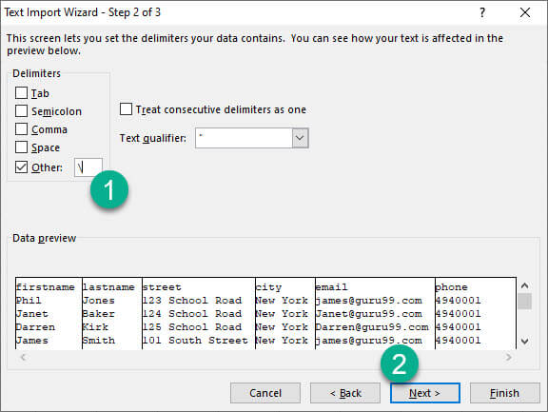

* Now instade of selecting the Comma Delimiter, Select Other and set Slash (\) as delimiter on the Delimiters panel
* Then click on Next Button.
* Then click on Finish Button
* Now Import data in Existing worksheet

You will get the folliwing data

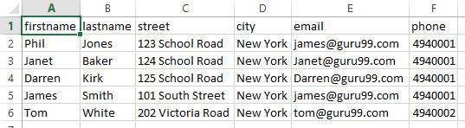

**How to Import MS Access Data into Excel [Example]**

In this tutorial, we are going to import data from a simple external database powered by Microsoft Access database. We will import the products table into excel. You can download the Microsoft Access database.

* Open a new workbook
* Click on the DATA tab
* Click on from Access button as shown below

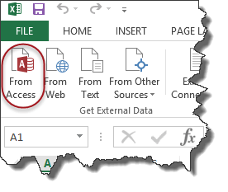

You will get the dialogue window shown below

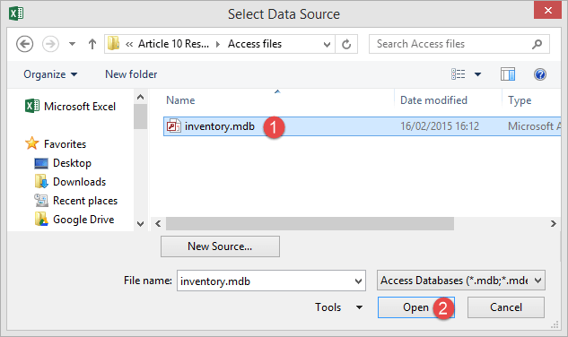

* Browse to the database that you downloaded and
* Click on Open button

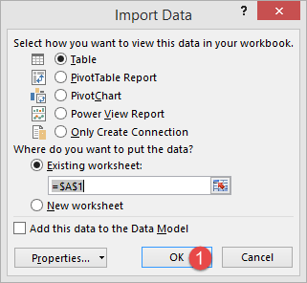

* Click on OK button
* You will get the following data

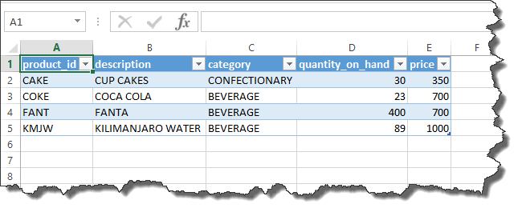

**How to Import SQL Database Data into Excel [Example]**

In this tutorial, we are going to import data from a SQL external database. This exercise assumes you have a working instance of SQL Server and basics of SQL Server.

First we create SQL file to import in Excel. If you have already SQL exported file ready, then you can skip following two step and go to [next step](https://www.guru99.com/import-sql-data-excel.html#1).

1. Create a new database named EmployeesDB
2. Run the following queary

USE EmployeeDB

GO

CREATE TABLE [dbo].[employees](

[employee_id] [numeric](18, 0) NOT NULL,

[full_name] [nvarchar](75) NULL,

[gender] [nvarchar](50) NULL,

[department] [nvarchar](25) NULL,

[position] [nvarchar](50) NULL,

[salary] [numeric](18, 0) NULL,

CONSTRAINT [PK_employees] PRIMARY KEY CLUSTERED

(

[employee_id] ASC

)WITH (PAD_INDEX = OFF, STATISTICS_NORECOMPUTE = OFF, IGNORE_DUP_KEY = OFF, ALLOW_ROW_LOCKS = ON, ALLOW_PAGE_LOCKS = ON) ON [PRIMARY]

) ON [PRIMARY]

GO

INSERT INTO employees(employee_id,full_name,gender,department,position,salary)

VALUES

('4','Prince Jones','Male','Sales','Sales Rep',2300)

,('5','Henry Banks','Male','Sales','Sales Rep',2000)

,('6','Sharon Burrock','Female','Finance','Finance Manager',3000);

GO

### Importing Data to Excel using the Data Connection Wizard Dialog

* Create a new workbook in MS Excel
* Click on DATA tab

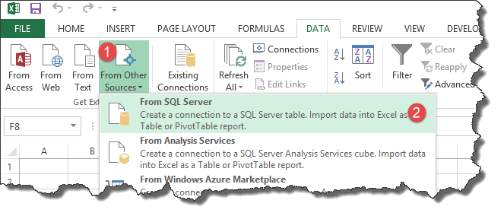

1. Select from Other sources button
2. Select from SQL Server as shown in the image above

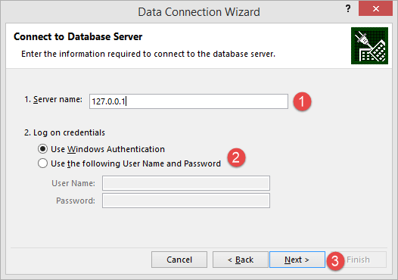

1. Enter the server name/IP address. For this tutorial, am connecting to localhost 127.0.0.1
2. Choose the login type. Since am on a local machine and I have windows authentication enabled, I will not provide the user id and password. If you are connecting to a remote server, then you will need to provide these details.
3. Click on next button

Once you are connected to the database server. A window will open, you have to enter all the details as shown in screenshot

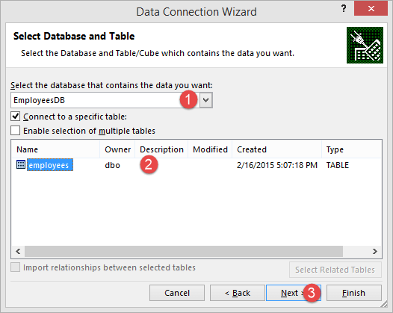

* Select EmployeesDB from the drop down list
* Click on employees table to select it
* Click on next button.

It will open a data connection wizard to save data connection and finish the process of connecting to the employee's data.

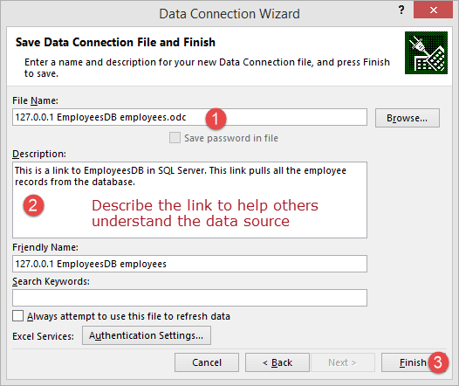

You will get the following window

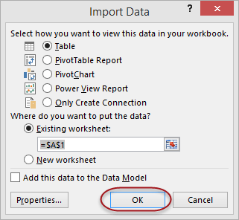

Click on OK button

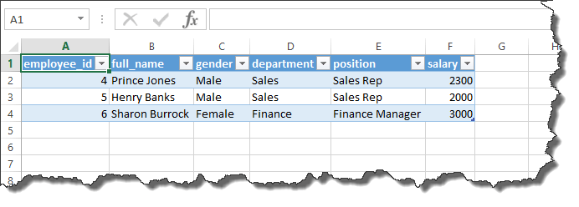

# How to Create Pivot Table in Excel: Beginners Tutorial

There will be times when you will be required to analyse large amounts of data and produce easy to read and understand reports. Pivot tables allow us to analyse such data and produce reports that meet our business reporting requirements.

In this tutorial, we are going to cover the following topics;

* [What is a Pivot Table?](https://www.guru99.com/pivot-tables-in-excel-beginner-s-guide.html#1)
* [Step by Step tutorial on creating pivot tables](https://www.guru99.com/pivot-tables-in-excel-beginner-s-guide.html#3)
* [2-Dimensional pivot tables](https://www.guru99.com/pivot-tables-in-excel-beginner-s-guide.html#4)
* [Visualizing pivot table data using charts](https://www.guru99.com/pivot-tables-in-excel-beginner-s-guide.html#5)

## What is a Pivot Table?

A Pivot Table is a summary of a large dataset that usually includes the total figures, average, minimum, maximum, etc. let's say you have a sales data for different regions, with a pivot table, you can summarize the data by region and find the average sales per region, the maximum and minimum sale per region, etc. Pivot tables allow us to analyse, summarize and show only relevant data in our reports.

## Step by Step tutorial on creating pivot tables

The image below shows the sample sales data collated from North wind access database.

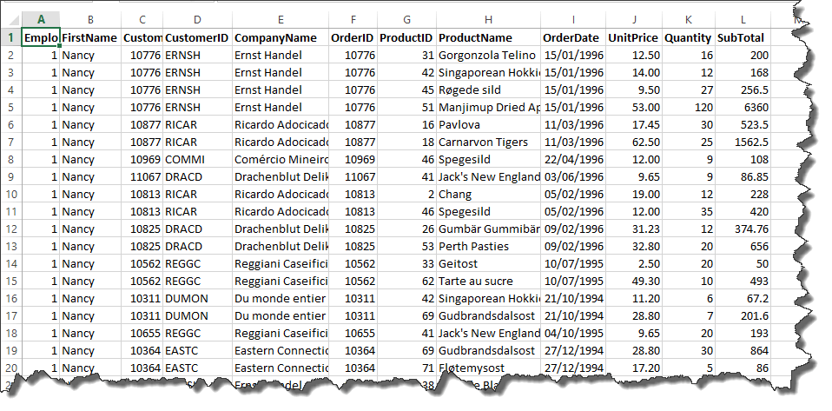

You can download the sample Excel data here.

As you can see from the above image, our spreadsheet contains a lot of data. Let's say we want to create a summary of customers, group all of their orders by product, and show the quantities, unit price and subtotals for all the transactions.

* Open the Excel file that you downloaded
* Click on INSERT tab on the ribbon

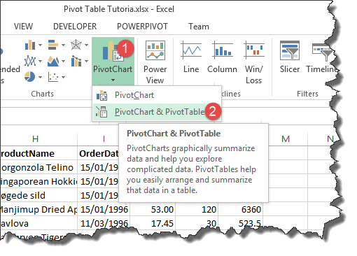

You will get the following window

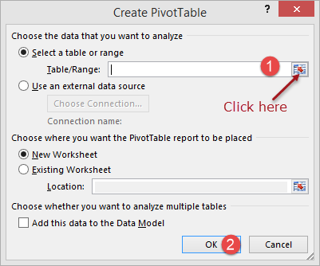

* Click on the select table/range button as shown in the image above
* You will get the following mini window

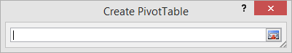

* Click in cell address A1
* Press Ctrl + A on the keyboard to select all the data cells
* Your mini window shown now appear as follows

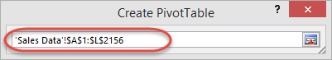

* Click on Close button to get back to the options window
* Click on OK button

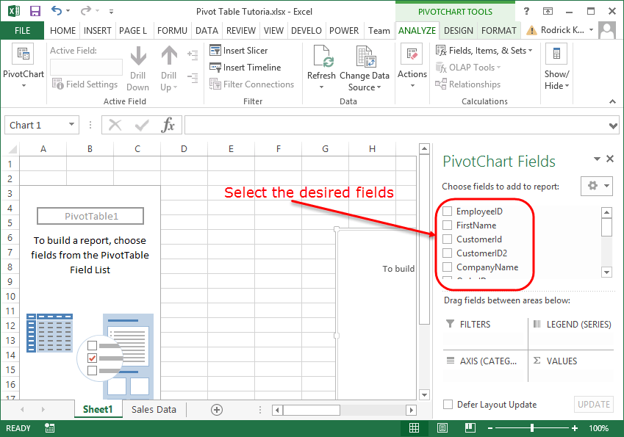

* Select the following fields
  + CompanyName
  + Product Name
  + UnitPrice
  + Quantity
  + SubTotal
* Your worksheet should now look as follows

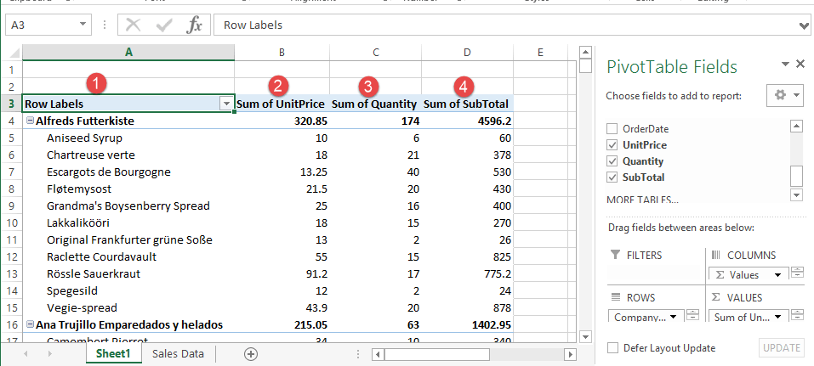

* Note the above data has been grouped by customer company name, product name, unit price, sum of quantities and the sum of the subtotals.
* Notice the drop down button next to Rows Labels. This button allows us to sort/filter our data. Let's assume we are only interested in Alfreds Futterkiste
* Click on the Row Labels drop down list as shown below

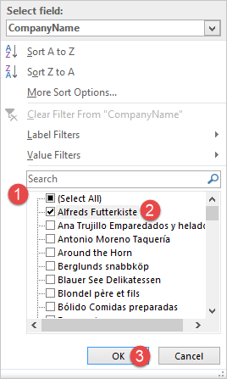

* Remove the tick from (Select All)
* Select Alfreds Futterkiste
* Click on OK button
* You will get the following data

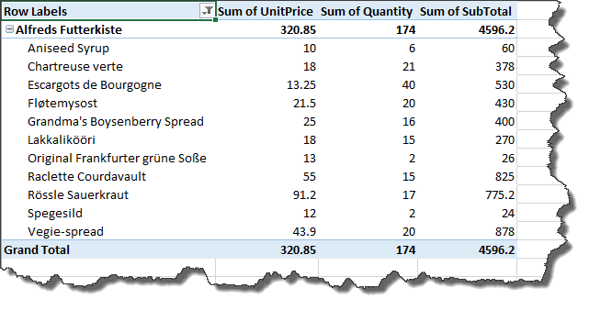

## 2-Dimensional pivot tables

A two-dimensional pivot table is a table that has fields on both rows and columns. Let's say we want to list employee names as rows and use columns to represent customer names and fill in the cells with the total sales.

* Activate the Sales Datasheet
* Click on INSERT tab
* Click on Pivot Chart & Table button
* Select all the data. Excel should now remember the previous range so you just have to click on OK button
* A new sheet will be created with the pivot table tools
* Select the fields as shown in the image below

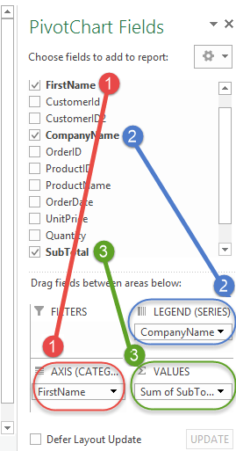

Your pivot table will now look as follows

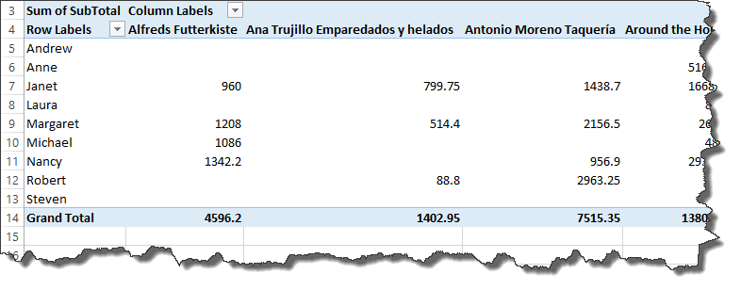

## Visualizing pivot table data using charts

With Excel 2013, you do not need to create the charts manually. Excel will create the charts for you as you create your pivot tables, change aggregate functions, apply filters, etc.

The chart below was automatically created for us from the simple pivot chart exercise that filtered data for Alfreds Futterkiste only.

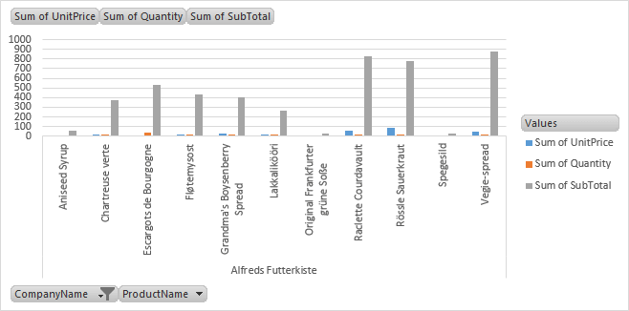

## Summary

Pivot tables and charts enable us to summarize and analyse large datasets. We can use aggregate functions such as SUM, MINIMUM, MAXIMUM, AVERAGE, etc. the charts are automatically created and updated for us by excel as we work with the data.

**Advanced Charts & Graph in Excel**

Graphics, images, and charts are great ways to visualize and represent the data, and Excel does exactly same thing for us by automatically creating the charts. There may be times when we would like to go beyond the basic charts that excel creates for us. This tutorial will focus on that complexity.

## What is an advanced chart?

An advanced chart is a chart that goes beyond the basic charts created by Excel. Let's say you have more than one set of data that you would like to compare on the same chart, you can create your basic chart with one set of data then add more datasets to it and apply other items i.e. formatting to the chart. This is what advanced charts are all about.

## The importance of advanced charts

* They provide consolidated information in a single chart that makes it easier to compare more than one data set and make decisions quickly
* They allow us to customize the look and feel of the charts

## Step by step example of creating advanced charts

In this tutorial exercise, we will assume that we run a blog and have software that gives us the number of monthly visitors. We would like to see the relationship between the numbers of articles published per month vs the total month traffic. We will work with the following data set.

|  |  |  |
| --- | --- | --- |
| Month | Articles Published | Site Visitors |
| Jan | 20 | 120 |
| Feb | 16 | 145 |
| Mar | 19 | 130 |
| Apr | 25 | 200 |
| Jun | 20 | 230 |
| Jul | 13 | 221 |

* Create a new workbook in Excel
* Enter the data shown above
* Create a basic column chart as shown below. If you do not know how to create a basic chart, then read the article on charts.

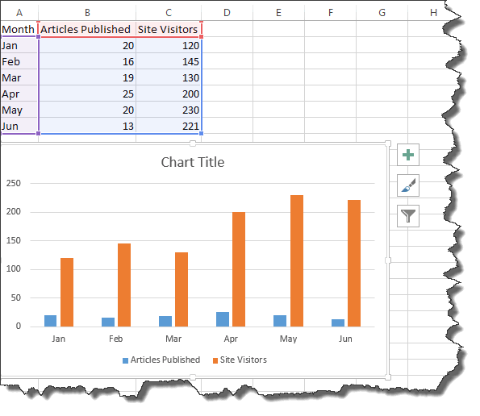

It's now time to take our charts beyond the basics. Select the orange bars representing traffic

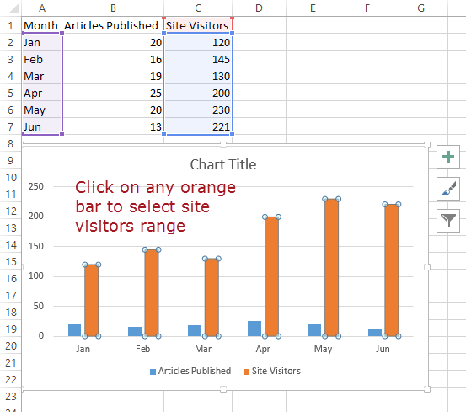

Click on change chart type as shown below

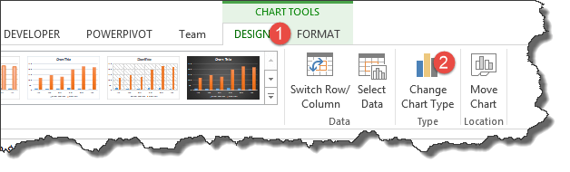

* You will get the following dialog window

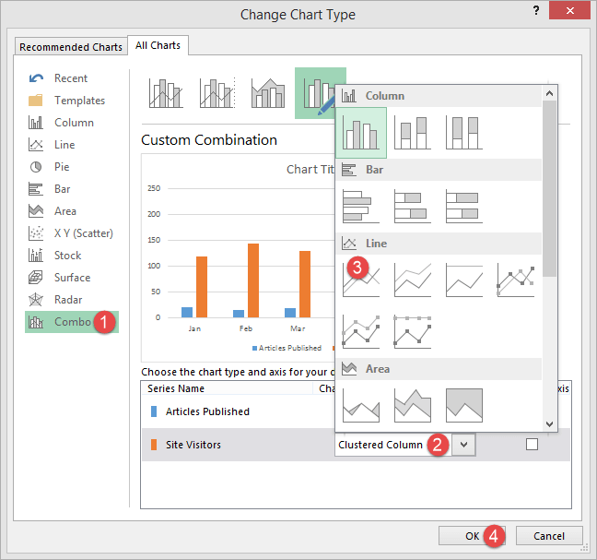

1. Select Combo
2. Click on the clustered column
3. Select Line chart
4. Click on OK button

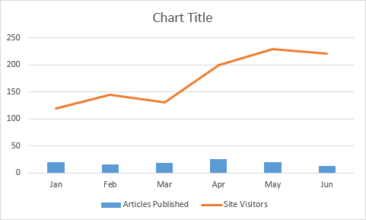

Congratulations, you just created a chart with two types of charts in it.

Let's now add a secondary axis to our chart to make it look more presentable.

* Select the chart
* Click on Design under chart tools and select change chart type

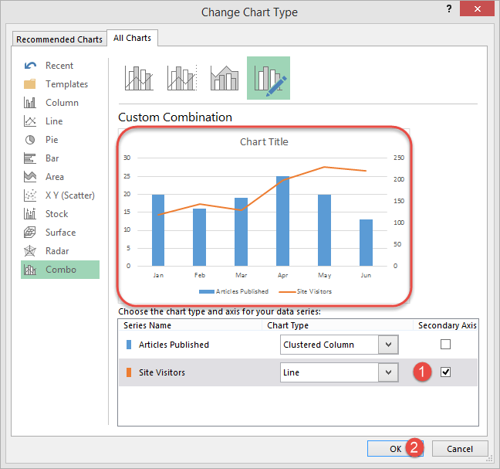

1. Click on Secondary Axis check box under Site Visitors
2. Click on OK button

Let's now edit the chart, primary and secondary axis titles as shown below.

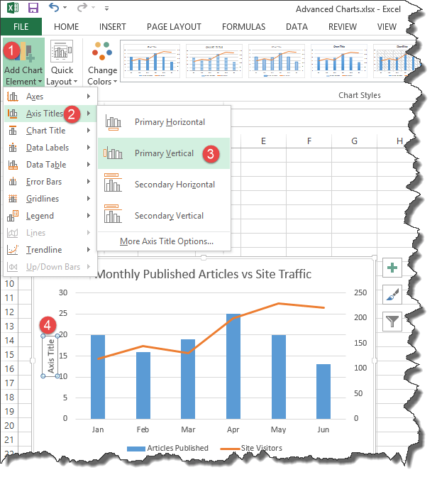

1. Go to Add chart elements
2. Click on Axis titles
3. Select primary verticals
4. Double click on the chart title and edit the title

Write Monthly Published Articles vs Site Traffic. Your complete chart should now look as follows

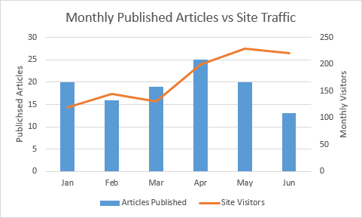

As you can see from the above complete chart, we have consolidated two data sets and visualized them in such a way that it easily shows the effect of one data set onto the other.

## Summary

Advanced charts are a great way of consolidating more than one data set and visualizing them to identity patterns, etc.

**What is Microsoft Office 365? Benefits of Excel on Cloud**

## What is Office 365?

Office 365 is a suite of programs from Microsoft that run both locally and can be synchronized to cloud storage as well. The programs can be accessed from. With Office 365, you can literally work from anywhere and share the work documents with colleagues who could be anywhere in the world. Devices supported by Office 365:

* Desktop computers – installed as Microsoft Office 365
* Web – Office online allows you to create and edit documents using lightweight versions of Office applications.
* Mobile devices – smartphones and tablets

Excel is also part of the programs that are shipped with Office 365. You can use the powerful features found in desktop versions of excel in the cloud based version too.

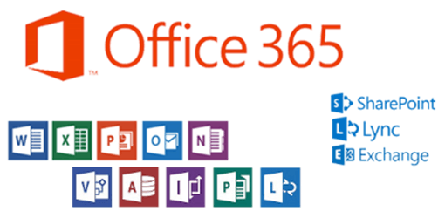

## Benefits of Office 365

* Improved user productivity
* Ability to access documents from multiple devices and locations
* Easily share documents with colleagues
* 1 TB storage with OneDrive
* How to subscribe to Office 365
* Easily recover data from the cloud if you lose your computer or it crashes etc.

## Disadvantages of Office 365

* Since this is a cloud based service, there is a possibility of outages if something happens with the cloud services for Office 365
* Ease of access from multiple devices/locations may also pose security risks if the users do not follow security best practices

## How to subscribe to Office 365

If you would like to try out Office 365 or get more details, you can visit this link. <http://products.office.com/en-us/business/office> or <http://products.office.com/en-us/try>. Since this is a subscription based service, you will be required to pay for it every month. You can try it for free for 30 days.

## Devices supported by Office 365?

* Android powered devices
* iOS phones and iOS powered tablets
* Windows powered devices (Smartphones and tablets)
* Windows operating system(s)
* OS X operating system(s)

## Summary

The computing world is moving more towards cloud and mobile computing. Most users have access to mobile devices i.e. smartphones & tablets, and high speed internet. Most software companies have taken advantage of this powerful cloud and[Mobile](https://www.guru99.com/mobile-testing.html)computing technology to develop mobile apps that enhance users' productivity.

Office 365 is a powerful cloud based version of Microsoft office that includes excel as well. Office 365 gives you the ability to access, create and edit excel documents from multiple devices and locations. This greatly enhances your productivity as you can work from anywhere in the world.

# CSV vs Excel (.xls) - What's the Difference?

Excel and CSV both help store data in tabular format. Besides this commonality, there are tons of differences in their respective features and usages. Let's discuss these differences in detail this article

## ****Difference between Excel Vs CSV****

|  |  |
| --- | --- |
| **Excel** | **CSV** |
| * It is a binary file that holds information about all the worksheets in a workbook | * CSV stands for **C**omma **S**eparated **V**alues. It is a plain text format with a series of values separated by commas |
| * An Excel not only stores data but can also do operations on the data | * A CSV file is just a text file, it stores data but does not contain formatting, formulas, macros, etc. It is also known as flat files |
| * Excel is a spreadsheet that saves files into its own proprietary format viz xls or xlsx | * CSV is a format for saving tabular information into a delimited text file with extension .csv |
| * Files saved in excel cannot be opened or edited by text editors | * CSV files can be opened or edited by text editors like notepad |
| * In data-warehouse, Excel is preferable for detailed standardized schema specification | * In data-warehouse, CSV follows a fairly flat, simple schema |
| * Any programming language library to parse Excel data is generally larger, slower and complicated | * Any programming language to parse CSV data is trivial, generating it is extremely easy |
| * With no clear distinction or separation between numeric values and text, Excel can mess up with your postal codes and credit card numbers with its auto formatting features | * CSV is safe and can clearly differentiate between the numeric values and text. CSV does not manipulate data and stores it as-is. |
| * In Excel, you have to have a start tag and end tag for each column in each row | * In CSV, you write column headers only once |
| * Excel consumes more memory while importing data | * Importing CSV files can be much faster, and it also consumes less memory |
| * Reading large files user is much easier in Excel for the end user. Also, you can have additional functions like selecting individual cells for import, convert dates and time automatically, reading formulas and their results, filters, sorting, etc. | * Reading large files in CSV will not be as easier as Excel for the End User |
| * Apart from text, data can also be stored in form of charts and graphs | * Each record is stored as one line of a text file, and every newline signifies a new database row. CSV can not store charts or graphs |
| * Excel file can be opened with Microsoft Excel doc only | * CSV can be opened with any text editor in Windows like notepad, MS Excel, Microsoft Works 9, etc. |
| * Excel can connect to external data sources to fetch data. You can use custom add-in in Excel to increase its functionality. Excel allows for Review of Data with detailed tracking and commenting feature. | * All this functionality is not possible in CSV |
| * As a developer, it's difficult to programmatically manipulate Excel files since the Excel is proprietary. This is especially true for languages other than .NET | * As a developer it's easy to programmatically manipulate CSV since, after all, they are simple text files. |

## imilarities between CSV and Excel Files

CSV is the acronym for "comma separated values". It is used to store tabular data where the column names and row values are separated using commas. The following image illustrates this

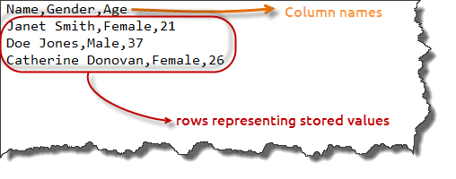

* Both can be opened in spreadsheet programs
* Both store data in tabular formats i.e. columns and rows
* Both can be manipulated using functions and features found in Excel.

The following screenshot shows a CSV file opened in Excel

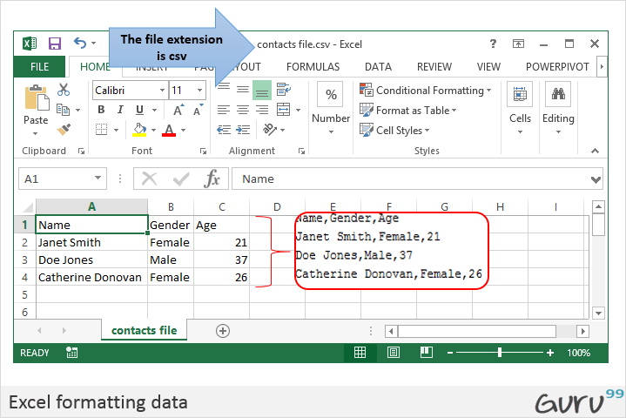

**Excel VLOOKUP Tutorial for Beginners: Learn with Examples**

### What is VLOOKUP?

Vlookup (V stands for 'Vertical') is an in-built function in excel which allows establishing a relationship between different columns of excel. In other words, it allows you to find (look up) a value from one column of data and returns it's respective or corresponding value from another column.

In this VLOOKUP guide, we will learn

* [Usage of VLOOKUP:](https://www.guru99.com/excel-vlookup-tutorial.html#1)
* [Steps for Applying the VLOOKUP function](https://www.guru99.com/excel-vlookup-tutorial.html#2)
* [VLOOKUP for Approximate Matches (TRUE Keyword as the last parameter)](https://www.guru99.com/excel-vlookup-tutorial.html#3)
* [Vlookup function applied between 2 different sheets placed in a same workbook](https://www.guru99.com/excel-vlookup-tutorial.html#4)

## Usage of VLOOKUP:

When you need to find some information in a large data-spreadsheet, or you need to search for the same kind of information throughout the spreadsheet use the Vlookup function.

Let's take an instance of Vlookup as:

**Company Salary Table**which ismanaged by the financial team of the Company – In **Company Salary Table**, you start with a piece of information which is already known (or easily retrieved). Information that serves as an index.

So as an Example:

You start with the information which is already available:

(In this Case, Employee's Name)

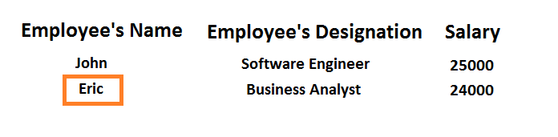

To find the information you don't know:

(In this case, we want to look up for Employee's Salary)

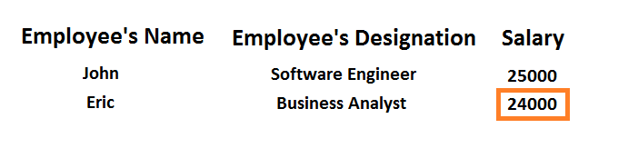

**Excel Spreadsheet for the above instance:**

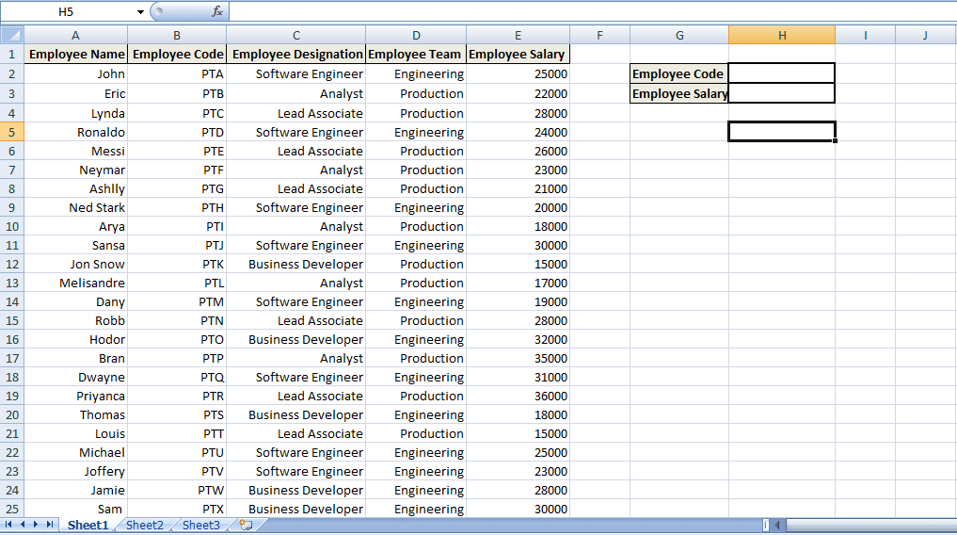

In the above spreadsheet, to find out the Employee Salary which we don know -

We will enter the Employee Code which is already available.

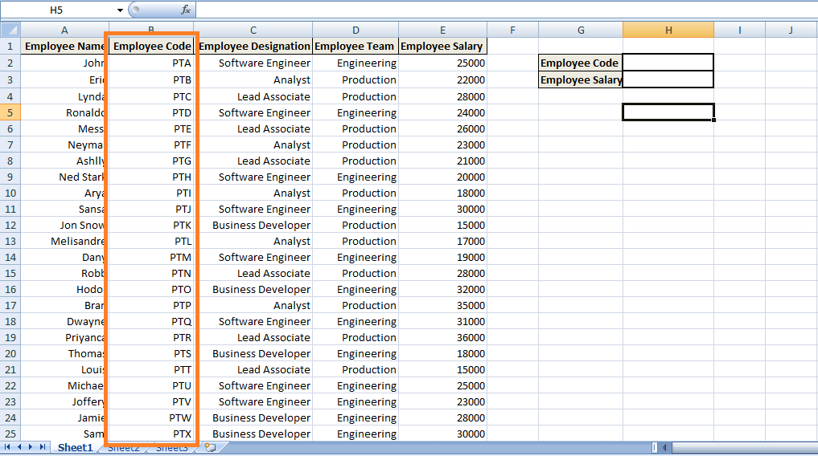

Moreover, **By Applying VLOOKUP,**value(Employee's salary) of the corresponding Employee's Code will be displayed.

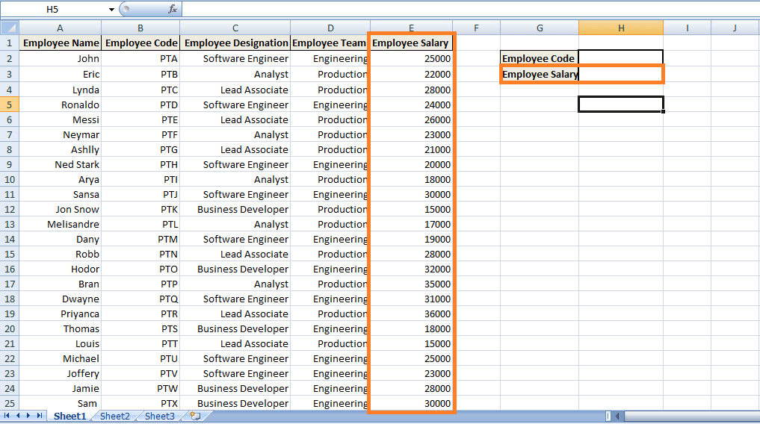

## Steps for Applying the VLOOKUP function

**Step 1)**we need to navigate to the cell where you want to view the Salary of the particular Employee.- (in this instance, Click the cell with index 'H3')

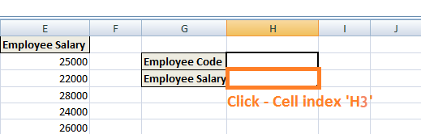

**Step 2)**Enter the VLOOKUP Function in the above Cell: Start with an **equal sign which denotes that a function is entered**, '**VLOOKUP' keyword** is used after the equal sign depicting VLOOKUP function **=VLOOKUP ()**

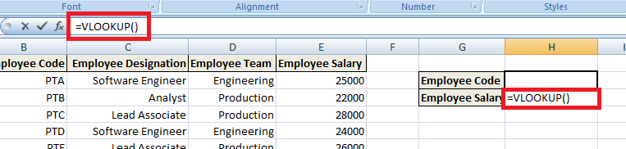

The parenthesis will contain the Set of Arguments (Arguments are the piece of data that function needs in order to execute).

**VLOOKUP uses four arguments or pieces of data:**

**Step 3) First Argument:**the first argument would be the cell reference (as the placeholder) for the value that needs to be searched or the lookup value. Lookup value refers to the data which is already available or data which you know. (In this case, Employee Code is considered as the lookup value so that the first argument will be H2, i.e., the value which needs to be looked up or searched, will be present on the cell reference 'H2').

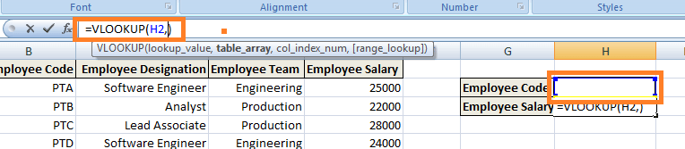

**Step 4) Second Argument:**It refers to the block of values that are needed to be searched. In Excel, this block of values is known as **table array** or the lookup table. In our instance, **the lookup table** would be **from cell reference B2 to E25,**i.e., the complete block where the corresponding value would be searched.

**NOTE: The lookup values or the data you know have to be in the left-hand column of your lookup table,i.e., your cell range.**

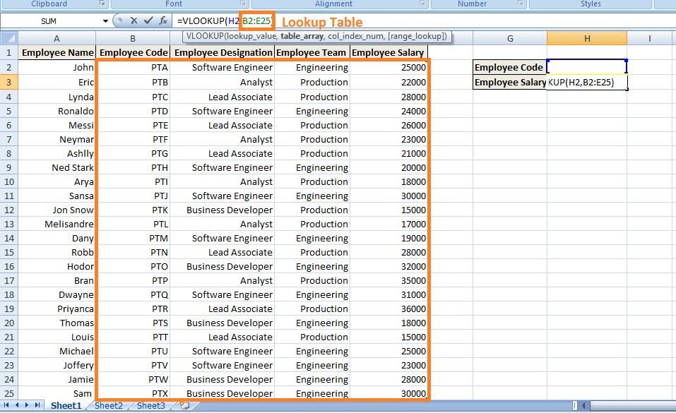

**Step 5) Third Argument:**It refers to the column reference. In other words, it notifies VLOOKUP where you expect to find the data, you want to view. (Column reference is the column index in the lookup table of the column where the corresponding value ought to be found.) In this case, the column reference would be 4 as the Employee's Salary column has an index of 4 as per the lookup table.

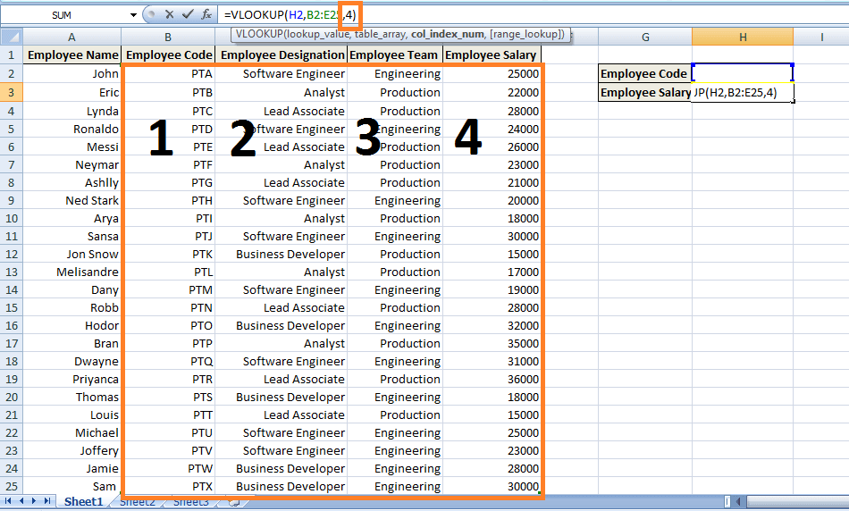

**Step 6) Fourth Argument:**The last argument is range lookup. It tells the VLOOKUP function whether we want the approximate match or the exact match to the lookup value. In this case, we want the exact match ('FALSE' keyword).

1. **FALSE:**Refers to the Exact Match.
2. **TRUE:**Refers for Approximate Match.

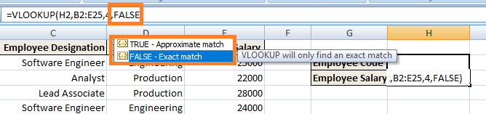

**Step 7)**Press 'Enter' to notify the cell that we have completed the function. However, you get an error message as below because no value has been entered in the cell H2i.e. No employee code has been entered in Employee Code which will allow the value for lookup.

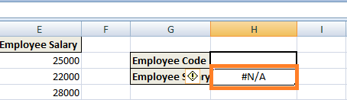

However, as you enter any Employee Code in H2, it will return the corresponding value i.e. Employee's Salary.

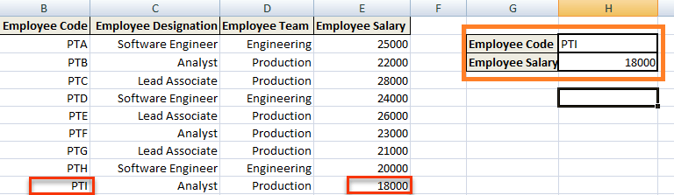

So in a brief what happened is I told the cell through the VLOOKUP formula is that the values which we know are present in the left-hand column of the data,i.e., depicting the column for Employee's Code. Now you have to look through my lookup table or my range of cells and in the fourth column to the right of the table find the value on the same row,i.e., the corresponding value (Employee's Salary) in the same row of the corresponding Employee's Code.

The above instance explained about the Exact Matches in VLOOKUP,i.e., FALSE Keyword as the last parameter.

## VLOOKUP for Approximate Matches (TRUE Keyword as the last parameter)

Consider a scenario where a table calculates discounts for the customers who do not want to buy exactly tens or hundreds of items.

As shown below, certain Company has imposed discounts on the quantity of items ranging from 1 to 10,000:

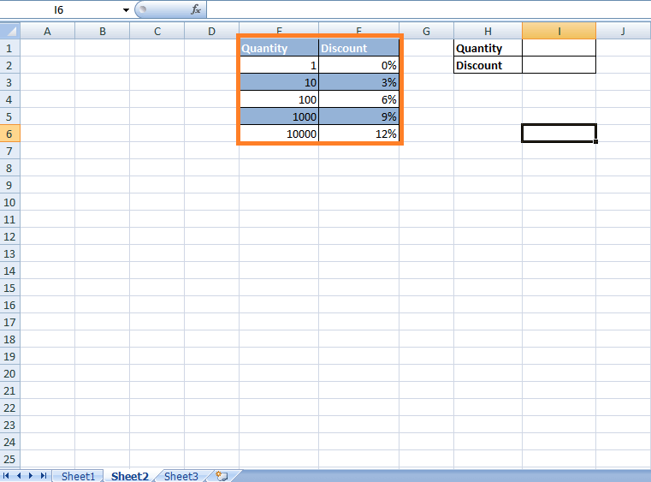

Now it is uncertain that the customer buys exactly hundreds or thousands of items. In this case, Discount will be applied as per the VLOOKUP's Approximate Matches. In other words, we do not want to limit them for finding matches to just the values present in the column that are 1, 10, 100, 1000, 10000. Here are the steps:

**Step 1) Click on the cell** where **the VLOOKUP function needs to be applied i.e. Cell reference 'I2'**.

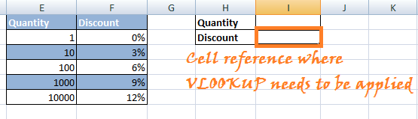

**Step 2)**Enter '=VLOOKUP()' in the cell. In the parenthesis **enter the set of Arguments**for the above instance.

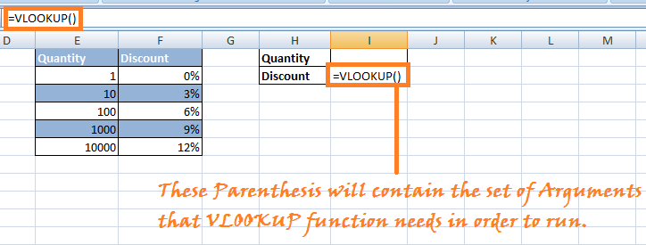

**Step 3)**Enter the Arguments:

**Argument 1:**Enter the Cell reference of the cell at which the value present will be searched for the corresponding value in the lookup table.

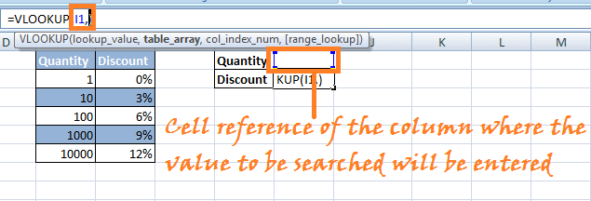

**Step 4) Argument 2:**Choose the lookup table or the table array in which you want VLOOKUP to search for the corresponding value.(In this case, choose the columns Quantity and Discount)

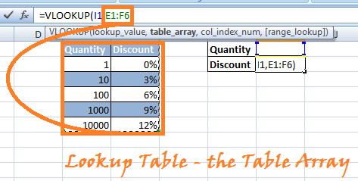

**Step 5) Argument 3:**The third argument would be the column index in the lookup table you want to be searched for the corresponding value.

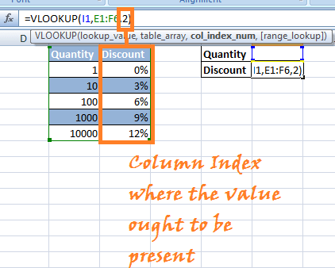

**Step 5) Argument4:**Last argument would be the condition for **Approximate Matches or Exact Matches.**In this instance, we are particularly looking for the Approximate matches **(TRUE Keyword).**

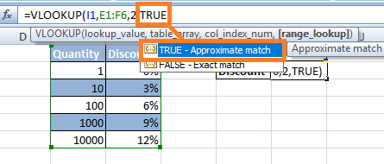

**Step 6)**Press 'Enter.' Vlookup formula will be applied to the mentioned Cell reference, and when you enter any number in the quantity field, it will show you the discount imposed based on **Approximate Matches in VLOOKUP.**

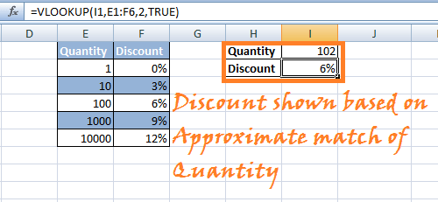

**NOTE:**If you want to use TRUE as the last parameter, you can leave it blank and by default it chooses TRUE for Approximate Matches.

## Vlookup function applied between 2 different sheets placed in the same workbook

Let's see an instance similar to the above case scenario. We are provided with one workbook containing two different sheets. One where Employee's Code along with Employee's Name and Employee's Designation is given another sheet contains Employee's Code and respective Employee's Salary (as shown below).

**SHEET 1:**

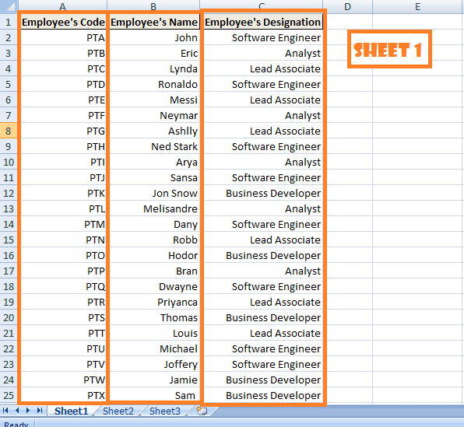

**SHEET 2:**

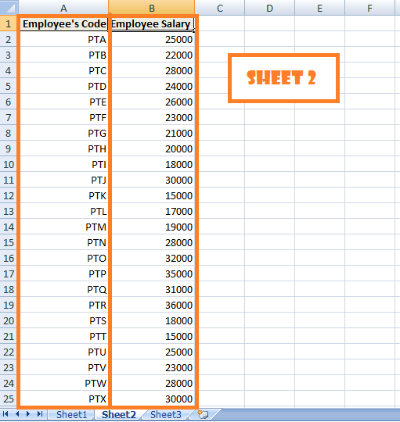

Now the objective is to view all the data in one page, i.e., Sheet 1 as below:

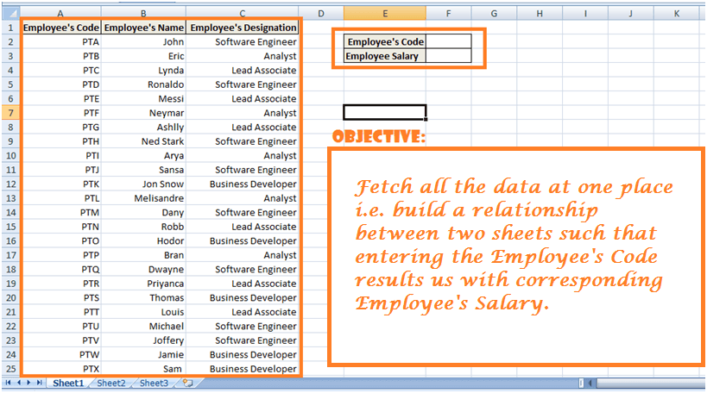

VLOOKUP can help us aggregate all the data so that we can see Employee's Code, Name, and Salary in one place or sheet.

We will start our work on Sheet 2 as that sheet provides us with two arguments of the VLOOKUP function that is – Employee's Salary is listed in Sheet 2 which is to be searched by VLOOKUP and **reference of the Column index is 2 (**as per the lookup table).

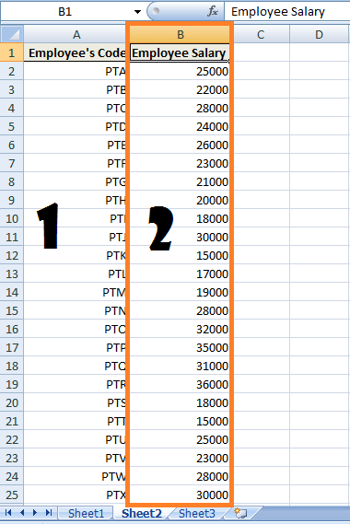

Also, we know we want to find the employee's salary corresponding to the Employee's Code.

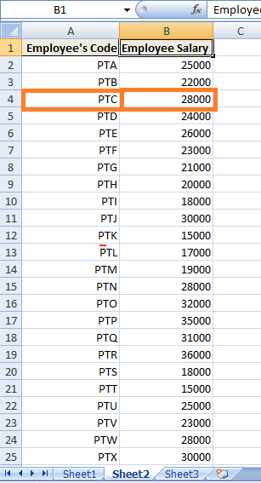

Moreover, that data starts in A2 and ends in B25. So that would be our **lookup table or the table array argument.**

**Step 1)**Navigate to sheet 1 and enter the respective headings as shown.

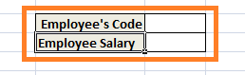

**Step 2)**Click on the cell where you want to apply the VLOOKUP function. In this case, it would be cell alongside Employee's Salary with cell reference 'F3'.

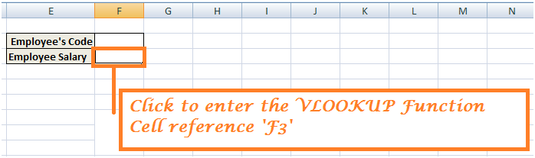

Enter the Vlookup function: =VLOOKUP ().

**Step 3) Argument 1:**Enter the cell reference which contains the value to be searched in the lookup table. In this case, 'F2' is the reference index which will contain Employee's Code to match for corresponding Employee's Salary in the lookup table.

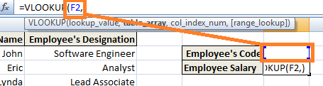

**Step 4) Argument 2:**In the second argument, we enter the lookup table or the table array. **However, in this instance, we have the lookup table situated in another sheet in the same workbook. Therefore, for building a relationship we need to enter address of the lookup table as Sheet2!A2:B25 – (A2:B25 refers to the lookup table in sheet 2)**

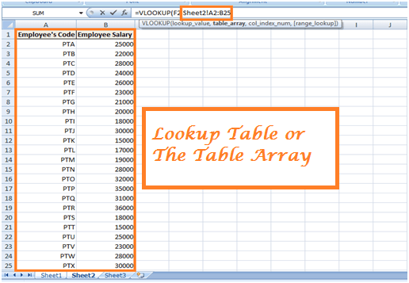

**Step 5) Argument 3:**Third argument refers to the Column index of the column present in Lookup table where values ought to be present.

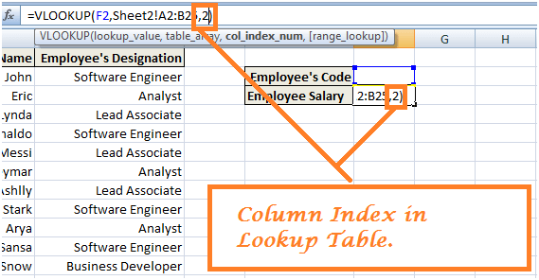

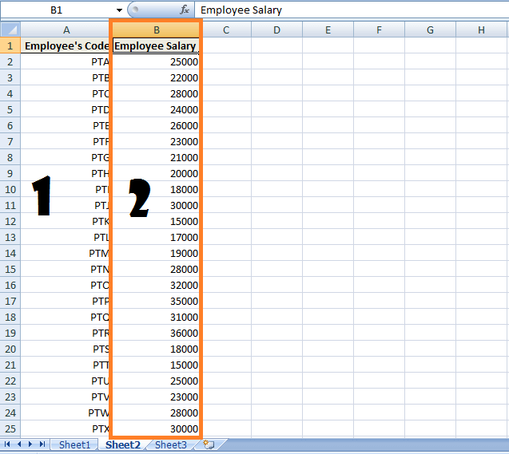

**Step 6) Argument 4:**Last Argument refers to the **Exact Matches (FALSE)**or **Approximate Matches (TRUE).**In this instance, we want to retrieve the exact matches for the Employee's Salary.

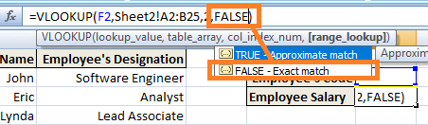

**Step 7)**Press Enter and when you enter the Employee's Code in the cell, you will be returned with corresponding Employee's Salary for that Employee's Code.

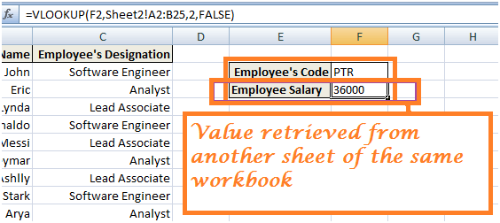

**Conclusion**

The above 3 scenarios explain the working of VLOOKUP Functions. You can play around using more instances. VLOOKUP is an important feature present in MS-Excel which allows you to manage data more efficiently.

**Excel ISBLANK Function: Learn with Example**

#### What is ISBLANK function?

ISBLANK function used to check whether a cell is empty or not. Since this is an information function, it always returns a Boolean value, true or false. If the cell contains a value it will return false and true will be returned if it is not empty.

ISBLANK function in excel is grouped under information function. Information functions help to take a decision based on their results. You may come across a situation where you want to find the blank cells in an excel cell.

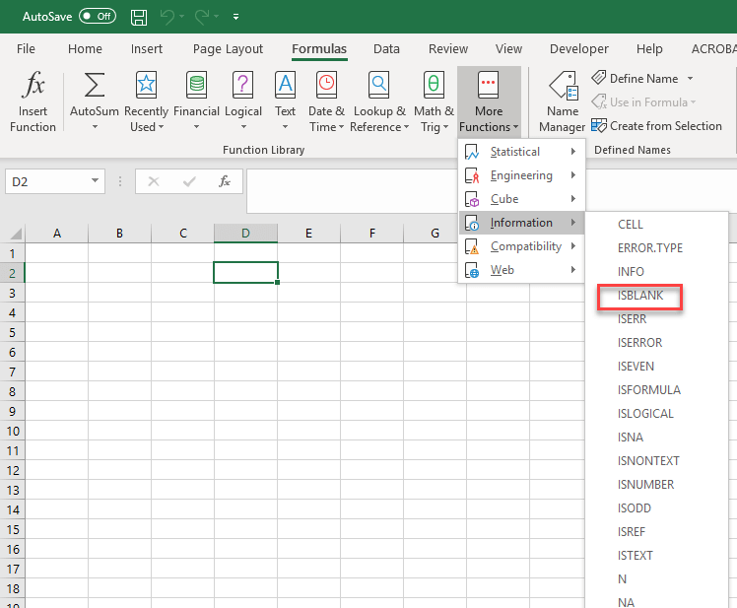

In this tutorial, you will learn:

* [How to use the ISBLANK function?](https://www.guru99.com/excel-isblank-function.html#1)
* [Example 1 How to use ISBLANK?](https://www.guru99.com/excel-isblank-function.html#2)
* [Example 2: How to use ISBLANK with different excel functions?](https://www.guru99.com/excel-isblank-function.html#3)
* [Example 3: How to use ISBLANK function with conditional formatting?](https://www.guru99.com/excel-isblank-function.html#4)

## How to use the ISBLANK function?

Within a large range of cells when you want to find the blank cell ISBLANK function is the better option.

It is also used along with other functions and some formatting methods in Excel.

**The formula for ISBLANK function**

This is a simple function in excel, and the format is.

=ISBLANK(Value)

Where Value can be a cell reference

## Example 1 How to use ISBLANK?

In following excel, given is the status of some orders. Order number and its delivery date are given. Let's find the orders which are not yet delivered.

| **S#** | **Order_Number** | **Delivery_ Date** |
| --- | --- | --- |
| 1 | 127504425 | 24-Nov-16 |
| 2 | 125387159 | 22-Dec-16 |
| 3 | 118531884 |  |
| 4 | 115178509 | 29-Dec-16 |
| 5 | 120962192 | 13-Jan-17 |
| 6 | 118427223 | 10-Feb-17 |
| 7 | 119727660 | 14-Feb-17 |
| 8 | 119787660 | 16-Feb-17 |
| 9 | 126387159 |  |
| 10 | 157504425 | 15-Jun-16 |

Here you can consider the orders which do not have a delivery date marked can be considered as not yet delivered. So can apply the formula ISBLANK to find the blank cells in the column delivery_date.

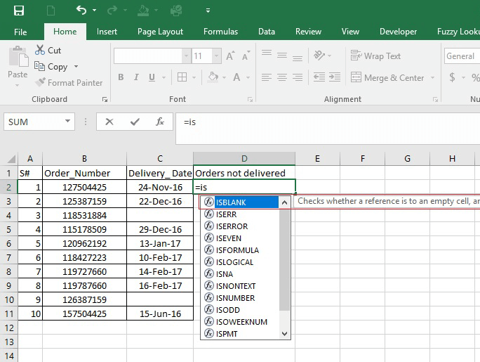

The format is '=ISBLANK(value)' for the value you can select the column delivery date corresponding to each order numbers.

So, the formula will be as given in the formula bar that is '**ISBLANK(C2)**' where C2 refers to the delivery date of the first order.

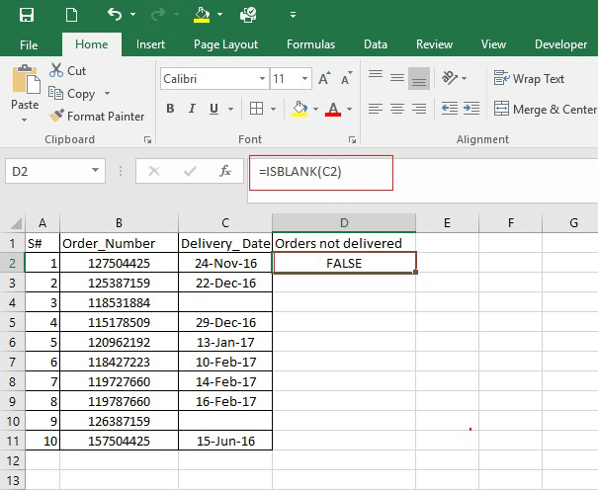

And the value returned as 'FALSE' since the delivery date is given which is a non-empty cell. You apply the same formula for the rest of the cells. For the order '118531884' delivery date is not given and the formula returns the result as 'TRUE.'

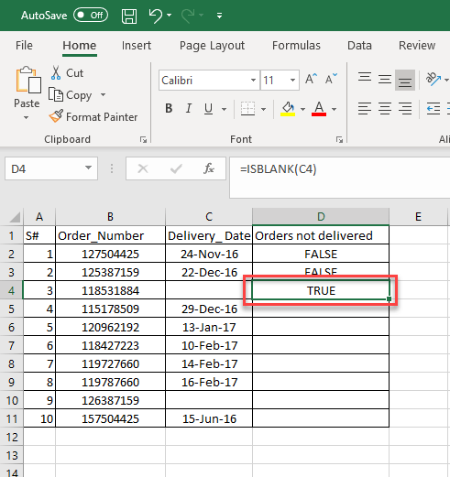

To find the undelivered orders applying the formula to each cell. For the orders '118531884, 126387159' delivery date is not given and is an empty cell. So, the ISBLANK function returns true. The delivery date which is true is the order not yet delivered. 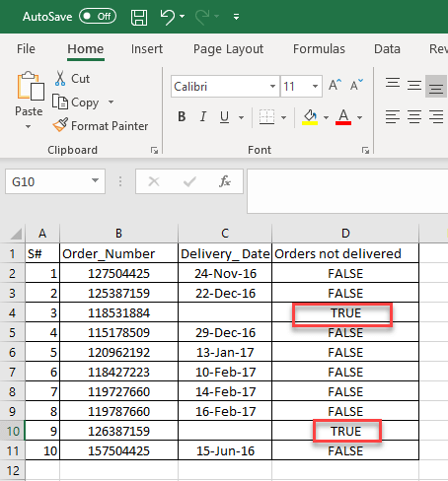

## Example 2: How to use ISBLANK with different excel functions?

In the above example, the ISBLANK function result gives TRUE or FALSE.The data is given below with order numbers and delivery date. In the status column, you want to get the result as 'complete' for orders which are delivered and 'No' for which are not delivered.

| **S#** | **Order_Number** | **Delivery_ Date** | **Status** |
| --- | --- | --- | --- |
| 1 | 127504425 | 24-Nov-16 |  |
| 2 | 125387159 | 22-Dec-16 |  |
| 3 | 118531884 |  |  |
| 4 | 115178509 | 29-Dec-16 |  |
| 5 | 120962192 | 13-Jan-17 |  |
| 6 | 118427223 | 10-Feb-17 |  |
| 7 | 119727660 | 14-Feb-17 |  |
| 8 | 119787660 | 16-Feb-17 |  |
| 9 | 126387159 |  |  |
| 10 | 157504425 | 15-Jun-16 |  |

To get the results in the way you want, have to use some another function along with ISBLANK. IF function is used along with ISBLANK, to give result according to the two different conditions. If the cell is blank, it will return 'No' otherwise 'Complete.'

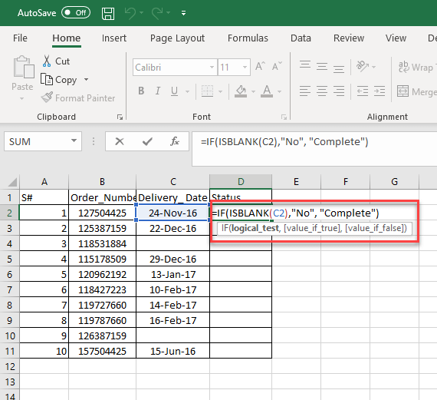

The formula applied is

=IF(ISBLANK(C2), "No", "Complete")

Here,

* the ISBLANK function will check the cell of delivery date, and according to the value, it will result in the true or false.
* This True/False is fed to the IF function that returns a 'No' if the cell is empty and statement 'Complete' if a value is present.

Here is the complete output

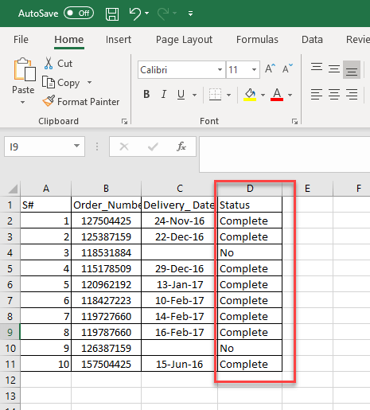

After applying the formula to the status of each order will get which are orders delivered and not delivered yet. Here the two orders are not completed the delivery rest are delivered.

## Example 3: How to use ISBLANK function with conditional formatting?

ISBLANK function can be associated with conditional formatting to find blank cells and format the cells accordingly.

**Step 1)**Consider the following dataset that consists of data order_number, bill amount, delivery status. And you want to highlight the bill amount for which delivery is not completed.

| **S#** | **Order_Number** | **Delivery_ Date** | **Bill_Amount** | **Status** |
| --- | --- | --- | --- | --- |
| 1 | 127504425 | 24-Nov-16 | $500 | Complete |
| 2 | 125387159 | 22-Dec-16 | $120 | Complete |
| 3 | 118531884 |  | $130 | No |
| 4 | 115178509 | 29-Dec-16 | $100 | Complete |
| 5 | 120962192 | 13-Jan-17 | $78 | Complete |
| 6 | 118427223 | 10-Feb-17 | $460 | Complete |
| 7 | 119727660 | 14-Feb-17 | $321 | Complete |
| 8 | 119787660 | 16-Feb-17 | $12 | Complete |
| 9 | 126387159 |  | $100 | No |
| 10 | 157504425 | 15-Jun-16 | $741 | Complete |

**Step 2) S**elect the entire data, apply conditional formatting from the Home menu. Home->Conditional Formatting->New Rule

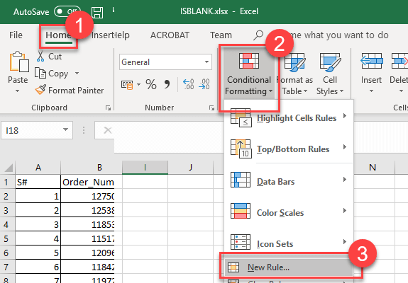

**Step 3)**

Select the option 'Use a formula to determine which cells to format.' This will allow you to insert a formula for a range of cells.

Give the formula '=ISBLANK($A$1:$E$11)' within the space.

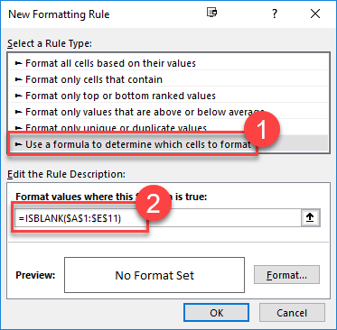

**Step 4)**Select the format which you want to apply to the cells from the format button.

1. By hitting the format button, you will get a dialogue window to select the format of the cells where the formula is applied.
2. Here, select the fill option to high light the formula applied cells where the condition matches.
3. Select the color you want to show
4. Hit the 'OK' button.

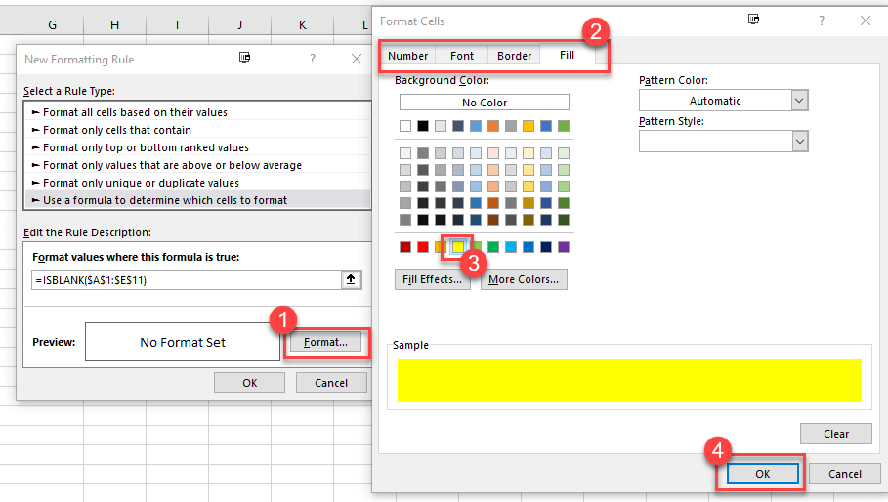

**Step 5)** Format will appear in the preview, click 'OK' button to apply.

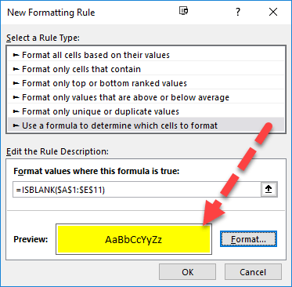

**Step 6)** It will high light the blank cells after applying the ISBLANK formula with conditional formatting. Since the range value didn't work here, you have to apply the same rule for the entire column to get the result as below.

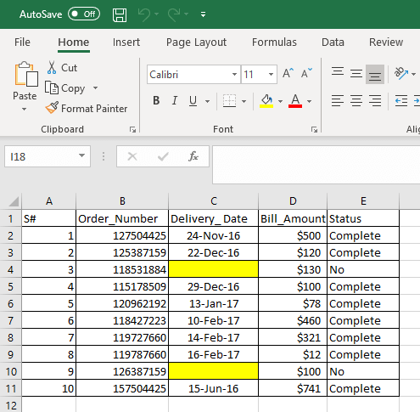

### Summary

* ISBLANK function will return a true or false value. True indicates the cell is blank.
* ISBLANK function can be used for conditional formatting as well as with other excel functions.
* An easy method to find blank cells within a large data set.
* Range of cells will not work with ISBLANK.

# Sparkline in Excel with EXAMPLES

## What is Sparkline in Excel?

A Sparkline is a small graph which used to represent a series of data. Apart from a well-fledged chart, it fits into a single cell. It is commonly used to showcase the data trend for a particular period. Three different data visualizations are available

1. Line
2. Column
3. Win/Loss

It is an instant chart that prepares for a range of values. Sparkline is used to showcase the data trend for a while.

In this Sparkline tutorial, you will learn

* [What is Sparkline in Excel?](https://www.guru99.com/excel-sparkline-example.html#1)
* [Why use Sparkline?](https://www.guru99.com/excel-sparkline-example.html#2)
* [Types of Sparkline](https://www.guru99.com/excel-sparkline-example.html#3)
* [How to insert Sparkline into excel?](https://www.guru99.com/excel-sparkline-example.html#4)
* [Create a Report with a Table](https://www.guru99.com/excel-sparkline-example.html#5)
* [How to format a Sparkline?](https://www.guru99.com/excel-sparkline-example.html#6)
* [Why use Sparkline?](https://www.guru99.com/excel-sparkline-example.html#7)

## Why use Sparkline?

Sparkline graph helps you to avoid the chore of creating a big chart which can be confusing during analysis. It is a common visualization technique used in dashboards when you want to picture a portion of data from a large dataset.

Sparkline is not an object like excel graphs; it resides in a cell as ordinary data. When you increase the size of the Excel, Sparkline automatically fit into the cells according to its size.

## Types of Sparkline

From the Insert menu, select the type of Sparkline you want. It offers three types of Sparkline.

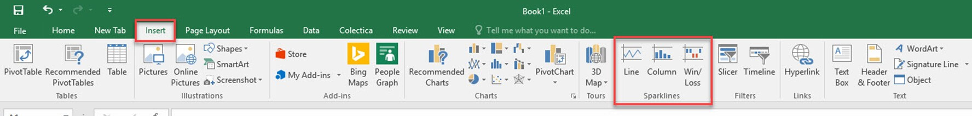

1. **Line**: Sparklines will be in the form of lines, and high values will indicate fluctuations in height difference.
2. **Column**: Form of column chart or bar chart. Each bar shows each value.
3. **Win/Loss**: It is mainly used to show negative values like ups and downs on the floated costs.

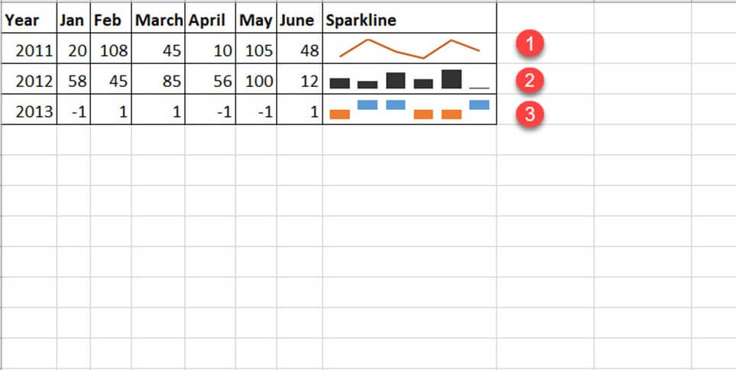

Depending on the type, it gives different visualization to the selected data. Where the line is a tiny chart similar to the line chart, the column is a miniature of bar chart and win/loss resembles waterfall charts.

## How to insert Sparkline into excel?

You need to select a particular column data, to insert the Sparkline.

Consider the following demo data: Status of some pending stock for different years is below. To make a quick analysis, let's make a Sparkline for each year.

| **Year** | **Jan** | **Feb** | **March** | **April** | **May** | **June** |
| --- | --- | --- | --- | --- | --- | --- |
| 2011 | 20 | 108 | 45 | 10 | 105 | 48 |
| 2012 | 48 | 10 | 0 | 0 | 78 | 74 |
| 2013 | 12 | 102 | 10 | 0 | 0 | 100 |
| 2014 | 1 | 20 | 3 | 40 | 5 | 60 |

**Step 1**) Select the next column to 'June' and insert Sparkline from insert menu. Select anyone from the three types of Sparkline.

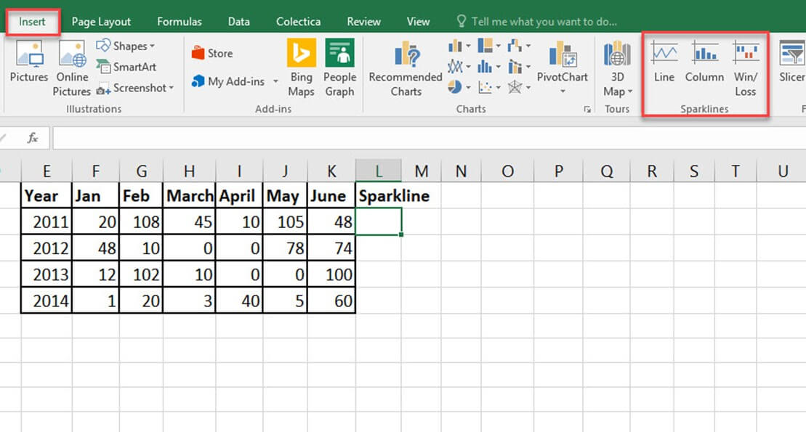

**Step 2)** A selection window will appear to select the range of cells for which the Sparkline should insert.

By clicking the arrow near data range box, a range of cells can be choosen.

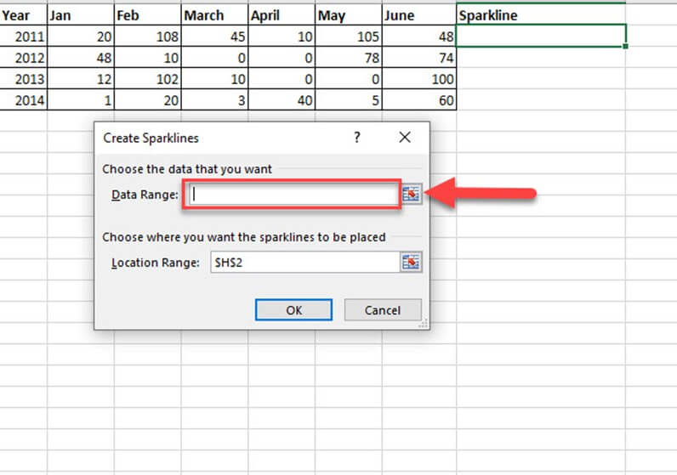

**Step 3)** Select the first row of the data for the year 2011 in 'Data Range' text box. The range will shown as B2: G2.

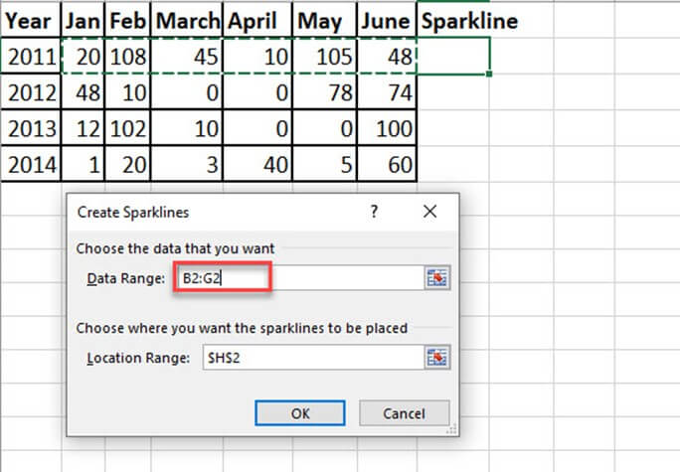

**Step 4)** Another range selection indicates where you want to insert the Sparkline. Give the address of the cell you need the Sparkline.

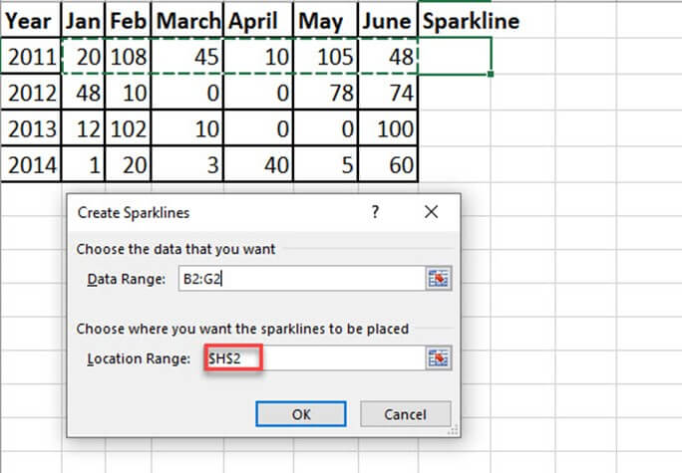

**Step 5)** Once you set the 'Data Range' and 'Location Range' press 'OK' button.

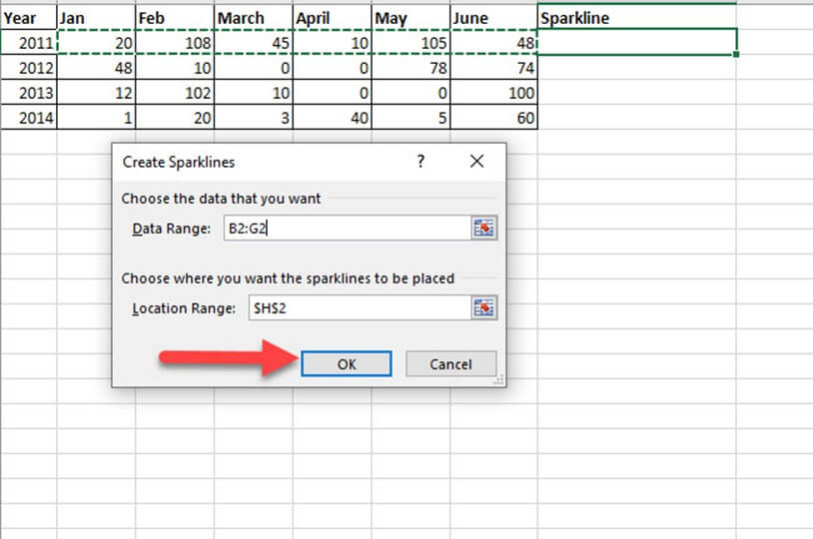

**Step 6)** Now the Sparkline is created for the selected data, and it gets inserted in the selected cell H3.

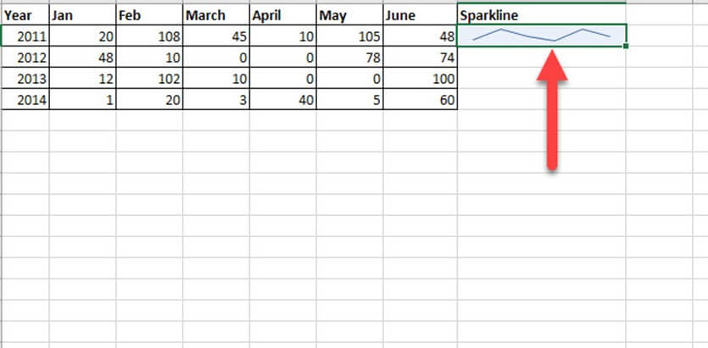

## Create a Report with a Table

You have a sales report for four years: 2015, 2016, 2017 respectively. Details included in this table are country, product, and gross sales.

Let's find the trend of sales for this product for different years.

**Step 1**) Create a column analysis next to gross sales for 2018. And in the next step, you are going to insert the Sparkline.

| **S#** | **Country** | **Product** | **Gross Sales 2015** | **Gross Sales 2016** | **Gross Sales 2017** | **Gross Sales 2018** |
| --- | --- | --- | --- | --- | --- | --- |
| 1 | Canada | Carretera | $ 32,370.00 | $ 30,216.00 | $ 352,625.00 | $ 34,440.00 |
| 2 | Germany | Carretera | $ 26,420.00 | $ 352,100.00 | $ 43,125.00 | $ 7,210.00 |
| 3 | France | Carretera | $ 32,670.00 | $ 4,404.00 | $ 600,300.00 | $ 4,473.00 |
| 4 | Singapore | Carretera | $ 13,320.00 | $ 6,181.00 | $ 34,056.00 | $ 9,282.00 |
| 5 | United States of America | Carretera | $ 37,050.00 | $ 8,235.00 | $ 32,670.00 | $ 22,296.00 |
| 6 | Mexico | Carretera | $ 529,550.00 | $ 236,400.00 | $ 13,320.00 | $ 423,500.00 |
| 7 | China | Carretera | $ 13,815.00 | $ 37,080.00 | $ 534,450.00 | $ 17,703.00 |
| 8 | Spain | Carretera | $ 30,216.00 | $ 8,001.00 | $ 645,300.00 | $ 17,340.00 |
| 9 | Japan | Carretera | $ 37,980.00 | $ 603,750.00 | $ 36,340.00 | $ 41,250.00 |
| 10 | Korea (Republic of) | Carretera | $ 18,540.00 | $ 10,944.00 | $ 962,500.00 | $ 32,052.00 |
| 11 | Italy | Carretera | $ 37,050.00 | $ 32,280.00 | $ 23,436.00 | $ 9,192.00 |
| 12 | Costa Rica | Carretera | $ 333,187.50 | $ 36,340.00 | $ 527,437.50 | $ 148,200.00 |
| 13 | Taiwan | Carretera | $ 287,400.00 | $ 529,550.00 | $ 37,980.00 | $ 488,950.00 |
| 14 | Argentina | Carretera | $ 15,022.00 | $ 10,451.00 | $ 11,802.00 | $ 754,250.00 |
| 15 | Denmark | Carretera | $ 43,125.00 | $ 225,500.00 | $ 25,692.00 | $ 33,210.00 |
| 16 | Belgium | Carretera | $ 9,225.00 | $ 25,932.00 | $ 8,001.00 | $ 690,300.00 |

**Step 2)** Select the cell in which you want to insert the Sparkline. Go to Insert menu from the menu bar. Select any one of the Sparkline from the list of Sparkline.

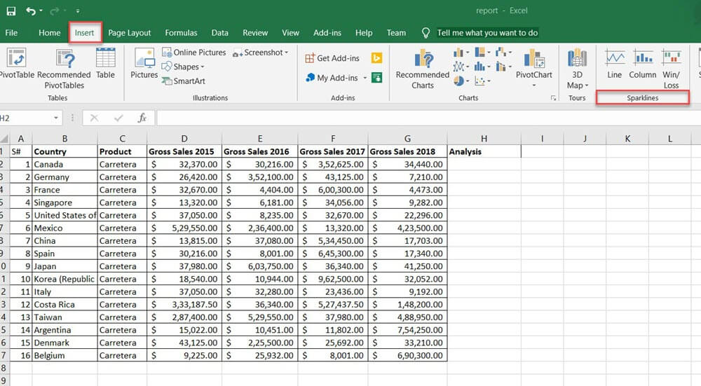

**Step 3)** Select any one of the sparkline types that you want to insert. It will ask for the range of cells. Select the line type from the available sparkline type.

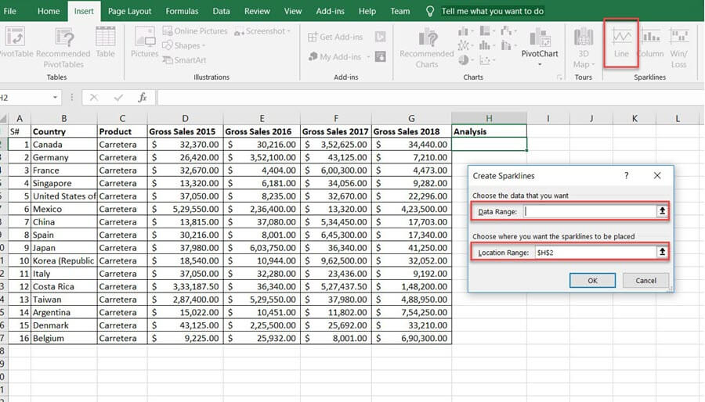

Data Range indicates, which data the Sparkline need to insert. Location range is the cell address where you want to add the Sparkline.

**Step 4)** Here, the data range is from the cell data contains 'Gross sales 2015 to 2018' and location range is from H3. Press the 'OK' button after this.

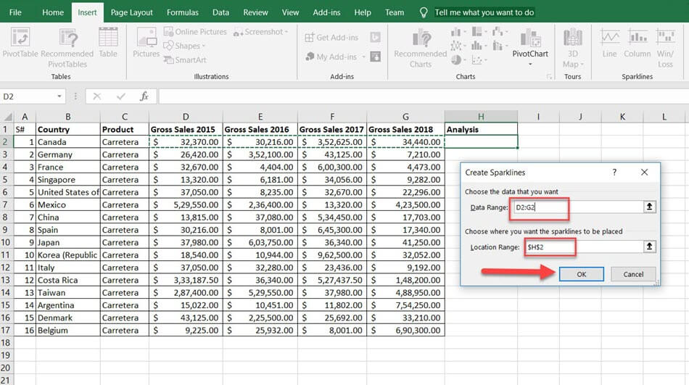

**Step 5)** The Sparkline will be inserted into the H3 cell. You can apply the Sparkline to entire data by dragging the same to downwards.

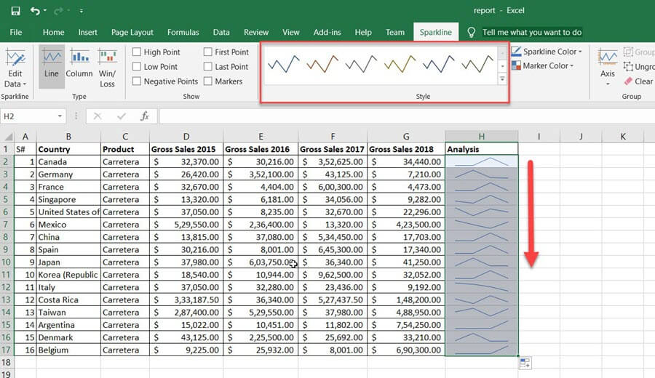

Now the Sparkline is created.

## How to format a Sparkline?

To format Sparkline, first Click on the created Sparkline. A new tab named design will appear on the menu bar which includes the Sparkline tools and will help you to change its color and style. See the available options one by one.

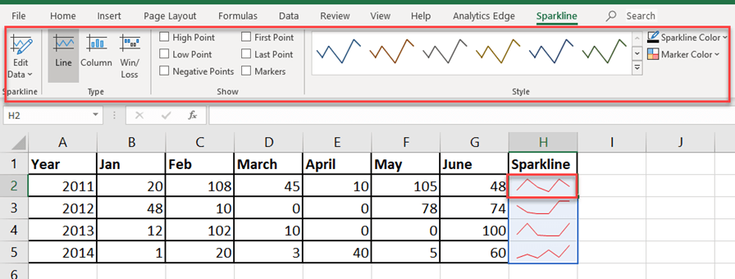

The different properties of Sparkline can customize according to your need. Style, color, thickness, type, the axis is some among them.

### How to change the style of the Sparkline?

**Step 1)**Select a style from the 'Style' option within the design menu. The styles included in a dropdown.

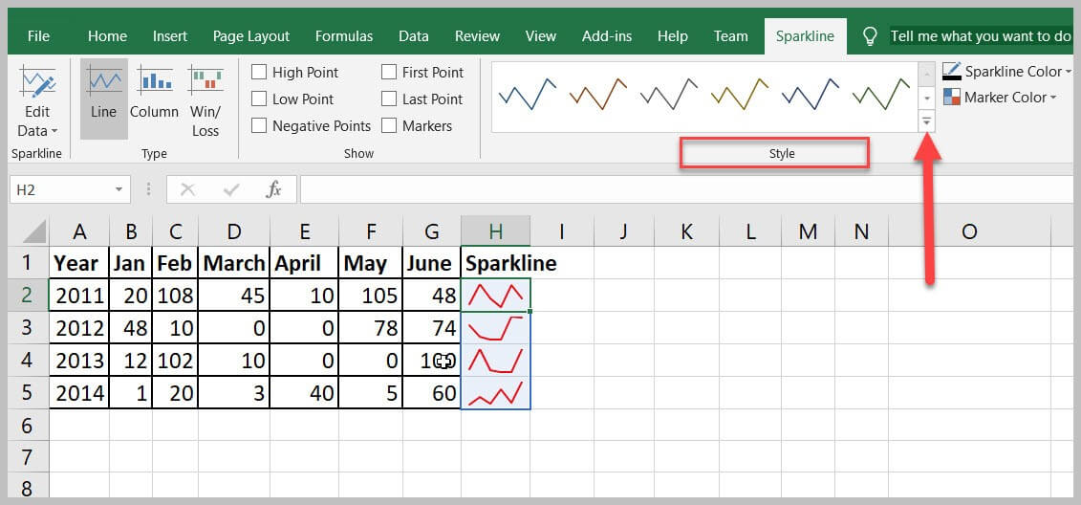

**Step 2)** Click on the down arrow near to the style option to select your favorite style from an extensive design catalog.

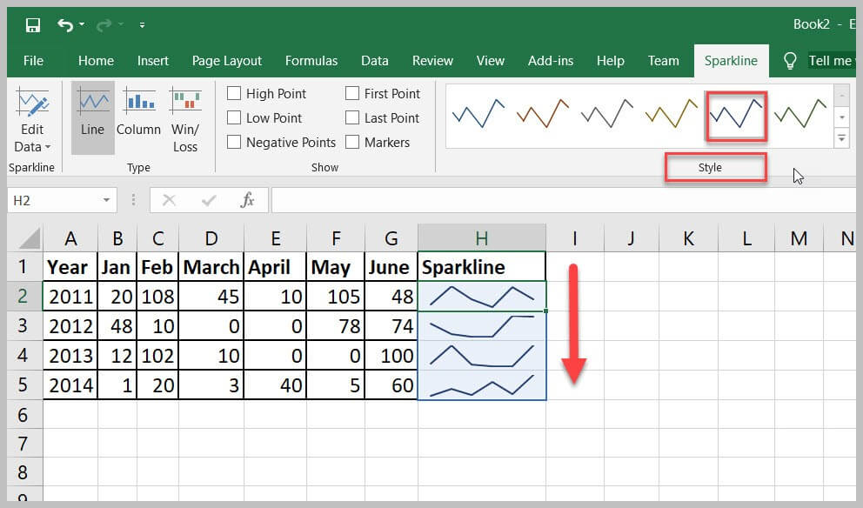

### How to change the color of the Sparkline?

The color and thickness of the Sparkline can be changed using the Sparkline Color option. It offers a variety of colors.

**Step 1)** Select the Sparkline and select the Sparkline Color option from the design menu.

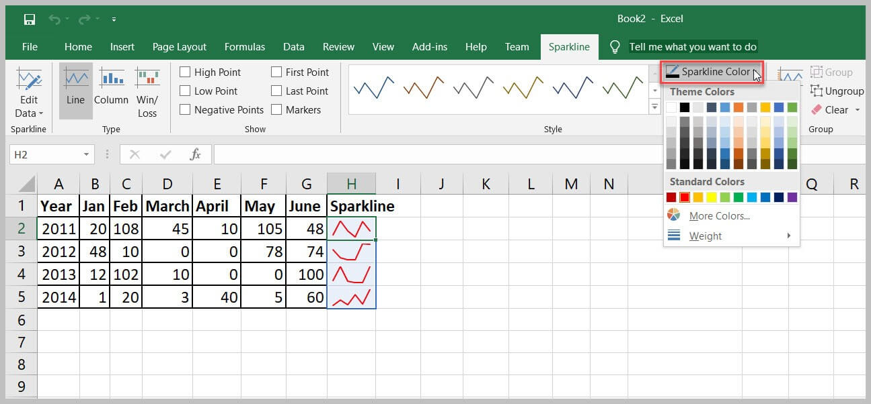

**Step 2)** Click on the color you want to change. The Sparkline will update with the selected color.

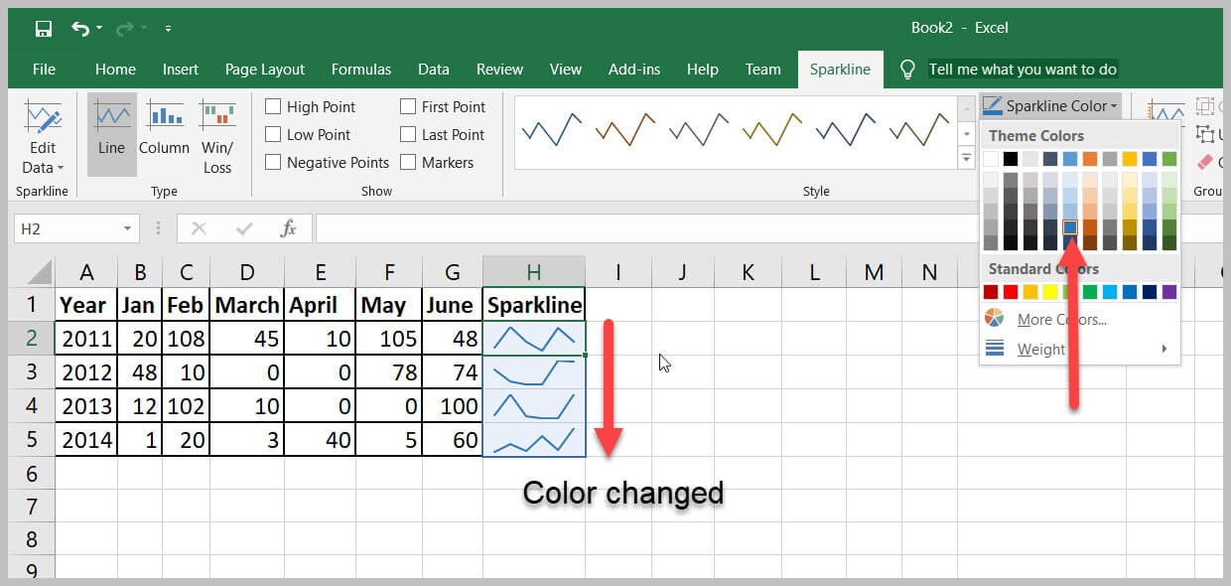

### Change the width of lines.

The width of the lines can be adjusted with the option available in the 'Sparkline Color' window.

**Step 1)** Select the Sparkline then go to design menu in the menu bar.

**Step 2)** Click on the Sparkline Color' option.

**Step 3)** Select the Weight option to make changes in thickness to the inserted Sparkline.

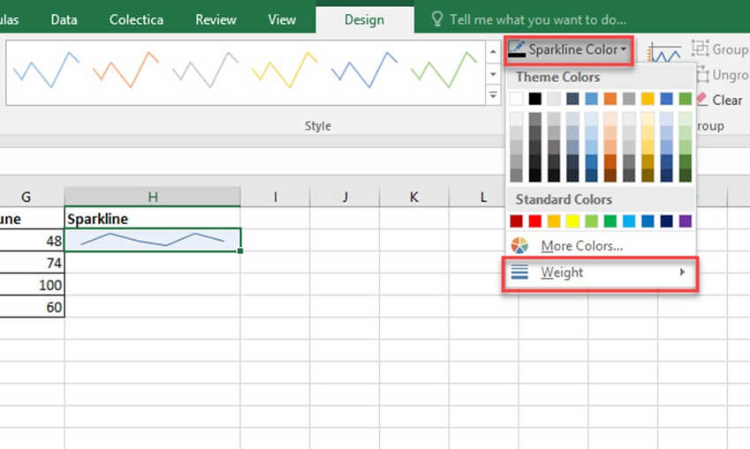

**Step 4)**Move to Weight option. This will give a list of predefined thickness. Customization in Weight is also available.

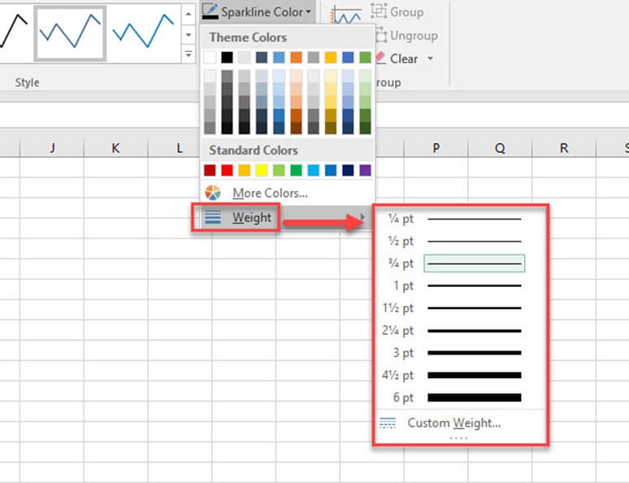

### Highlighting the data points

You can highlight the highest, lowest points, and the entire data points on a Sparkline. By this you to get a better view of the data trend.

**Step 1)** Select the created Sparkline in any cell then move to the design menu. You can see different checkboxes to highlight the data points.

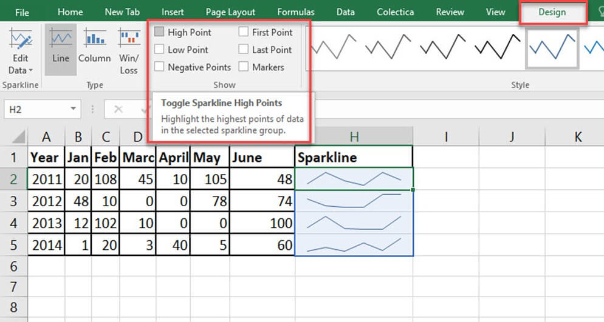

**Step 2)** Give checkmark according to the data points you want to highlight. And the options available are:

* High/Low Point: Highlights the high spot the high and low points on the Sparkline.
* First/Last Point: This will help to highlight the first and last data points on the Sparkline.
* Negative Points: Use this to highlight negative values.
* Markers: This option applies only to line Sparkline. It will highlight all data points with a marker. Different color and style are available with more marker colors and lines.

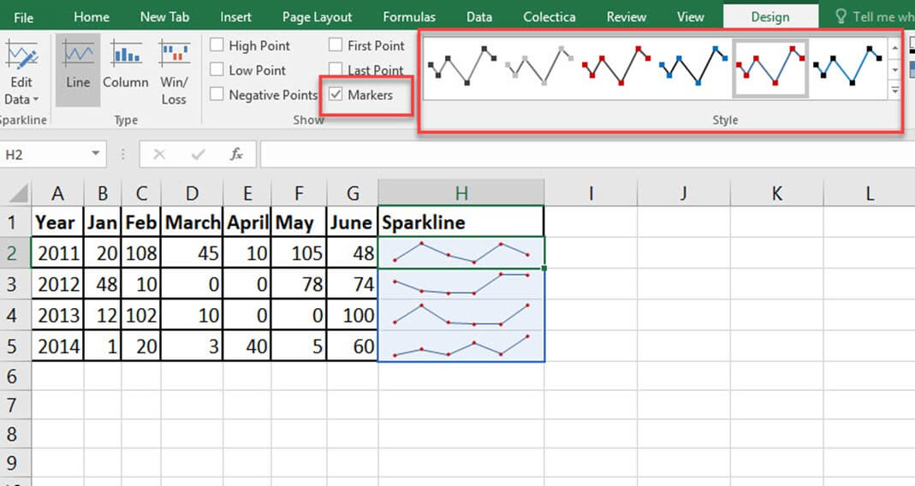

### Deleting the Sparkline

You can't remove the Sparkline by hitting the 'delete' key on a keyboard. To delete the Sparkline, you should go to the 'Clear' option.

**Step 1)** Select the cell, which included the Sparkline.

**Step 2)** Go to Sparkline tools design menu.

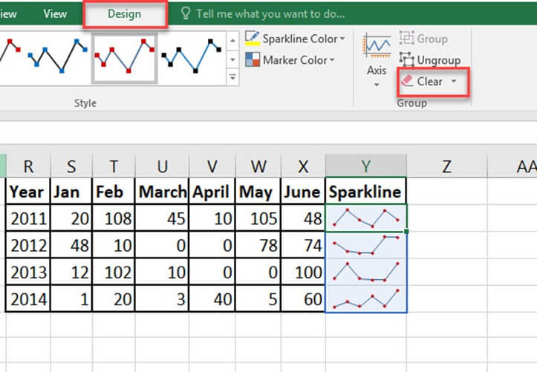

**Step 3)** Click on the clear option this will delete the selected Sparkline from the cell.

## Why use Sparkline?

Here are important reasons for using Sparkline:

* Visualization of data like temperature or stock market price.
* Transforming data into a compact form.
* Data reports generating for a short time.
* Analyze data trends for a particular time.
* Easy to understand the fluctuations in the data.
* A better understanding of high and low data points.
* Negative values can float effectively by sparkline.
* Sparkline automatically adjusts its size once the cell width is changed.

#### Summary

* Sparkline is a small chart which does not recommend an axes or coordinates
* Sparkline can apply on a single column or row of data series.
* Different formatting properties are available for the Sparkline.
* Sparkline is a micrograph which fit into a single cell.
* A single delete key press will not remove a created Sparkline.
* The different data points can highlight in a Sparkline.

# SUMIF function in Excel: Learn with EXAMPLE

## What is SUMIF Function?

SUMIF is the function used to sum the values according to a single criterion. Using this function, you can find the sum of numbers applying a condition within a range. This function comes under Math & Trigonometry functions. Similar to the name, this will sum if the criteria given is satisfied. This function is used to find the sum of particular numbers within a large data set.

In this tutorial, you will learn-

* [What is SUMIF Function?](https://www.guru99.com/sumif-function-excel.html#6)
* [How to use the SUMIF function?](https://www.guru99.com/sumif-function-excel.html#1)
* [Formula of MS SUMIF](https://www.guru99.com/sumif-function-excel.html#2)
* [Example 1: Using SUMIF](https://www.guru99.com/sumif-function-excel.html#3)
* [Example 2: How to use SUMIF with comparison operators](https://www.guru99.com/sumif-function-excel.html#4)
* [Example 3: How to use SUMIF with dates](https://www.guru99.com/sumif-function-excel.html#5)

## How to use the SUMIF function?

SUMIF will sum the range of cells according to the criteria specified. The range of cells to where the condition should be applied, the constraint according to that the sum will calculate, the range of cell for which the sum to calculate according to the condition need specify within the formula.

## Formula of MS SUMIF

Generally, follow a format where the criteria and criteria range, etc. need to be provided.

SUMIF(range,criteria,sum range)

[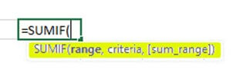](https://www.guru99.com/images/1/052819_1101_SUMIFfuncti1.jpg)

* **Range**: The range of cells which included the criteria
* **Criteria**: The condition that must be satisfied
* **Sum range:** The range of cells to add if the condition is satisfied.

## Example 1: Using SUMIF

Given the data table with order numbers and the bill amount. Need to find the sum of the bill amount for particular orders.

**Step1)** You want to find the sum of the bill amount for a particular brand order where the order number starts with 'Amzcd.'

|  |  |  |
| --- | --- | --- |
| S# | Order No | Bill Amount |
| 1 | Amzcd 008 | $450 |
| 2 | Amzcd 009 | $500 |
| 3 | AFJK 010 | $1,102 |
| 4 | Amzcd 011 | $850 |
| 5 | Amzcd 012 | $564 |
| 6 | ABVF 013 | $345 |
| 7 | Amzcd 014 | $10.50 |
| 8 | Amzcd 015 | $835.50 |
| 9 | ABVF 016 | $1,236 |
| 10 | AFJK 017 | $478.20 |
| 11 | Amzcd 018 | $100.25 |

**Step 2)** Select the cell below to the bill amount and apply the formula to find the sum of bill amount only for the orders, which starts with 'Amzcd.'

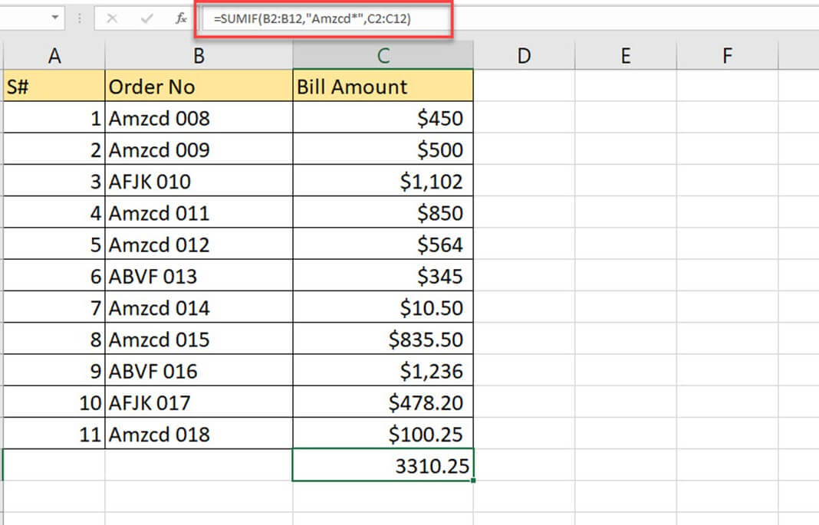

**Step 3)** The formula applied is

'=SUMIF (B2: B12, "Amzcd*," C2: C12)'

* B2: B12 is the range of cell where the criteria will be checking.
* 'Amzcd*' is the criteria applied where the starting of the order number.
* C2: C12 is the range of cells to add according to the criteria

**Step 4)** If you check the table, highlighted are the bill amounts summed according to the criteria given. The bill amount for every order starts with 'Amzcd' are selected, and the sum will find.

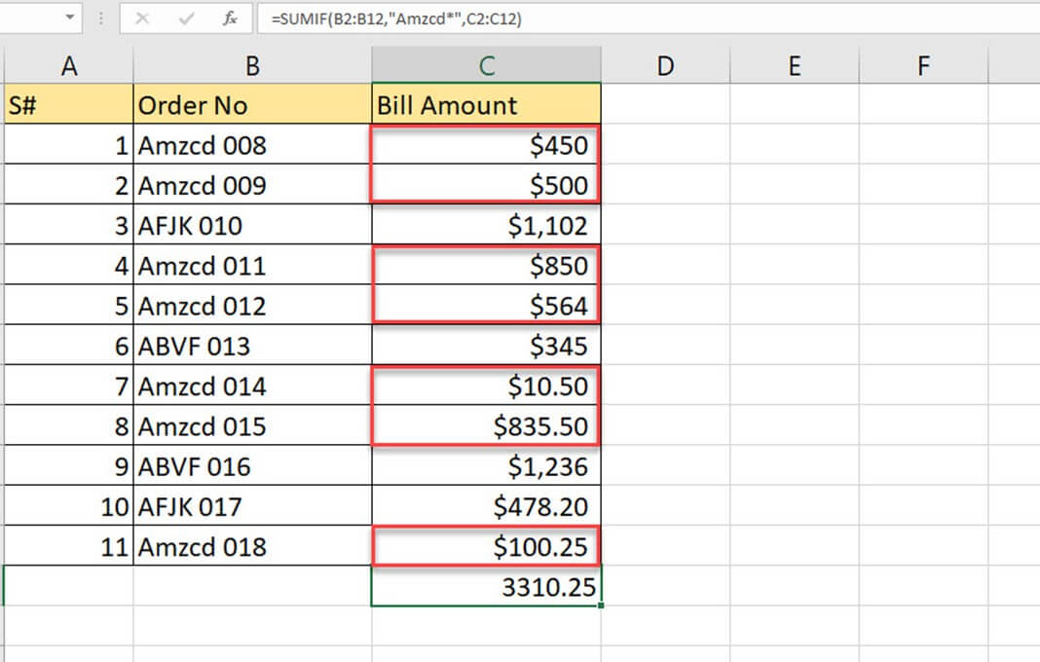

**Step 5)** Check the end of the column bill amount to see the sum of the bill amount, which satisfies the condition given.

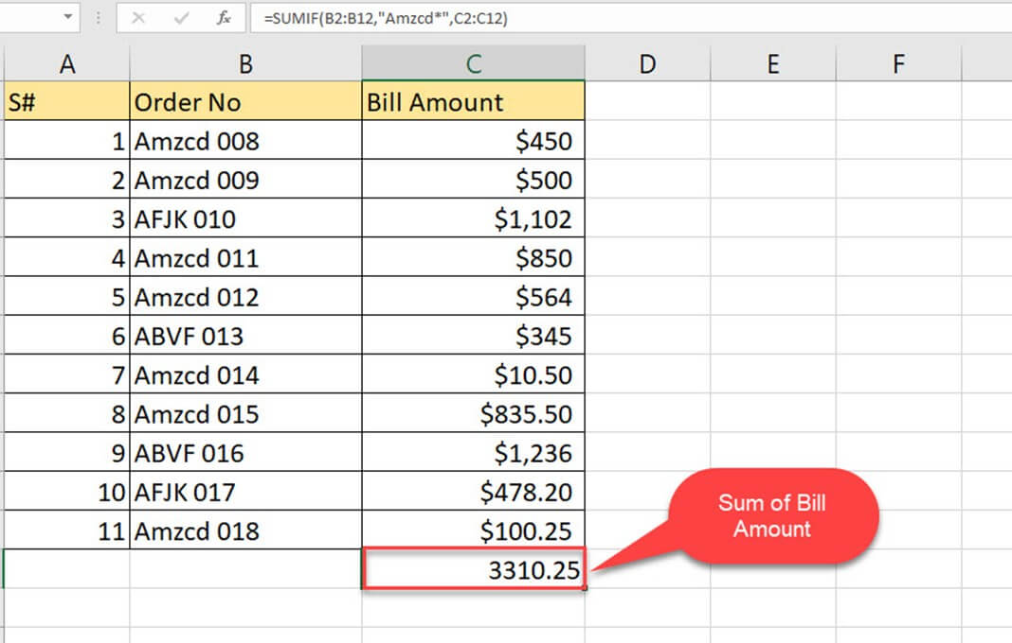

## Example 2: How to use SUMIF with comparison operators

A set of comparison operators exists in excel. The SUMIF function can use along with comparison operators. Comparison operators can use to specifying the conditions within the SUMIF function. So if the comparison operation returns a true value, it will sum up the values.

**Step 1)** You have the table of data with name products, Qty, and price. How can you find the total price for the product for which the Qty is greater than and equal to 100?

|  |  |  |  |
| --- | --- | --- | --- |
| S# | Product | Qty | Price |
| 1 | Soft drinks | 100 | $1,789 |
| 2 | Dress Materials | 80 | $752 |
| 3 | Edible Oil | 150 | $489 |
| 4 | Nuts | 500 | $2,589 |
| 5 | Cookies | 205 | $1,500 |
| 6 | Footwear | 130 | $300 |
| 7 | Electronic Items | 100 | $4,500 |
| 8 | vegetables | 410 | $3,752 |
| 9 | Toys | 50 | $200 |
| 10 | Furniture | 210 | $500 |

**Step 2)** If you apply the criteria into logical format 'Qty>=100', and the SUMIF formula can form as below.

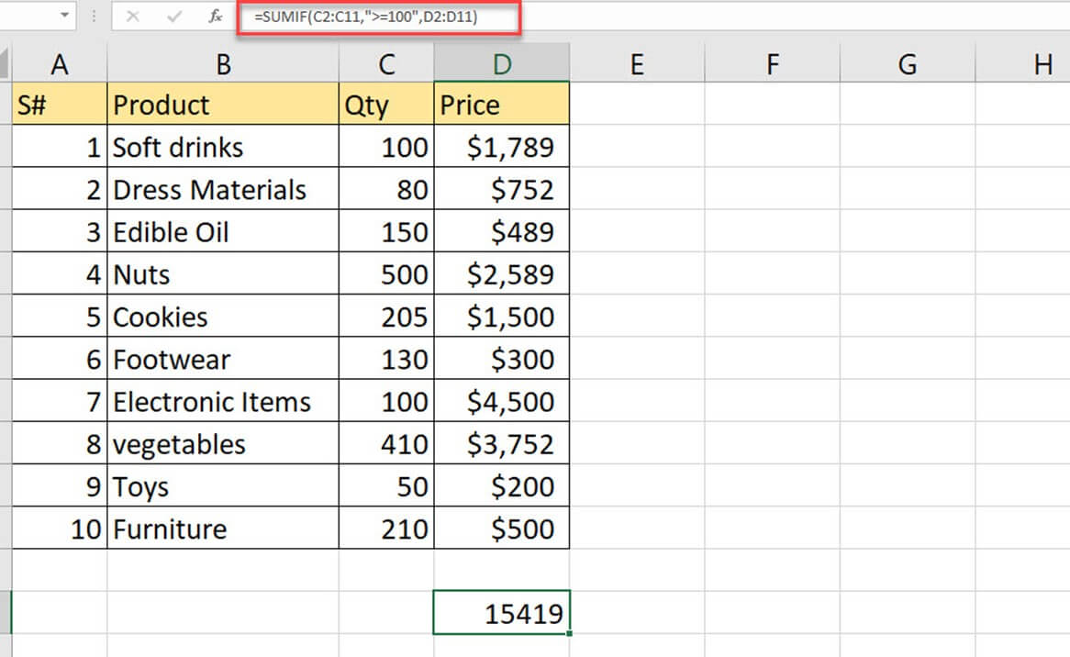

**Step 3)** The formula applied is

=SUMIF (C2: C11,">=100", D2: D11)

* C2: C11 is the range of cell where the criteria will be looking for
* '>=100' is the condition which expressed with comparison operator greater than and equal to
* D2: D11 is the range to be summed according to the criteria

**Step 4)** Highlighted cells are the prices which satisfy the criteria, where the Qty>=100

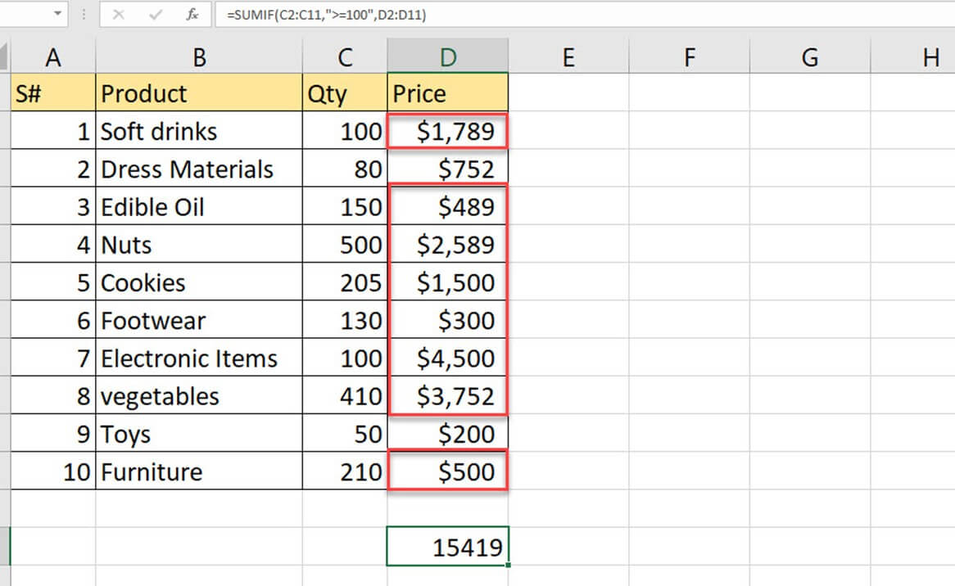

**Step 5)** The sum of values are in the cell D13; it is the sum of prices for the products which have Qty greater than or equal to 100.

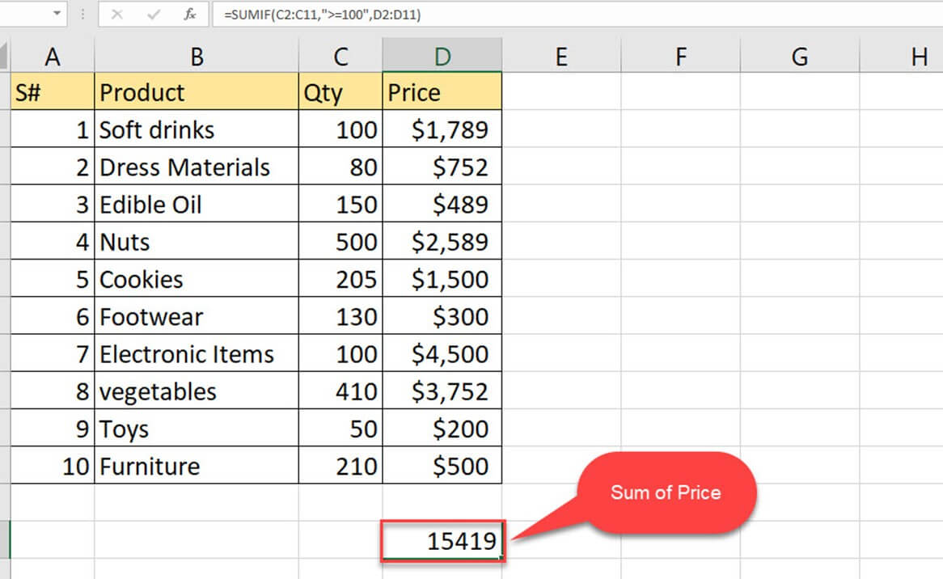

## Example 3: How to use SUMIF with dates

In this example, you will learn how to use SUMIF function with the date. The criteria can also give in the form of date.

**Step 1)** The table shows different account numbers, bill dates, and payment. The amount needs to be paid to the corresponding account within the bill date given. By using the SUMIF, you can try to find the sum of the amount to be paid for June.

|  |  |  |  |
| --- | --- | --- | --- |
| S# | Account Number | Bill Date | Payment |
| 1 | 9160250011660588 | 1/4/2019 | 25000 |
| 2 | 9160250011689568 | 1/28/2019 | 15000 |
| 3 | 9160250012356588 | 1/31/2019 | 8500 |
| 4 | 9160250899560588 | 6/2/2019 | 9635 |
| 5 | 9160260231660588 | 2/10/2019 | 4582 |
| 6 | 9160250011658588 | 6/25/2019 | 10265 |
| 7 | 9160457811660588 | 3/1/2019 | 8132 |
| 8 | 9160250011670858 | 3/12/2019 | 9562 |
| 9 | 9160250011663569 | 6/15/2019 | 7895 |
| 10 | 9160250321660456 | 6/18/2019 | 2566 |

**Step 2)** Since the date is with you, the criteria can form as '>5/31/2019' which refer to the dates after May. Here the comparison operator and date are using at a time with SUMIF.

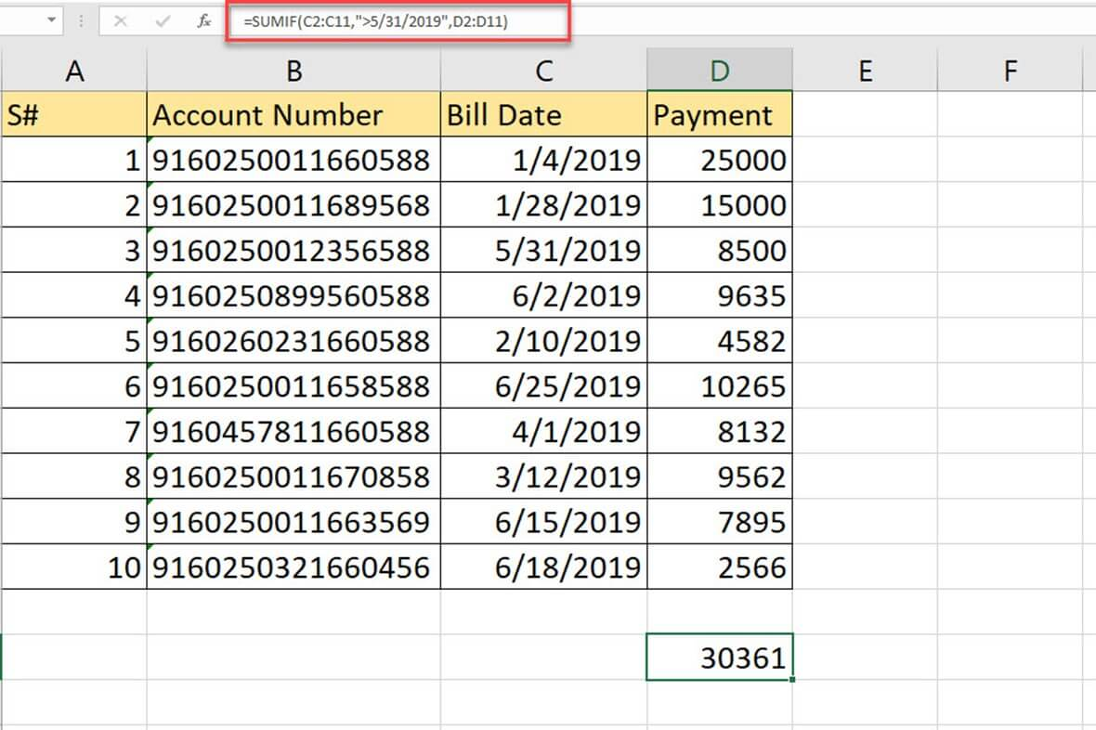

**Step 3)** The formula applied is

=SUMIF (C2: C11,">5/31/2019", D2: D11)

* C2: C11 is the range of cells where the dates are given and are the range where given criteria will be looking for
* '>5/31/2019' is the criteria where date greater than '5/31/2019'
* D2: D11 range of numbers to add once the condition is satisfied

**Step 4)** Below are the cell values which satisfies the applied condition, and the sum of these values will find.

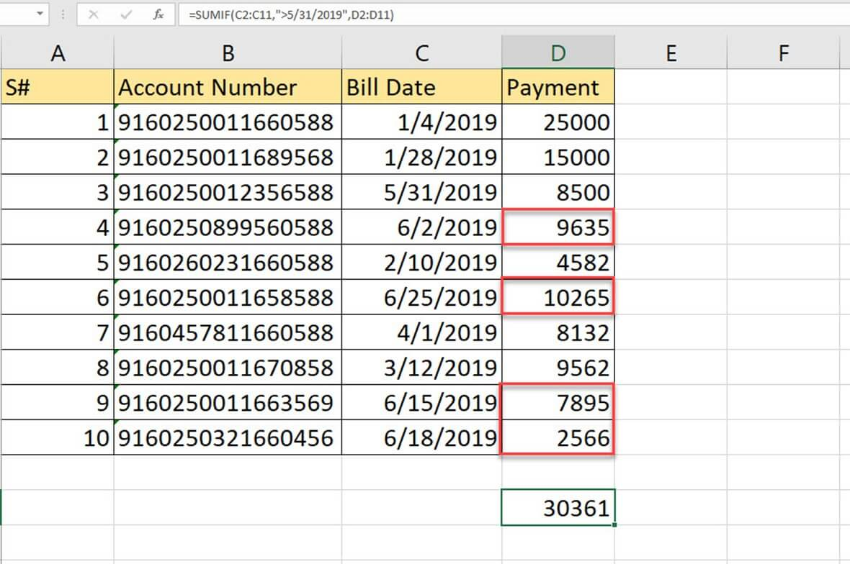

**Step 5)** The sum is there in D13. And is the total amount to be paid to multiple accounts for June.

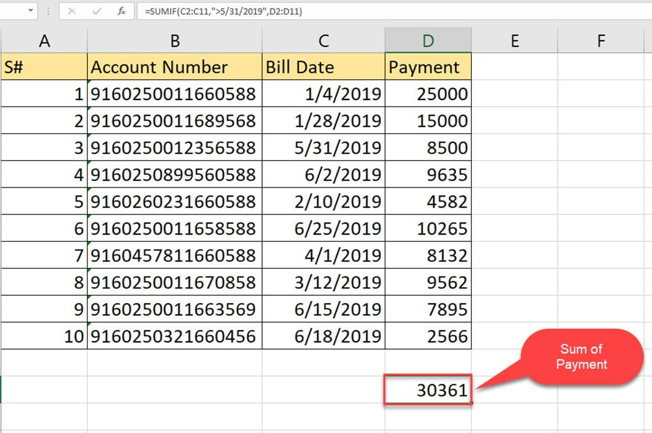

## Summary

* SUMIF function will make the sum of values according to criteria given.
* SUMIF function is compatible with numeric, date, text data
* Conditions can express from the result of other functions or operators
* SUMIF function can be applied only for a single column at a time
* A unique condition is allowed to check with SUMIF function
* #VALUE will be an error result when the range does not match with criteria range
* Part of the word or sentence will be matched using a wildcard. Asterisks symbol use with a series of characters and question mark for a single character.
* While using text along with numeric values, the criteria should enclose within a double quotation, but not if it consists only of a numeric value.

# 17 BEST Excel Alternatives in 2020 (Free/Paid)

Excel is a spreadsheet software included in the Microsoft office suite. It widely is used to create grids of numbers and formulas that specify calculations, inventory tracking, and accounting, and more.

However, it has some limitations like a lack of security, and controlling different versions of the same file is also very difficult. Here is a curated list of Top tools that are capable of replacing Microsoft Office Excel. The list contains both open source(free) and commercial(paid) software.

### 1) Google Spreadsheet

[](https://www.guru99.com/images/1/102219_1342_17BESTExcel1.png)

Google Spreadsheet is a popular cloud-based application that enables you to create, update, delete, and share data online. This Ajax based application is compatible with CSV (Comma-separated values) file.

**Features:**

* It has built-in formulas, a range of conditional formatting options, and pivot tables.
* This application allows you to access spreadsheets from phone or computer.
* It has explore panel, which provides an overview of data and generates pre-populated charts.
* Everyone can work on the same spreadsheet.
* It automatically saves changes.

**Link:** <https://www.google.com/sheets/about/>

### 2) Airtable

[](https://www.guru99.com/images/1/102219_1342_17BESTExcel2.png)

Airtable is a spreadsheet solution for enterprises and businesses of all sizes. It offers organization and collaboration functionalities in an effective and mobile-friendly table solutions.

**Features:**

* It allows you to organize projects, content, and ideas into a centralized system.
* This software offers support for form management.
* It helps you to filter, sort, and rearrange data.
* It offers customizable views and fields.

**Link:** <https://airtable.com/invite/r/phva8Bgs>

### 3) OpenOffice

[](https://www.guru99.com/images/1/102219_1342_17BESTExcel3.png)

OpenOffice Calc is a tool that helps you to calculate, analyze, and present your data in reports. It helps you to export spreadsheet directly as PDF files.

**Features:**

* It provides cell formatting options for templates, borders, backgrounds, and more.
* You can calculate cell value based on constraint given in other cells.
* This tool has a scenario manager that enables you to perform what-if analysis of data with the touch of a button.
* You can save spreadsheets in XML based format.
* Apache OpenOffice calc supports multiple users.
* You can use a Portable Document Format (.pdf) to send the output to other people.

**Link:** <https://www.openoffice.org/product/calc.html>

### 4) LibreOffice

[https://www.guru99.com/images/1/102219_1342_17BESTExcel4.png](https://www.guru99.com/images/1/102219_1342_17BESTExcel4.png)

LibreOffice Calc is an easy to use open-source software product. It helps you to calculate, analyze, and manage data. It has numerous statistical and banking functions to create formulas and perform complex calculations on data.

**Features:**

* You can arrange, filter, and store data.
* LibreOffice allows you to show or hide certain data ranges.
* It provides dynamic charts that automatically update altered data.
* It provides real time data sheets that can be integrated into sheets and reports.
* You can perform collaborative work on spreadsheets.
* This software has a dynamic feature of building a chart that updates automatically when data changes.
* You can drag and drop tables from any database to sheet.

**Link:** <https://www.libreoffice.org/>

### 5) WPS Office Spreadsheets

[https://www.guru99.com/images/1/102219_1342_17BESTExcel5.png](https://www.guru99.com/images/1/102219_1342_17BESTExcel5.png)

WPS Office Spreadsheets is a powerful tool that contains hundreds of most commonly used functions and formulas. This software can be run on Microsoft Windows, Linux, iOS, macOS, and Android platforms.

**Features:**

* It includes a built-in table and cell styles.
* This tool provides customizable charts, including line, scatter, column, pie, bar, and more.
* It supports advanced pivot tables, allowing you to analyze and summarize data.
* You can forecast and find solutions for complex problems using what-if analysis.
* WPS Office Spreadsheets allows you to open and edit multiple documents.
* It has more than 50 keyboard shortcuts.
* Supports track changes comments.

**Link:** <https://www.wps.com/download/>

### 6) Numbers

[](https://www.guru99.com/images/1/102219_1342_17BESTExcel6.png)

Numbers can create a beautiful spreadsheet that includes tables and images. You can collaborate with your team on PC, iPhone, iPad, or Mac.

**Features:**

* It provides ready to use templates.
* Numbers support numerous functions.
* It allows you to summarize your tables.
* This tool has a library of more than 700 customizable shapes.
* You can sketch a diagram and add notes to visualize your data.
* It enables you to work with your team in real time on spreadsheets stored on Box or iCloud.

**Link:** <https://www.apple.com/numbers/>

### 7) Smartsheet

[https://www.guru99.com/images/1/102219_1342_17BESTExcel7.png](https://www.guru99.com/images/1/102219_1342_17BESTExcel7.png)

Smartsheet is a software as a service (SAS) that offers collaboration and work management. It automates repetitive processes by sending alerts, requesting updates, and locking row-based changes.

**Features:**

* Smartsheet allows you to automate workflow, including forms.
* You can quickly toggle between card view, grid view, and calendar view.
* It supports live reporting.
* You can easily collaborate with others.
* This software supports mobile app integration with other applications like Google, Salesforce, and Slack.
* Smartsheet allows you to manage resources and domain sharing.

**Link:** <https://www.smartsheet.com/>

### 8) Sheetgo

[](https://www.guru99.com/images/1/102219_1342_17BESTExcel8.png)

Sheetgo is a cloud-based software that enables you to manage the workflow of spreadsheets. It enables you to create, edit, delete, and update connections inside Google sheet files.

**Features:**

* You can save your dynamic data.
* Sheetgo connects and filters colored data between spreadsheets.
* It allows you to bring data from more than one sheet into a single master sheet.
* You can combine data from many tabular formats.
* This application helps you to filter out data while transferring data between sheets.

**Link:** <https://www.sheetgo.com/>

### 9) Thinkfree

[](https://www.guru99.com/images/1/102219_1342_17BESTExcel9.png)

Thinkfree is an application that enables you to edit and view spreadsheets. This tool helps you to insert and calculate data or format the cells.

**Features:**

* It enables you to draw an object on the scribble pad and insert it in the sheet.
* You can change the cell formatting like number format, indentation, text wrapping, and borders.
* You can fill the empty cells with the values.
* It provides functions for finding the value, or reference location of a particular cell.

**Link:** <https://www.thinkfree.com/download/>

### 10) PlanMaker

PlanMaker is a spreadsheet software that is available on Microsoft Windows, Windows Mobile, and Linux. It has numerous design features that allow you to create presentation-quality worksheets.

[](https://www.guru99.com/images/1/102219_1342_17BESTExcel10.jpg)

**Features:**

* You can exchange worksheets between any version of PlanMaker.
* This software has 430 calculation functions.
* You can select and format more than one worksheet simultaneously.
* It provides intelligent filling of cell areas with rows of values.
* You can create an attractive worksheet using headers, footers, and borders.
* PlanMaker contains 430+ calculation functions.
* You can fill drawing with images, gradients, colors, and patterns.
* This software allows you to insert more than 80 varieties of charts.

**Link:** <https://www.freeoffice.com/en/freeoffice-planmaker>

### 11) TreeGrid SpreadSheet

[](https://www.guru99.com/images/1/102219_1342_17BESTExcel11.png)

TreeGrid SpreadSheet is a tool that offers you a cell-based AJAX grid. It has many predefined and custom formula functions. This software helps you to manipulate individual selected cell groups or cells.

**Features:**

* It supports Google Chrome, Mozilla Firefox, Opera, iOS, and Android mobile.
* This application provides localized formulas.
* It automatically adds rows and columns on the scroll.
* This tool provides a fully customizable cell popup menu.
* It has advanced JavaScript API to control the grid.
* TreeGrid SpreadSheet can be localized to any language, including texts, date as well as number format.
* This tool provides editable formals with references to a specific sheet.

**Link:** <http://www.treegrid.com/Sheet>

### 12) SSuite Axcel Professional

[](https://www.guru99.com/images/1/102219_1342_17BESTExcel12.png)

SSuite Axcel Professional is spreadsheet software that helps you to calculate, analyze, summarize your important data in charts or reports.

**Features:**

* It provides chart vizard to select from 8 categories of 2D and 3D charts.
* You can recognize spreadsheets to show or hide specific data ranges or to format ranges according to conditions.
* It automatically updates the dynamic data presented in the chart.
* This tool has a scenario manager that enables you to perform what if analysis of data with the touch of a button.

**Link:** <https://www.ssuiteoffice.com/freedownloads.htm>

### 13) Azquo

[](https://www.guru99.com/images/1/102219_1342_17BESTExcel13.jpg)

Azquo is a spreadsheet program that allows provides auditable and verifiable data in spreadsheets. It is built for an analyst that means you can manage data without needing expert IT skills.

**Features:**

* Azquo tells you who changed data, what, when, as well as where.
* It allows you to import data from internal or external sources.
* You can control your data, users, and their permissions from one place.
* It enables you to work online and offline.
* This tool has a scenario manager that enables you to perform what if analysis of data with the touch of a button.
* You can control your data and user permissions.

**Link:** <http://www.azquo.com/>

### 14) Spread

[](https://www.guru99.com/images/1/102219_1342_17BESTExcel14.png)

Spread is a spreadsheet solution for JavaScript and .NET platform. This tool includes more than 450 formulas. It allows you to customize data input forms.

**Features:**

* It provides API for input forms, dashboard, and chart apps.
* You can optimize app size and speed using a modular structure.
* It gives code free extensibility and customization.
* You can group, sort, and filter out numerical data.
* This tool offers hassle-free data binding.

**Link:** <https://www.grapecity.com/spread>

### 15) Gnumeric

[](https://www.guru99.com/images/1/102219_1342_17BESTExcel15.png)

Gnumeric is an open-source tool that is a part of GNOME free application software desktop project. This tool enables you to import data in several file formats like HTML, Lotus 1-2-3, LaTex, and CSV.

**Features:**

* It helps you to organize numeric value in rows and columns.
* You can perform and update complex calculations by defining and modifying steps subsequently.
* Gnumeric enables you to create and display graphical plots of data using bar plotline charts and pie charts.
* You can perform any task involving dates, times, names, or numbers.

**Link:** <http://www.gnumeric.org/download.html>

### 16) Scoro

[](https://www.guru99.com/images/1/102219_1342_17BESTExcel16.png)

Scoro is a SaaS software that helps you to track and manage finances client base, compile and send quotes and invoices. This cloud base tool has useful features for medium and small size teams.

**Features:**

* It allows you to make data-driven decisions using reports.
* You can integrate with Nemours accounting software.
* It boosts revenue by planning your team's work time and resources.
* You can directly feed all your finance and sales documents and add them to the report.
* It includes management tools like shared tasks, timesheets, team calendars, and automated time tracking.

**Link:** <https://www.scoro.com/>

### 17) Zoho Sheet

[](https://www.guru99.com/images/1/102219_1342_17BESTExcel17.png)

Zoho Sheet is a spreadsheet application for collaborative teams. It supports 350+ functions that help you to perform complex and basic calculations without any problem.

**Features:**

* You can record macros of a task or use VBA (Visual Basic for Applications) code to perform the action with one button click.
* It automatically detects and removes data related to anomalies.
* You can highlight parts of data with conditional formats.
* It allows you to export sheets in numerous file formats, including .pdf and .html.
* You can publish a spreadsheet and decide who can see formula cells.
* This software helps you to collect your data with forms.
* It supports 23+ different languages.

**Link:** <https://www.zoho.com/sheet/>

# Excel PDF

Excel is the most powerful tool to manage and analyze various types of Data. This eBook covers in-depth lessons on how to use various Excel formulas, Tables and Charts for managing small to large scale business process.

## Key Highlights of Excel PDF are

* 186+ pages
* eBook Designed for beginners
* Beautifully annotated screenshots
* You will get lifetime access

[https://www.guru99.com/images/1/ebook_look_inside.png](https://www.guru99.com/pdf/excel_preview.pdf)

[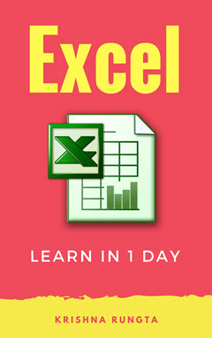](https://www.guru99.com/pdf/excel_preview.pdf)

### Inside this PDF

1. Introduction to Microsoft Excel 101
2. How to Add, Subtract, Multiply, Divide in Excel
3. Excel Data Validation, Filters, Grouping
4. Best Excel Formulas & Functions: You Need to Know Now
5. IF, AND, OR, Nested IF & NOT Logical Functions in Excel
6. How to Create Charts in Excel: Types & Examples
7. How to make Budget in Excel: Personal Finance Tutorial
8. How to Import Data into Excel from Access, XML, Text file, SQL Server
9. How to Create Pivot Table in Excel: Beginners Tutorial
10. Advanced Charts & Graph in Excel
11. What is Microsoft Office 365? Benefits of Excel on Cloud
12. CSV vs Excel (.xls) - What's the Difference?
13. Excel VLOOKUP Tutorial for Beginners: Learn with Examples
14. Excel ISBLANK Function: Learn with Example
15. Sparkline in Excel with EXAMPLES
16. SUMIF function in Excel: Learn with EXAMPLE

# Excel VBA Tutorial for Beginners: Learn in 3 Days

## What is VBA?

VBA stands for Visual Basic for Applications. It is a combination of the Microsoft's event-driven programming language Visual Basic with Microsoft Office Applications such as Microsoft Excel.

VBA enables you to automate various activities in Excel like generating reports, preparing charts & graphs, doing calculations, etc. This automation activity is also often referred as Macro. This way it helps users to save their time spent behind running the repetitive steps.

### Here is what we cover in the Course

|  |  |
| --- | --- |
| [**Tutorial**](https://www.guru99.com/introduction-to-macros-in-excel.html) | Introduction to Macros in Excel |
| [**Tutorial**](https://www.guru99.com/creating-your-first-visual-basic-for-applications-vba-in-excel.html) | Creating your First Visual Basic for Applications (VBA) in Excel |
| [**Tutorial**](https://www.guru99.com/vba-data-types-variables-constant.html) | VBA Data Types, Variables & Constant |
| [**Tutorial**](https://www.guru99.com/vba-arrays.html) | VBA Arrays |
| [**Tutorial**](https://www.guru99.com/vba-operators.html) | VBA Excel Form Control & Activex Control |
| [**Tutorial**](https://www.guru99.com/vba-arithmetic-operators.html) | VBA Arithmetic Operators |
| [**Tutorial**](https://www.guru99.com/vba-string-operators.html) | VBA String Operators |
| [**Tutorial**](https://www.guru99.com/vba-comparison-operators.html) | VBA Comparison Operators |
| [**Tutorial**](https://www.guru99.com/vba-logical-operators.html) | VBA Logical Operators |
| [**Tutorial**](https://www.guru99.com/vba-functions-subroutine.html) | Excel VBA Call a Subroutine |
| [**Tutorial**](https://www.guru99.com/vba-function.html) | Excel VBA Function Tutorial: Return, Call, Examples |
| [**Tutorial**](https://www.guru99.com/vba-range-objects.html) | VBA Range Objects |
| [**Tutorial**](https://www.guru99.com/excel-vba-tutorial-pdf.html) | Excel VBA Tutorial PDF |

### What should I know?

Nothing! This training assumes you an absolute beginner to VBA. But knowledge of Excel will help

# How to Write Macros in Excel: Step by Step Tutorial

As humans, we are creatures of habit. There are certain things that we do on a daily basis, every working day. **Wouldn't it be better if there were some magical way of pressing a single button and all of our routine tasks are done? I can hear you say yes.** Macro helps you to achieve that. In a layman's language, a macro is a recording of your routine steps in Excel that you can replay using a single button.

## What is an Excel Macro?

An **Excel Macro** is a piece of programming code that runs in Excel environment and helps automate routine tasks. A macro is an excel task recording and playback tool. You simply record your Excel steps and the macro will play it back. You need little knowledge of VBA to make advanced modifications in the macro.

We will cover the following topics in this tutorial.

* [The Importance of Macros in Excel](https://www.guru99.com/introduction-to-macros-in-excel.html#2)
* [What is VBA in a layman's language?](https://www.guru99.com/introduction-to-macros-in-excel.html#3)
* [Macro Basics](https://www.guru99.com/introduction-to-macros-in-excel.html#4)
* [Step by Step Example of Recording Macros in Excel](https://www.guru99.com/introduction-to-macros-in-excel.html#5)

## The Importance of Macros in Excel

Let's say you work as a cashier for a water utility company. Some of the customers pay through the bank and at the end of the day, you are required to download the data from the bank and format it in a format that meets your business requirements.

You can import the data into Excel and format. The following day you will be required to perform the same ritual. It will soon become boring and tedious. **Macros solve such problems by automating such routine tasks**. You can use a macro to record the steps of

* Importing the data
* Formatting it to meet your business reporting requirements.

## What is VBA in a layman's language?

**VBA is the acronym for Visual Basic for Applications.** It is a programming language that Excel uses to record your steps as you perform routine tasks. You do not need to be a programmer or a very technical person to enjoy the benefits of macros in Excel. Excel has features that automatically generated the source code for you. Read the article on Vba for more details.

## Macro Basics

**Macros are one of the developer features. By default, the tab for developers is not displayed in excel. You will need to display it via customize report**

Macros can be used to compromise your system by attackers. By default, they are disabled in excel. If you need to run macros, you will need to enable running macros and only run macros that you know come from a trusted source

If you want to save macros, then you must save your workbook in a macro-enabled format *.xlsm

The macro name should not contain any spaces.

Always fill in the description of the macro when creating one. This will help you and others to understand what the macro is doing.

## Step by Step Example of Recording Macros in Excel

We will work with the scenario described in the importance of macros excel. We will work with the following CSV file.

[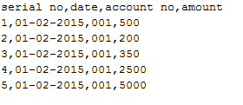](https://www.guru99.com/images/5-2015/050215_1033_Introductio111.png)

You can download the above file here

We will create a macro enabled template that will import the above data and format it to meet our business reporting requirements.

## Enable Developer Option

To execute VBA program, you have to have access to developer option in Excel. Enable the developer option as shown below and pin it into your main ribbon in Excel.

**Step 1)** Go to main menu "FILE" and selection option "Options."

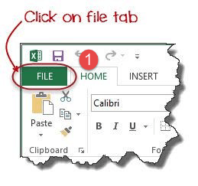

**Step 2)**Select "Options" from the menu list as shown in screen shot below.

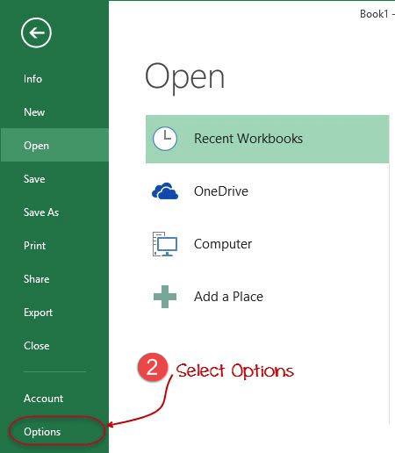

**Step 3**) Now another window will open, in that window do following things

* Click on Customize Ribbon
* Mark the checker box for Developer option
* Click on OK button

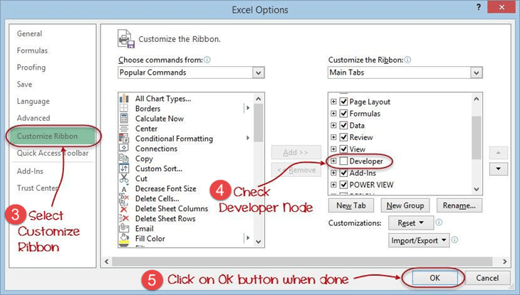

**Step 4**) You will now be able to see the DEVELOPER tab in the ribbon

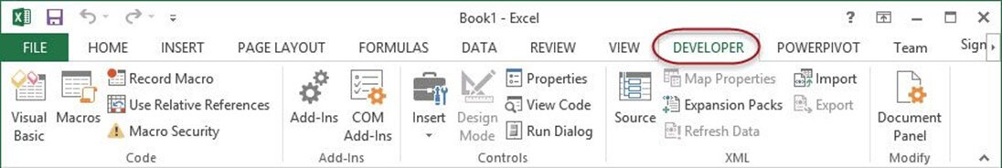

First, we will see how we can create a command button on the spreadsheet and execute the program.

* Create a folder in drive C named Bank Receipts
* Paste the receipts.csv file that you downloaded

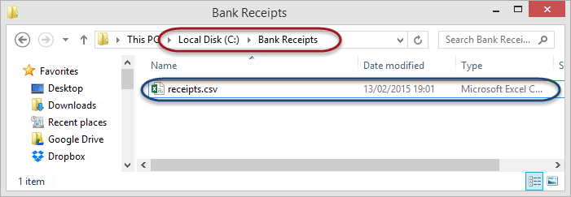

1. Click on the DEVELOPER tab
2. Click on Record Macro as shown in the image below

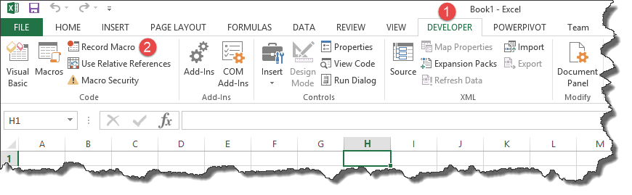

You will get the following dialogue window

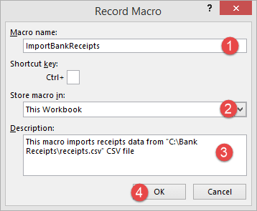

1. Enter ImportBankReceipts as the macro name.
2. Step two will be there by default
3. Enter the description as shown in the above diagram
4. Click on "OK" tab

* Put the cursor in cell A1
* Click on the DATA tab
* Click on From Text button on the Get External data ribbon bar

You will get the following dialogue window

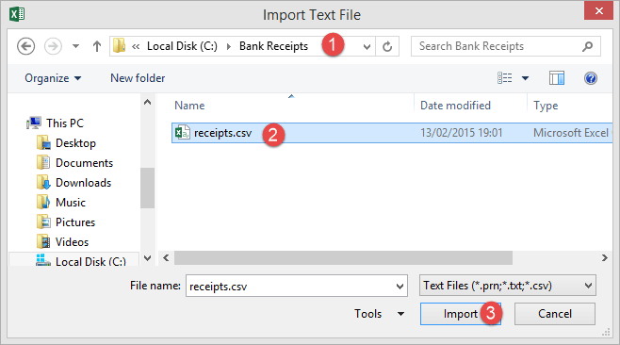

* Go to the local drive where you have stored the CSV file
* Select the CSV file
* Click on Import button

You will get the following wizard

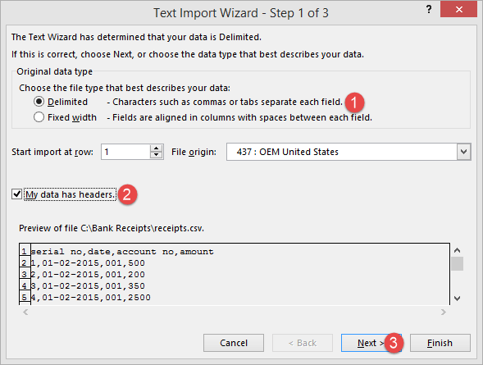

Click on Next button after following the above steps

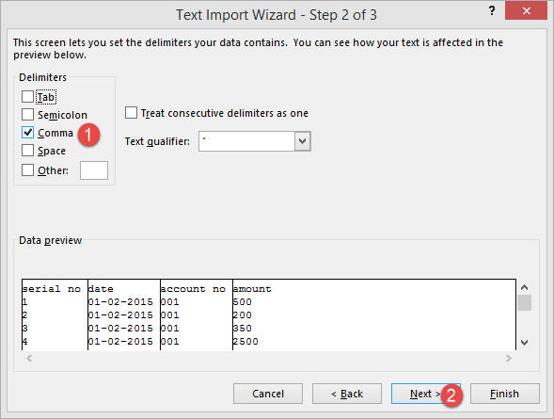

Follow the above steps and click on next button

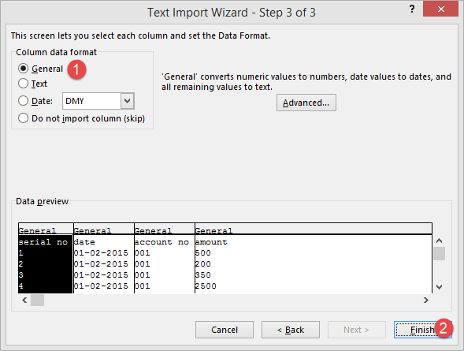

* Click on Finish button
* Your workbook should now look as follows

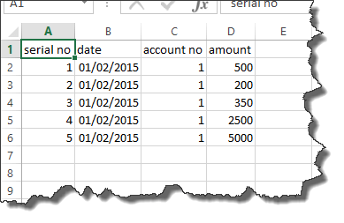

Make the columns bold, add the grand total and use the SUM function to get the total amount.

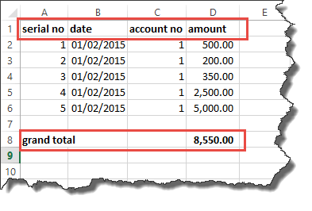

Now that we have finished our routine work, we can click on stop recording macro button as shown in the image below

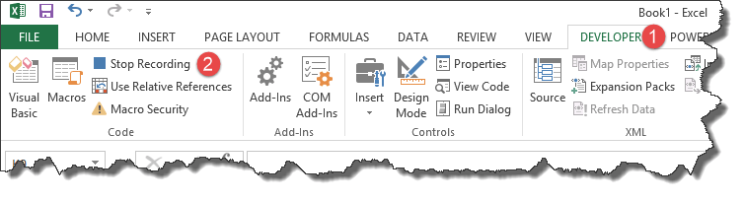

Before we save our work book, we will need to delete the imported data. We will do this to create a template that we will be copying every time we have new receipts and want to run the ImportBankReceipts macro.

* Highlight all the imported data
* Right click on the highlighted data
* Click on Delete
* Click on save as button
* Save the workbook in a macro enabled format as shown below

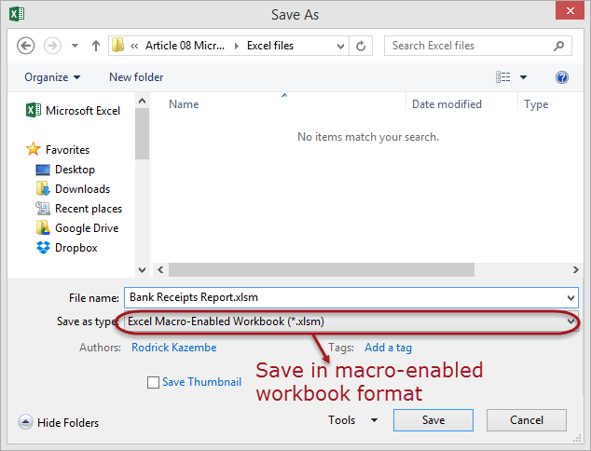

* Make a copy of the newly saved template
* Open it
* Click on DEVELOPER tab
* Click on Macros button

You will get the following dialogue window

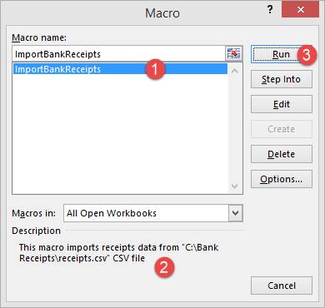

1. Select ImportBankReceipts
2. Highlights the description of your macro
3. Click on Run button

You will get the following data



Congratulations, you just created your first macro in excel.

## Summary

Macros simplify our work lives by automating most of the routine works that we do. Macros in Excel are powered by Visual Basic for Applications.

# How to Create Visual Basic for Applications (VBA) in Excel with Examples

Everybody in this country should learn how to program a computer... because it teaches you how to think." -Steve Jobs

I wish to extend the wise words of Steve Jobs and say everyone in the world should learn how to program a computer. You may not necessary end up working as a programmer or writing programs at all but it will teach you how to think.

In this tutorial, we are going to cover the following topics.

* [What is VBA?](https://www.guru99.com/creating-your-first-visual-basic-for-applications-vba-in-excel.html#1)
* [Why VBA?](https://www.guru99.com/creating-your-first-visual-basic-for-applications-vba-in-excel.html#2)
* [Personal & business applications of VBA in excel](https://www.guru99.com/creating-your-first-visual-basic-for-applications-vba-in-excel.html#3)
* [Visual Basic For Applications VBA basics](https://www.guru99.com/creating-your-first-visual-basic-for-applications-vba-in-excel.html#4)
* [Step by step example of creating a simple EMI calculator in Excel](https://www.guru99.com/creating-your-first-visual-basic-for-applications-vba-in-excel.html#5)

## What is VBA?

**VBA stands for Visual Basic for Applications**. Before we go into further details, let's look at what computer programming is in a layman's language. Assume you have a maid. If you want the maid to clean the house and do the laundry. You tell her what to do using let's say English and she does the work for you. As you work with a computer, you will want to perform certain tasks. Just like you told the maid to do the house chores, you can also tell the computer to do the tasks for you.

The process of telling the computer what you want it to do for you is what is known as computer programming. Just as you used English to tell the maid what to do, you can also use English like statements to tell the computer what to do. The English like statements fall in the category of high level languages. VBA is a high level language that you can use to bend excel to your all powerful will.

VBA is actually a sub set of Visual Basic 6.0 BASIC stands for **B**eginners **A**ll-Purpose **S**ymbolic **I**nstruction **C**ode.

## Why VBA?

* It uses English like statements to write instructions
* Creating the user interface is like using a paint program. You just have to drag, drop and align the graphical user interface controls.
* Short learning curve. From day one that you start learning, you can immediately start writing simple programs.
* Enhances the functionality of excel by allowing you to make excel behave the way you want it to

## Personal & business applications of VBA in excel

For personal use, you can use it for simple macros that will automate most of your routine tasks. Read the article on Macros for more information on how you can achieve this.

For business use, you can create complete powerful programs powered by excel and VBA. The advantage of this approach is you can leverage the powerful features of excel in your own custom programs.

## Visual Basic for Applications VBA basics

Before we can write any code, we need to know the basics first. The following basics will help you get started.

* **Variable** – in high school we learnt about algebra. Find (x + 2y) where x = 1 and y = 3. In this expression, x and y are variables. They can be assigned any numbers i.e. 1 and 3 respective as in this example. They can also be changed to say 4 and 2 respectively. Variables in short are memory locations. As you work with VBA, you will be required to declare variables too just like in algebra classes
* **Rules for creating variables**
  + Don't use reserved words – if you work as a student, you cannot use the title lecturer or principal. These titles are reserved for the lecturers and the school authority. Reserved words are those words that have special meaning in Vba and as such, you cannot use them as variable names.
  + Variable names cannot contain spaces – you cannot define a variable named first number. You can use firstNumber or first_number.
  + Use descriptive names – it's very tempting to name a variable after yourself but avoid this. Use descriptive names i.e. quantity, price, subtotal etc. this will make your VBA code easy to read
* Arithmetic operators - The rules of Brackets of Division Multiplication Addition and Subtraction (BODMAS) apply so remember to apply them when working with expressions that use multiple different arithmetic operators. Just like in excel, you can use
  + + for addition
  + - for subtraction
  + * for multiplication
  + / for division.
* Logical operators - The concept of logical operators covered in the earlier tutorials also apply when working with VBA. These include
  + If statements
  + OR
  + NOT
  + AND
  + TRUE
  + FALSE

## Enable Developer Option

* Create a new workbook
* Click on the ribbon start button
* Select options
* Click on customize ribbon
* Select the developer checkbox as shown in the image below
* Click OK

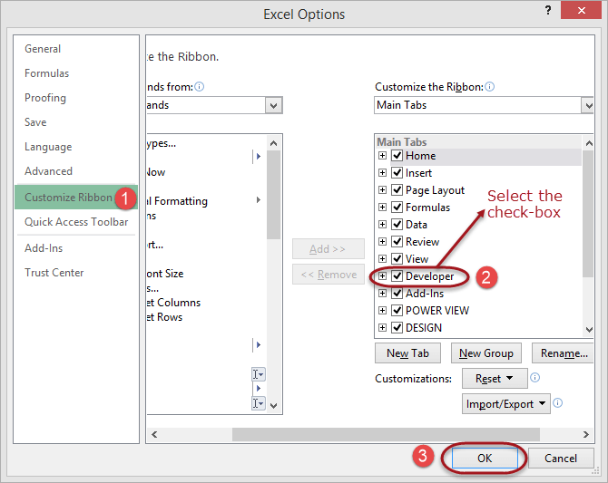

You will now be able to see the DEVELOPER tab in the ribbon

### VBA Hello world

Now we will demonstrate how to program in VBA. All program in VBA has to start with "Sub" and end with "End sub". Here the name is the name you want to assign to your program. While sub stands for a subroutine which we will learn in the later part of the tutorial.

Sub name()

.

.

.

End Sub

We will create a basic VBA program that displays an input box to ask for the user's name then display a greeting message

This tutorial assumes you have completed the tutorial on Macros in excel and have enabled the DEVELOPER tab in excel.

* Create a new work book
* Save it in an excel macro enabled worksheet format *.xlsm
* Click on the DEVELOPER tab
* Click on INSERT drop down box under controls ribbon bar
* Select a command button as shown in the image below

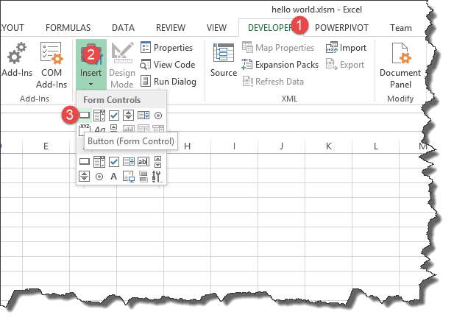

Draw the command button anywhere on the worksheet

You will get the following dialogue window

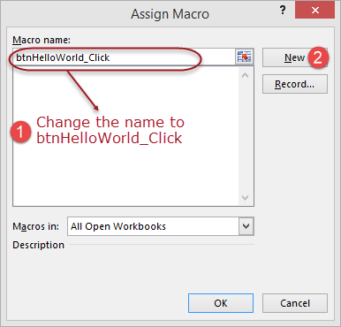

* Rename the macro name to btnHelloWorld_Click
* Click on new button
* You will get the following code window

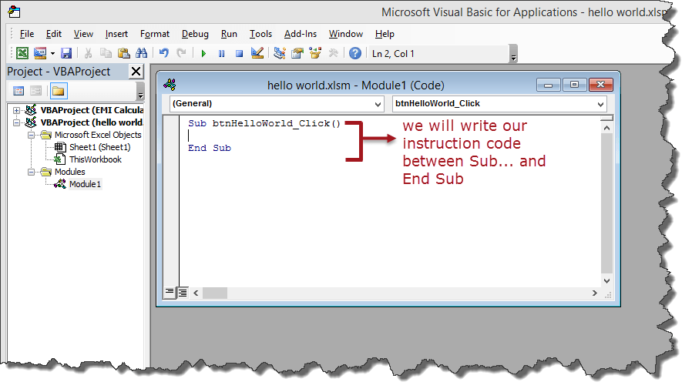

Enter the following instruction codes

Dim name As String

name = InputBox("Enter your name")

MsgBox "Hello " + name

HERE,

* **"Dim name as String"** creates a variable called name. The variable will accept text, numeric and other characters because we defined it as a string
* **"name = InputBox("Enter your name")"** calls the built in function InputBox that displays a window with the caption Enter your name. The entered name is then stored in the name variable.
* "**MsgBox "Hello " + name"** calls the built in function MsgBox that display Hello and the entered name.

Your complete code window should now look as follows

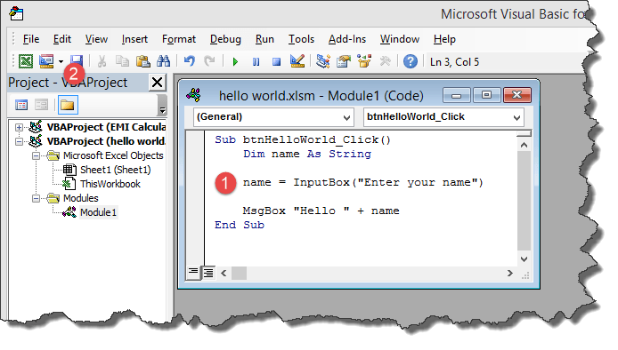

* Close the code window
* Right click on button 1 and select edit text
* Enter Say hello

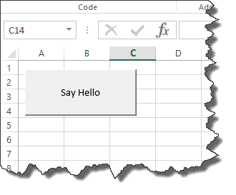

* Click on Say Hello
* You will get the following input box

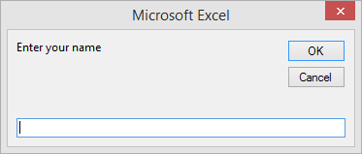

* Enter your name i.e. Jordan
* You will get the following message box

[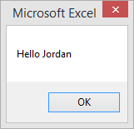](https://www.guru99.com/images/5-2015/050215_1102_Creatingyou7.png)

Congratulations, you just created your first VBA program in excel

## Step by step example of creating a simple EMI calculator in Excel

In this tutorial exercise, we are going to create a simple program that calculates the EMI. EMI is the acronym for Equated Monthly Instalment. It's the monthly amount that you repay when you get a loan. The following image shows the formula for calculating EMI.

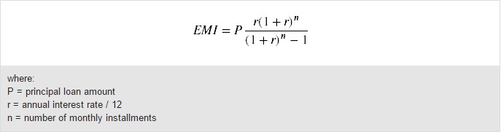

The above formula is complex and can be written in excel. The good news is excel already took care of the above problem. You can use the PMT function to compute the above.

The PMT function works as follows

=PMT(rate,nper,pv)

**HERE,**

* **"rate"** this is the monthly rate. It's the interest rate divided by the number of payments per year
* **"nper"** it is the total number of payments. It's the loan term multiplied by number of payments per year
* **"pv"** present value. It's the actual loan amount

Create the GUI using excel cells as shown below

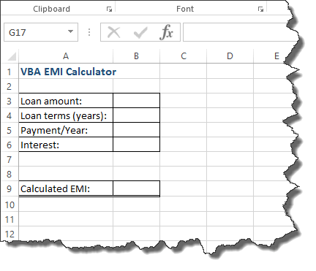

Add a command button between rows 7 and 8

Give the button macro name btnCalculateEMI_Click

Click on edit button

Enter the following code

Dim monthly_rate As Single, loan_amount As Double, number_of_periods As Single, emi As Double

monthly_rate = Range("B6").Value / Range("B5").Value

loan_amount = Range("B3").Value

number_of_periods = Range("B4").Value * Range("B5").Value

emi = WorksheetFunction.Pmt(monthly_rate, number_of_periods, -loan_amount)

Range("B9").Value = emi

**HERE,**

* **"Dim monthly_rate As Single,…"** Dim is the keyword that is used to define variables in VBA, monthly_rate is the variable name, Single is the data type that means the variable will accept number.
* **"monthly_rate = Range("B6").Value / Range("B5").Value"** Range is the function used to access excel cells from VBA, Range("B6").Value makes reference to the value in B6
* **"WorksheetFunction.Pmt(…)"** WorksheetFunction is the function used to access all the functions in excel

The following image shows the complete source code

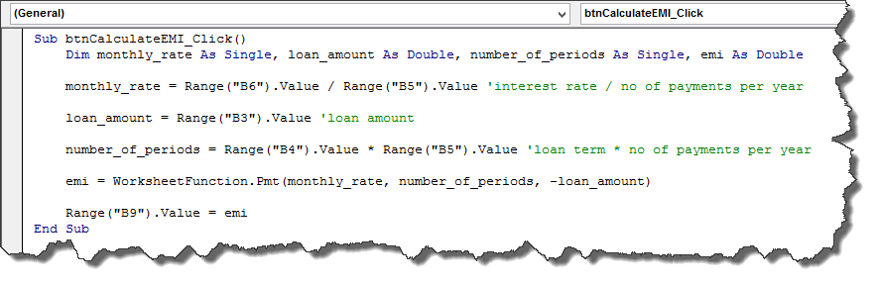

* Click on save and close the code window
* Test your program as shown in the animated image below

[](https://www.guru99.com/images/5-2015/emi.gif)

## Example 2

**Step 1)** Under Developer tab from the main menu, click on "Visual Basic" icon it will open your VBA editor.

[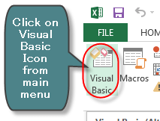](https://www.guru99.com/images/vba/062416_1048_WhatisVBA5.png)

**Step 2)** It will open a VBA editor, from where you can select the Excel sheet where you want to run the code. To open VBA editor double click on the worksheet.

[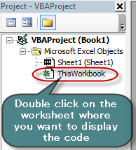](https://www.guru99.com/images/vba/062416_1048_WhatisVBA6.png)

It will open a VBA editor on the right-hand side of the folder. It will appear like a white space.

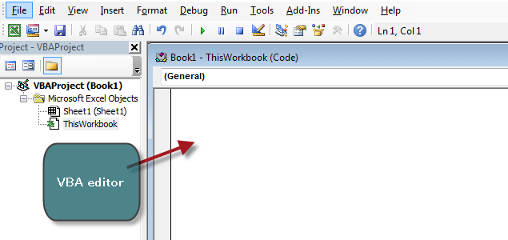

**Step 3)** In this step we going to see our fist VBA program. To read and display our program we need an object. In VBA that object or medium in a MsgBox.

* First, write "Sub" and then your "program name" (Guru99)
* Write anything you want to display in the MsgBox (guru99-learning is fun)
* End the program by End Sub

[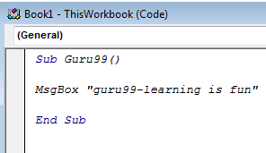](https://www.guru99.com/images/vba/062416_1048_WhatisVBA8.png)

**Step 4)** In next step you have to run this code by clicking on the green run button on top of the editor menu.

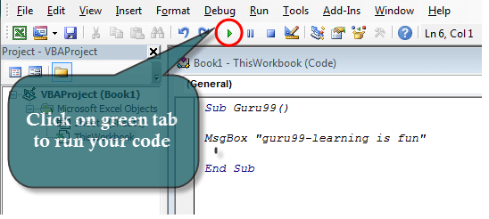

**Step 5)** When you run the code, another window will pops out. Here you have to select the sheet where you want to display the program and click on "Run" button

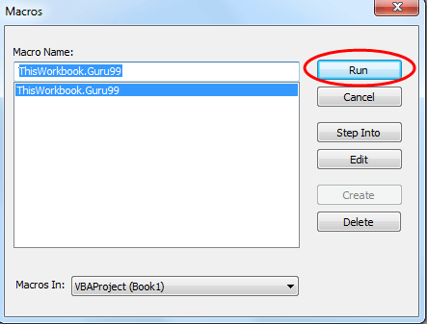

**Step 6)** When you click on Run button, the program will get executed. It will display the msg in MsgBox.

[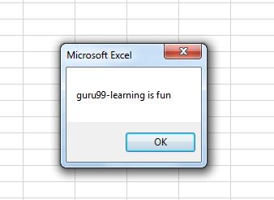](https://www.guru99.com/images/vba/062416_1048_WhatisVBA11.png)

## Summary

VBA stands for Visual Basic for Application. It's a sub component of visual basic programming language that you can use to create applications in excel. With VBA, you can still take advantage of the powerful features of excel and use them in VBA.

# Excel VBA Variables, Data Types & Constant

Variables are used in almost all computer program and VBA is no different. It's a good practice to declare a variable at the beginning of the procedure. It is not necessary, but it helps to identify the nature of the content (text, data, numbers, etc.)

In this tutorial, you will learn-

* [VBA Variables](https://www.guru99.com/vba-data-types-variables-constant.html#1)
* [VBA Data-Types](https://www.guru99.com/vba-data-types-variables-constant.html#2)
* [Constant in VBA](https://www.guru99.com/vba-data-types-variables-constant.html#3)

## VBA Variables

Variables are specific values that are stored in a computer memory or storage system. Later, you can use that value in code and execute. The computer will fetch that value from the system and show in the output. Each variable must be given a name.

To name the variable in VBA, you need to follow the following rules.

* It must be less than 255 characters
* No spacing is allowed
* It must not begin with a number
* Period is not permitted

Here are some example for Valid and Invalid names for variables in VBA.

|  |  |
| --- | --- |
| [VBA Data Types, Variables & Constant](https://www.guru99.com/images/vba/062416_1101_VBADataType1.png) **Valid Names** | [VBA Data Types, Variables & Constant](https://www.guru99.com/images/vba/062416_1101_VBADataType2.png) **Invalid Names** |
| My_Watch | My.Watch |
| NewCar1 | 1_NewCar (not begin with number) |
| EmployeeID | Employee ID ( Space not allowed) |

In VBA, we need to declare the variables before using them by assigning names and data type.

In VBA, Variables are either declared Implicitly or Explicitly.

* **Implicitly**: Below is an example of a variable declared Implicitly.
  + label=guru99
  + volume=4
* **Explicitly**: Below is an example of variable declared Explicitly. You can use "Dim" keyword in syntax
  + **Dim** Num As Integer
  + **Dim** password As String

VBA variable is no different than other programming languages. To declare a variable in VBA you use the keyword **"Dim."**

**Syntax for VBA Variable,**

To declare a variable in VBA, type Dim followed by a name:

Sub Exercise ()

Dim <name>

End Sub

Before we execute the variables we have to record a macro in Excel. To record a macro do the following -

**Step 1)**: Record the Macro 1

**Step 2)** : Stop Macro 1

**Step 3)**: Open the Macro editor, enter the code for variable in the Macro1

**Step 4):** Execute the code for Macro 1

Example, for VBA Variable

Sub Macro1()

Dim Num As Integer

Num = 99

MsgBox " Guru " & Num

End Sub

When you run this code, you will get the following output in your sheet.

[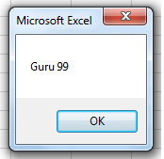](https://www.guru99.com/images/vba/062416_1101_VBADataType3.png)

## Excel VBA Data-Types

Computer cannot differentiate between the numbers (1,2,3..) and strings (a,b,c,..). To make this differentiation, we use Data Types.

VBA data types can be segregated into two types

* **Numeric Data Types**

|  |  |  |
| --- | --- | --- |
| **Type** | **Storage** | **Range of Values** |
| Byte | 1 byte | 0 to 255 |
| Integer | 2 bytes | -32,768 to 32,767 |
| Long | 4 bytes | -2,147,483,648 to 2,147,483,648 |
| Single | 4 bytes | -3.402823E+38 to -1.401298E-45 for negative values 1.401298E-45 to 3.402823E+38 for positive values. |
| Double | 8 bytes | -1.79769313486232e+308 to -4.94065645841247E-324 for negative values 4.94065645841247E-324 to 1.79769313486232e+308 for positive values. |
| Currency | 8 bytes | -922,337,203,685,477.5808 to 922,337,203,685,477.5807 |
| Decimal | 12 bytes | +/- 79,228,162,514,264,337,593,543,950,335 if no decimal is use +/- 7.9228162514264337593543950335 (28 decimal places) |

* **Non-numeric Data Types**

|  |  |  |
| --- | --- | --- |
| **Data Type** | **Bytes Used** | **Range of Values** |
| String (fixed Length) | Length of string | 1 to 65,400 characters |
| String (Variable Length) | Length + 10 bytes | 0 to 2 billion characters |
| Boolean | 2 bytes | True or False |
| Date | 8 bytes | January 1, 100 to December 31, 9999 |
| Object | 4 bytes | Any embedded object |
| Variant(numeric) | 16 bytes | Any value as large as Double |
| Variant(text) | Length+22 bytes | Same as variable-length string |

In VBA, if the**data type is not specified, it will automatically declare the variable as a Variant.**

Let see an example, on how to declare variables in VBA. In this example, we will declare three types of variables string, joining date and currency.

**Step 1)** Like, in the previous tutorial, we will insert the commandButton1 in our Excel sheet.

[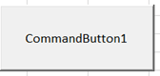](https://www.guru99.com/images/vba/062416_1101_VBADataType4.png)

**Step 2)** In next step, right-click on the button and select View code. It will open the code window as shown below.

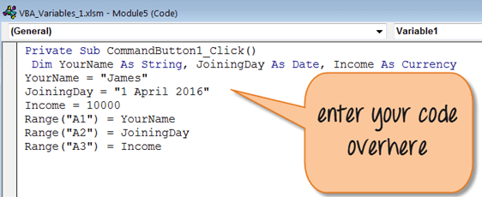

**Step 3)** In this step,

* Save your file by clicking on save button [VBA Data Types, Variables & Constant](https://www.guru99.com/images/vba/062416_1101_VBADataType6.png)
* Then click on Excel icon [VBA Data Types, Variables & Constant](https://www.guru99.com/images/vba/062416_1101_VBADataType7.png) in the same window to return the Excel sheet.
* You can see the design mode is "on" highlighted in green

[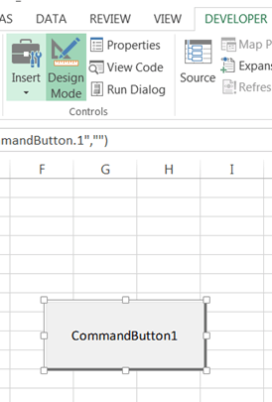](https://www.guru99.com/images/vba/062416_1101_VBADataType8.png)

**Step 4)** Turn off design mode, before clicking on command button

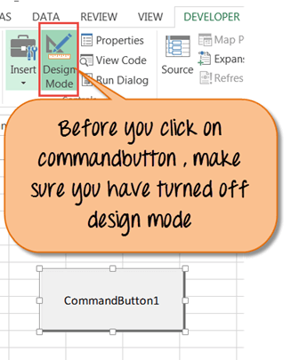

**Step 5)** After turning off the design mode, you will click on commandButton1. It will show the following variable as an output for the range we declared in code.

* Name
* Joining Date
* Income in curreny

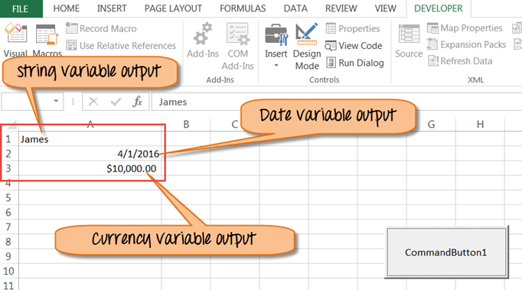

## Constant in VBA

Constant is like a variable, but you cannot modify it. To declare a constant in VBA you use keyword **Const**.

There are two types of constant,

* Built-in or intrinsic provided by the application.
* Symbolic or user defined

You can either specify the scope as **private** by default or **public**. For example,

Public Const DaysInYear=365

Private Const Workdays=250

Download Excel containing above code

**Summary:**

* Variables are specific values that are stored in a computer memory or storage system.
* You can use "Dim" keyword in syntax to declare variable explicitly
* VBA data types can be segregated into two types
  + Numeric Data Types
  + Non-numeric Data Types
* In VBA, if the data type is not specified. It will automatically declare the variable as a Variant
* Constant is like a variable, but you cannot modify it. To declare a constant in VBA you use keyword **Const**.

# Excel VBA Array: Dynamic, Multidimensional Types with Example

## What is an VBA Array?

An array is defined as a memory location capable of storing more than one value. The values must all be of the same data type. Let's say you want to store a list of your favourite beverages in a single variable, you can use an array to do that.

By using an array, you can refer to the related values by the same name. You can use an index or subscript to tell them apart. The individual values are referred as the elements of the array. They are contiguous from index 0 through the highest index value.

This tutorial assumes you are using Microsoft Excel version 2013. The knowledge still applies to other versions of Microsoft Excel as well.

In this VBA Programming tutorial, you will learn-

* [What are Advantages of arrays?](https://www.guru99.com/vba-arrays.html#2)
* [Types of arrays](https://www.guru99.com/vba-arrays.html#3)
* [How to use Array in Excel VBA](https://www.guru99.com/vba-arrays.html#4)
* [Testing our application](https://www.guru99.com/vba-arrays.html#5)

## What are Advantages of arrays?

The following are some of the benefits offered by array function

1. Group logically related data together – let's say you want to store a list of students. You can use a single array variable that has separate locations for student categories i.e. kinder garden, primary, secondary, high school, etc.
2. Arrays make it easy to write maintainable code. For the same logically related data, it allows you to define a single variable, instead of defining more than one variable.
3. Better performance – once an array has been defined, it is faster to retrieve, sort, and modify data.

## Types of arrays

VBA supports two types of arrays namely;

* **Static** – These types of arrays have a fixed pre-determined number of elements that can be stored. One cannot change the size of the data type of a Static Array. These are useful when you want to work with known entities such as the number of days in a week, gender, etc.

**For Example**: Dim ArrayMonth(12) As String

* **Dynamic** – These types of arrays do not have a fixed pre-determined number of elements that can be stored. These are useful when working with entities that you cannot predetermine the number.

**For Example**: Dim ArrayMonth() As Variant

**Syntax to declare arrays**

**Static arrays**

The syntax for declaring **STATIC** arrays is as follows:

Dim arrayName (n) as datatype

**HERE,**

|  |  |
| --- | --- |
| **Code** | **Action** |
| Dim arrayName (n) datatype | 1. It declares an array variable called arrayName with a size of n and datatype. Size refers to the number of elements that the array can store. |

**Dynamic arrays**

The syntax for declaring **DYNAMIC** arrays is as follows:

Dim arrayName() as datatype

ReDim arrayName(4)

**HERE,**

|  |  |
| --- | --- |
| **Code** | **Action** |
| Dim arrayName () datatype | 1. It declares an array variable called arrayName without specifying the number of elements |
| ReDim arrayName(4) | 1. It specifies the array size after the array has been defined. |

**Array Dimensions**

An array can be one dimension, two dimensions or multidimensional.

* **One dimension**: In this dimension, the array uses only one index. For example, a number of people of each age.
* **Two dimensions**: In this dimension, the array uses two indexes. For example, a number of students in each class. It requires number of classes and student number in each class
* **Multi-dimension**: In this dimension, the array uses more than two indexes. For example, temperatures during the daytime. ( 30, 40, 20).

## How to use Array in Excel VBA

We will create a simple application. This application populates an Excel sheet with data from an array variable. In this example, we are going to do following things.

* Create a new Microsoft Excel workbook and save it as Excel Macro-Enabled Workbook (*.xlsm)
* Add a command button to the workbook
* Set the name and caption properties of the command button
* Programming the VBA that populates the Excel sheet

Let do this exercise step by step,

**Step 1 – Create a new workbook**

1. Open Microsoft Excel
2. Save the new workbook as VBA Arrays.xlsm

**Step 2 – Add a command button**

**Note:** This section assumes you are familiar with the process of creating an interface in excel. If you are not familiar, read the tutorial [VBA Excel Form Control & ActiveX Control](https://www.guru99.com/vba-operators.html). It will show you how to create the interface

1. Add a command button to the sheet

[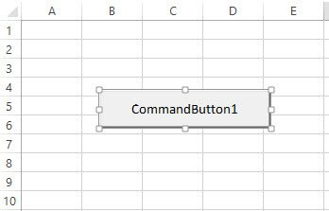](https://www.guru99.com/images/vba/062416_1125_VBAArrays1.jpg)

1. Set the name property to cmdLoadBeverages
2. Set the caption property to Load Beverages

Your GUI should now be as follows

[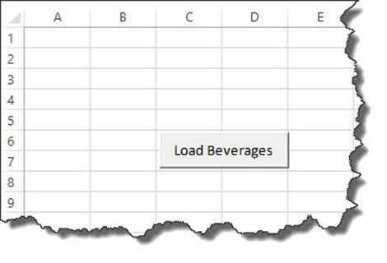](https://www.guru99.com/images/vba/062416_1125_VBAArrays2.jpg)

**Step 3 – Save the file**

1. Click on save as button
2. Choose Excel Macro-Enabled Workbook (*.xlsm) as shown in the image below

[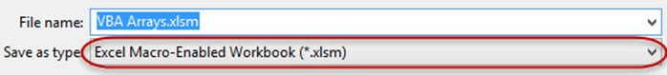](https://www.guru99.com/images/vba/062416_1125_VBAArrays3.jpg)

**Step 4 – Write the code**

We will now write the code for our application

1. Right click on Load Beverages button and select view code
2. Add the following code to the click event of cmdLoadBeverages

Private Sub cmdLoadBeverages_Click()

Dim Drinks(1 To 4) As String

Drinks(1) = "Pepsi"

Drinks(2) = "Coke"

Drinks(3) = "Fanta"

Drinks(4) = "Juice"

Sheet1.Cells(1, 1).Value = "My Favorite Beverages"

Sheet1.Cells(2, 1).Value = Drinks(1)

Sheet1.Cells(3, 1).Value = Drinks(2)

Sheet1.Cells(4, 1).Value = Drinks(3)

Sheet1.Cells(5, 1).Value = Drinks(4)

End Sub

**HERE,**

|  |  |
| --- | --- |
| **Code** | **Action** |
| Dim Drinks(1 To 4) As String | * It declares an array variable called Drinks. The first array index is 1 and the last array index is 4. |
| Drinks(1) = "Pepsi" | * Assigns the value Pepsi to the first array element. The other similar code does the same for the other elements in the array. |
| Sheet1.Cells(1, 1).Value = "My Favorite Beverages." | * Writes the value My Favorite Beverages in cell address A1. Sheet1 makes reference to the sheet, and Cells(1,1) makes reference to row number 1 and column 1 (B) |
| Sheet1.Cells(2, 1).Value = Drinks(1) | * Writes the value of the array element with index 1 to row number two of column 1 |

## Testing our application

Select the developer tab and ensure that the Design mode button is "off." The indicator is, it will have a white background and not a coloured (greenish) background. (See image below)

[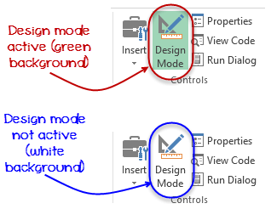](https://www.guru99.com/images/vba/062416_1125_VBAArrays4.png)

Click on Load Beverages button

You will get the following results

[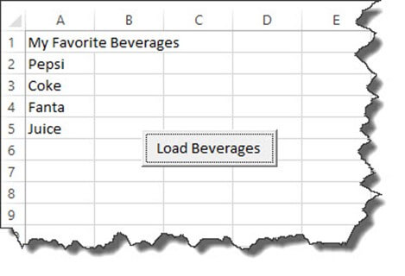](https://www.guru99.com/images/vba/062416_1125_VBAArrays5.jpg)

Download Excel containing above code

**Summary**

1. An array is a variable capable of storing more than one value
2. VBA supports static and dynamic arrays
3. Arrays make it easy to write maintainable code compared to declaring a lot of variables for data that is logically related.

# VBA Excel Form Control & ActiveX Control

## Creating VBA Form/GUI controls in Excel

GUI is the acronym for Graphical User Interface. The GUI is the part of the program that the user interacts with. A GUI is made up of controls. These controls can be used in a Form. The following table shows some of the most commonly used GUI controls in VBA.

|  |  |  |
| --- | --- | --- |
| **S/N** | **Control** | **Description** |
| 1 | Command | Used to execute code |
| 2 | Combo Box | Used to present a drop down list to the users |
| 3 | CheckBox | Used for true or false values. Multiple check boxes can have true value at the same time. |
| 4 | List Box | Used to present a simple list to the users |
| 5 | Text Box | Used to accept user input |
| 6 | Scroll Bar | Used for to provide a scrollbar for navigation purposes. |
| 7 | Spin Button | Used to increment or decrease numeric values by clicking on up or down arrows that appear in the spin button |
| 8 | Option Button | Used for true or false values. Only one option button can have a true value at a time. |
| 9 | Label | Used to display static text to the user |
| 10 | Image | Used to display images |
| 11 | Toggle Button | Button that has pressed and un-pressed states. |

In the GUI control,

1. Click on the developer tab
2. Click on Insert Drop down button

You will get the following drop down panel

[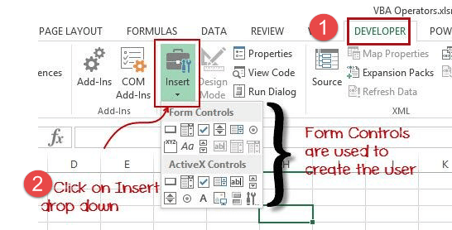](https://www.guru99.com/images/vba/062416_1143_VBAOperator3.png)

If you hover the mouse over control, the name of the control will appear as shown below

[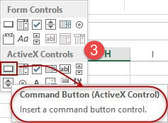](https://www.guru99.com/images/vba/062416_1143_VBAOperator4.png)

### Adding GUI controls to a spreadsheet

We will now add a command button to our workbook, for that we have to

* Click on Insert drop down
* Click on Command Button (ActiveX Control) as shown in the image above
* Drag and draw the button on the sheet

[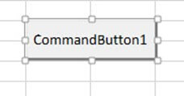](https://www.guru99.com/images/vba/062416_1143_VBAOperator5.jpg)

### Setting GUI control properties

We will now set the caption of the button to something more descriptive

[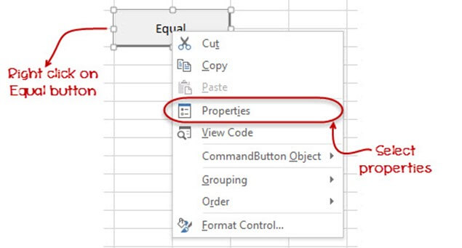](https://www.guru99.com/images/vba/062416_1143_VBAOperator6.jpg)

1. Right click on the equal button that we have just created
2. Select properties menu
3. You will get the following properties window

[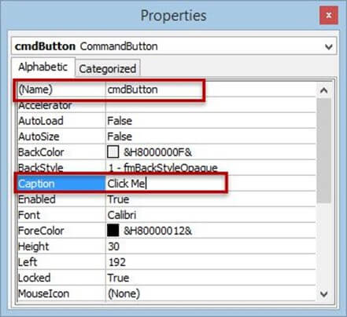](https://www.guru99.com/images/vba/062416_1143_VBAOperator7.jpg)

* Set the name property to btnButton. The name property is used to identify the control in the code window. btn is the prefix for the button.
* Set the Caption property to Click Me. The text in the caption property is what the users will see on the button.

Close the window when you are done.

You will get the following results.

[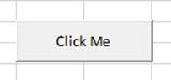](https://www.guru99.com/images/vba/062416_1143_VBAOperator8.jpg)

## How to use ActiveX control in VBA

In this section, we will see how to incorporate 'commandclick' button in VBA and execute a program using the button.

**Step 1)** In this step, click the option "insert button" from the Active X Control. Then select the command button option from it.

[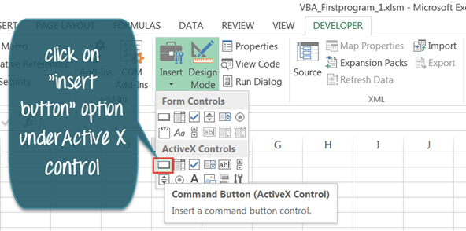](https://www.guru99.com/images/vba/062416_1048_WhatisVBA12.png)

**Step 2)** To insert "clickcommandbutton1" drag the mouse cursor to Excel sheet.

[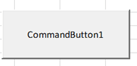](https://www.guru99.com/images/vba/062416_1048_WhatisVBA13.png)

**Step 3)** Then right click on the command button and select option "View Code".

[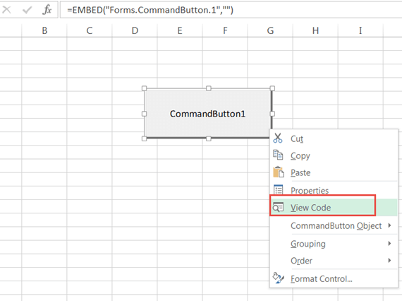](https://www.guru99.com/images/vba/062416_1048_WhatisVBA14.png)

**Step 4)** Check you are on the right sheet. A code editor will open. Enter your code.

* In code, we defined range A1 to A10.
* This range defines the cell number in the Excel sheet from "A1 to A10."
* Next, we define the string "Guru99 VBA Tutorial" in code
* So, when you click on "command button" in excel. It should print "Guru99 VBA Tutorial" in the cell range "A1 to A10."

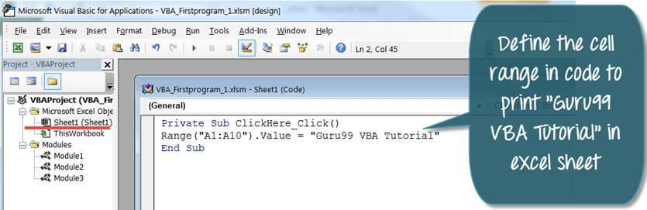

**Step 5)**In next step, save code file and then exit the editor. To return to the Excel file click the Excel sheet icon [What is VBA?](https://www.guru99.com/images/vba/062416_1048_WhatisVBA16.png) on the extreme left.

[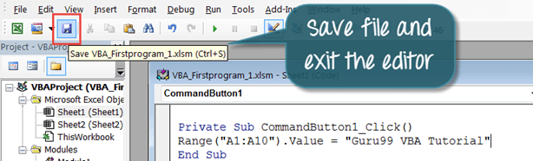](https://www.guru99.com/images/vba/062416_1048_WhatisVBA17.png)

**Step 6)**In Excel sheet, you will see Design Mode tab is on. Make sure it is "OFF" or else your code will not work.

[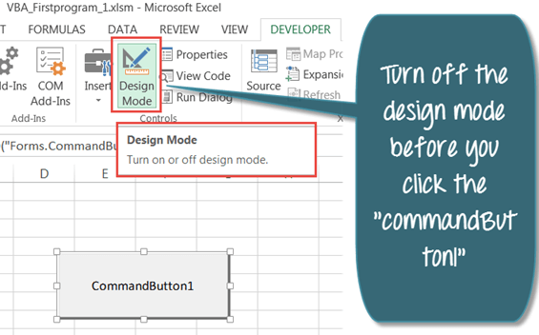](https://www.guru99.com/images/vba/062416_1048_WhatisVBA18.png)

**Step 7)** When design mode is off, there will be no green highlight on it. Now you can Click on the command button.

[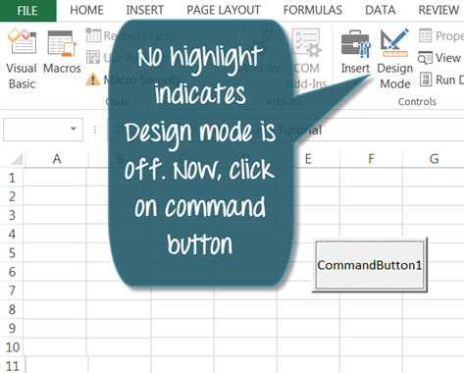](https://www.guru99.com/images/vba/062416_1048_WhatisVBA19.png)

**Step 8)** Click on "CommandButton1". It will print "Guru99 VBA Tutorial" in the cell range "A1 to A10".

[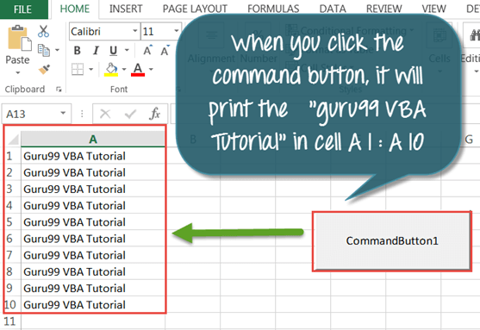](https://www.guru99.com/images/vba/062416_1048_WhatisVBA20.png)

## Prerequisite

##### Configure Microsoft Excel

As we see in previous tutorial, make sure your ribbon will have "Developer" icon as shown here.

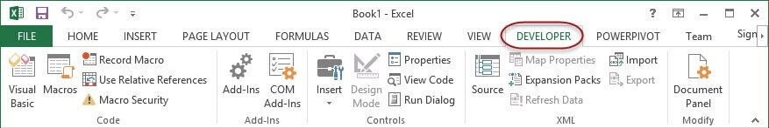

Now, rename sheet1 to "VBA Operator" as shown in screen-shot below. Save the workbook in an Excel Macro-Enabled Workbook (*.xlsm) file extension. (see the image below).

[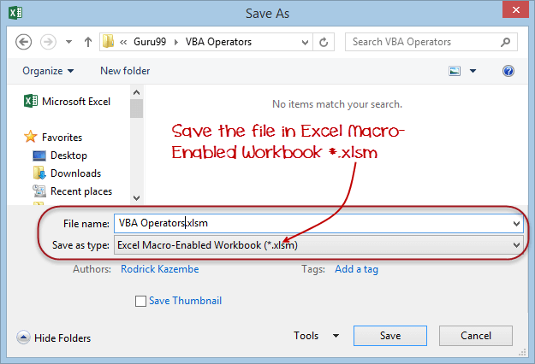](https://www.guru99.com/images/vba/062416_1143_VBAOperator2.png)

After that, click on Save button.

# VBA Arithmetic Operators: Multiplication, Division, Addition, Modulus

VBA Arithmetic Operators are used to perform arithmetic operations such as adding, subtracting, dividing or multiplying numbers.

The following table shows the arithmetic operators in VBA

|  |  |  |  |  |
| --- | --- | --- | --- | --- |
| **S/N** | **Operator** | **Description** | **Example** | **Output** |
| 1 | + | Addition: This operator is used to add up numbers | 2 + 2 | 4 |
| 2 | - | Subtraction: This operator is used to subtract numbers | 5 - 3 | 2 |
| 3 | * | Multiplication: This operator is used to multiply numbers | 3 * 2 | 6 |
| 4 | / | Division: This operator is used to divide numbers | 9 / 3 | 3 |
| 5 | ^ | Exponentiation: This operator is used to raise a number to the power of another number | 2^3 | 8 |
| 6 | mod | Modulus Operator: Divides a number and returns the remainder | 10 mod 3 | 1 |

VBA Arithmetic Operators: Modulus, Multiplication, Division, Addition

### VBA Arithmetic Operators Example

Add a button to the Excel sheet as we show earlier, and then follow the following points

[](https://www.guru99.com/images/vba/062416_1143_VBAOperator9.jpg)

* Change the name property to btnAdd
* Change the caption property to Add Operator
* Right click on the button
* Select view code
* You will get the following code window

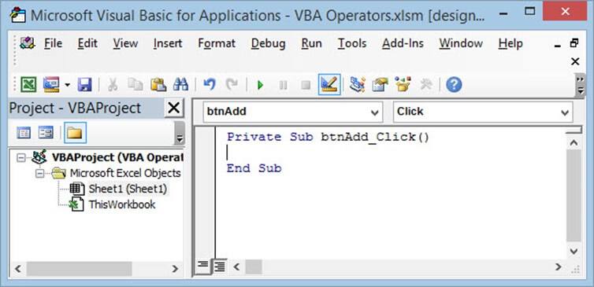

Enter the following code in between Private Sub btnAdd_Click() and End Sub

* Dim x As Integer, z As Integer
  + x = 2
  + z = 3
* MsgBox x + z, vbOKOnly, "Addition Operator"
* Click on save button
* Close the code editor window

Let's now execute our code

On the ribbon bar, look for the button Design Mode

[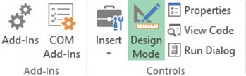](https://www.guru99.com/images/vba/062416_1143_VBAOperator11.jpg)

If the button is in active state (green background colour), then it's in design mode. You cannot execute code in this state**.**If it is not in the active state (white background color), then it allows you to run the code.

Click on Design Mode button

The button should now appear as follows

[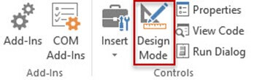](https://www.guru99.com/images/vba/062416_1143_VBAOperator12.jpg)

Click on Add operator

You will get the following results

[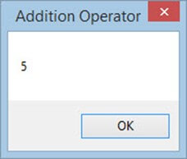](https://www.guru99.com/images/vba/062416_1143_VBAOperator13.jpg)

### Arithmetic Operators Tutorial exercise

The best way to learn is by practicing. Follow the above steps to create buttons for subtraction, division, multiplication and exponentiation.

Write the code for the buttons and test them to see if the code executes.

# VBA String Operators

## VBA String Operators

String data is used to hold data that is made up of numbers, characters, and symbols. "Jul-2015" is an example of a string data. It is made up of

* Characters (Jul)
* Symbol (-)
* Numbers (2015)

String operators are used to manipulate string data. For example, you can concatenate the value of July-2015 from the first 3 letters of the month and the year like "Jul-2015".

The following table shows the concatenation string operator.

|  |  |  |  |  |
| --- | --- | --- | --- | --- |
| **S/N** | **Operator** | **Description** | **Example** | **Output** |
| 1 | & | Concatenate: This operator is used to concatenate strings together | "John " & "Doe" | John Doe |

### Example Source Code

[VBA Operators](https://www.guru99.com/images/vba/062416_1143_VBAOperator14.jpg)

MsgBox "John " & "Doe", vbOKOnly, "Concatenate Operator"

Executing the above code produces the following result

[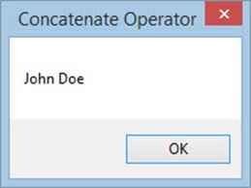](https://www.guru99.com/images/vba/062416_1143_VBAOperator15.jpg)

# VBA Comparison Operators: Not equal to, Less than or equal to, Greater than

## VBA Comparison operators

These are operators that are used to compare values. Comparison operators include equal to, less than, greater than and not equal to

The following table shows VBA Comparison Operators.

Comparison operators are used to compare values for validation purposes. Let's say you are developing a simple point of sale application. In this application, you want to validate the values entered before you post. In such cases, you can use comparison operators. This operator will check against the negative numbers or to ensure that the amount paid does not exceed the billed amount. Comparison operators come in handy in such situations.

|  |  |  |  |  |
| --- | --- | --- | --- | --- |
| **S/N** | **Operator** | **Description** | **Example** | **Output** |
| 1 | = | Equal: checks if two values are equal. It is also used as an assignment operator | If x = z Then | Returns true if they are equal, else it returns false |
| 2 | < | Less than: This operator is used to subtract numbers | If x < z Then | Returns true if x is less than z, else it returns false |
| 3 | > | Greater than: This operator is used to multiply numbers | If x > z Then | Returns true if x is greater than z, else it returns false |
| 4 | <> | Not equal to: This operator is used to divide numbers | If x <> z Then | Returns true if they are not equal, else it returns false |
| 5 | <= | Less than or equal to: | If x <= z Then | Returns true if x is less than or equal to z, else it returns false |
| 6 | >= | Greater than or equal to: | If x >= Then | Returns true if x is greater than z, else it returns false |

### Example source code

Equal Comparison Operator

If 2 = 1 Then

MsgBox "True", vbOKOnly, "Equal Operator"

Else

MsgBox "False", vbOKOnly, "Equal Operator"

End If

**HERE,**

* **"If 2 = 1 Then… Else… End If"** uses the if statement to evaluate the condition "2 = 1"
* **"MsgBox…"** Is a built-in function that displays a message box.
  + The first parameter "True" or "False" is what will be displayed in the message box. In our example, 2 is not equal to 1, therefore, it will show "false" in the msg box.
  + The second parameter "vbOKOnly" is the button that is displayed in the message box
  + The third parameter "Equal Operator" is the title of the message box.

Executing the above code gives the following results

[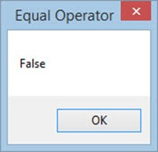](https://www.guru99.com/images/vba/062416_1143_VBAOperator16.jpg)

# VBA Logical Operators: AND, OR, NOT

VBA Logical Operators: AND, OR, NOT

## Logical Operators

Let's say you want to process a customer order. For that, you want to first check to see if the ordered product exists or not. If it does, you also want to check if the quantity on hand is enough. Logical operators come in handy in such cases. Logical operators are used to evaluate more than one condition.

|  |  |  |  |  |
| --- | --- | --- | --- | --- |
| **S/N** | **Operator** | **Description** | **Example** | **Output** |
| 1 | AND | AND: This is used to combine more than one condition. If all the conditions are true, AND evaluates to true. If any of the condition is false, AND evaluates to false | If true = true AND false = true THEN | false |
| 2 | OR | OR: This is used to combine more than one condition. If any of the conditions evaluate to true, OR returns true. If all of them are false, OR returns false | If true = true OR true = false THEN | true |
| 3 | NOT | NOT: This one works like an inverse function. If the condition is true, it returns false, and if a condition is false, it returns true. | If NOT (true) Then | false |

### Example Source Code

For the sake of simplicity, we will be comparing hard coded numbers.

Add ActiveX buttons to the sheet from the "Insert option."

Set the properties as shown in the image below

[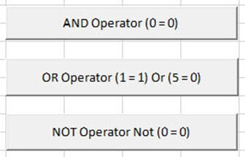](https://www.guru99.com/images/vba/062416_1143_VBAOperator17.jpg)

The following table shows the properties that you need to change and the values that you need to update too.

|  |  |  |  |
| --- | --- | --- | --- |
| **S/N** | **Control** | **Property** | **Value** |
| 1 | CommandButton1 | Name | btnAND |
|  |  | Caption | AND Operator (0 = 0) |
| 2 | CommandButton2 | Name | btnOR |
|  |  | Caption | OR Operator (1 = 1) Or (5 = 0) |
| 3 | CommandButton3 | Name | btnNOT |
|  |  | Caption | NOT Operator Not (0 = ) |

Add the following code to btnAND_Click

Private Sub btnAND_Click()

If (1 = 1) And (0 = 0) Then

MsgBox "AND evaluated to TRUE", vbOKOnly, "AND operator"

Else

MsgBox "AND evaluated to FALSE", vbOKOnly, "AND operator"

End If

End Sub

**HERE,**

* **"If (1 = 1) And (0 = 0) Then"** the if statement uses the AND logical operator to combine two conditions (1 = 1) And (0 = 0). If both conditions are true, the code above 'Else' keyword is executed. If both conditions are not true, the code below 'Else' keyword is executed.

Add the following code to btnOR_Click

Private Sub btnOR_Click()

If (1 = 1) Or (5 = 0) Then

MsgBox "OR evaluated to TRUE", vbOKOnly, "OR operator"

Else

MsgBox "OR evaluated to FALSE", vbOKOnly, "OR operator"

End If

End Sub

**HERE,**

* **"If (1 = 1) Or (5 = 0) Then"** the if statement uses the OR logical operator to combine two conditions (1 = 1) And (5 = 0). If any of the conditions is true, the code above Else keyword is executed. If both conditions are false, the code below Else keyword is executed.

Add the following code to btnNOT_Click

Private Sub btnNOT_Click()

If Not (0 = 0) Then

MsgBox "NOT evaluated to TRUE", vbOKOnly, "NOT operator"

Else

MsgBox "NOT evaluated to FALSE", vbOKOnly, "NOT operator"

End If

End Sub

**HERE,**

* **"If Not (0 = 0) Then"** the if statement uses the NOT logical operator to negate the result of the condition. If the conditions is true, the code below 'Else' keyword is executed. If the condition is true, the code above Else keyword is executed.

# Excel VBA Subroutine: How to call Sub with Example

## What is Subroutine?

A subroutine is a piece of code that performs a specific task and does not return a result. Subroutines are used to break down large pieces code into small manageable parts.

Let's say you have created a user interface with text boxes for accepting user input data. You can create a subroutine that clears the contents of the text boxes. A subroutine is appropriate in such a scenario because you do not want to return any results.

In this tutorial, you will learn-

* [Why use Subroutines](https://www.guru99.com/vba-functions-subroutine.html#2)
* [Rules of naming Subroutines and Functions](https://www.guru99.com/vba-functions-subroutine.html#3)
* [VBA Subroutine Syntax](https://www.guru99.com/vba-functions-subroutine.html#4)
* [How to call Subroutine in VBA](https://www.guru99.com/vba-functions-subroutine.html#5)

## Why use Subroutines

* **Break code into small manageable code**: An average computer program has thousands and thousands of source code lines. This introduces complexity. Subroutines help solve this problem by breaking down the program into small manageable chunks of code.
* **Code reusability**. Let's say you have a program that needs to access the database, almost all of the windows in the program will need to interact with the database. Instead of writing separate code for these windows, you can create a function that handles all database interactions. You can then call it from whichever window you want.
* **Subroutines and functions are self-documenting**. Let's say you have a function calculateLoanInterest and another that says connectToDatabase. By just looking at the name of the subroutine/function, the programmer will be able to tell what the program does.

## Rules of naming Subroutines and Functions

To use subroutines and functions, there are set of rules that one has to follow.

* A subroutine or function name cannot contain space
* A subroutine or function name should start with a letter or an underscore. It cannot start with a number or a special character
* A subroutine or function name cannot be a keyword. A keyword is a word that has special meaning in VBA. Words like Private, Sub, Function, and End, etc. are all examples of keywords. The compiler uses them for specific tasks.

## VBA Subroutine Syntax

You will need to enable the Developer tab in Excel to follow along with this example. If you do not know how to enable the Developer tab then read the tutorial on VBA Operators

**HERE in the syntax,**

Private Sub mySubRoutine(ByVal arg1 As String, ByVal arg2 As String)

'do something

End Sub

Syntax explanation

|  |  |
| --- | --- |
| **Code** | **Action** |
| * "Private Sub mySubRoutine(…)" | * Here the keyword "Sub" is used to declare a subroutine named "mySubRoutine" and start the body of the subroutine. * The keyword Private is used to specify the scope of the subroutine |
| * "ByVal arg1 As String, ByVal arg2 As String" : | * It declares two parameters of string data type name arg1 and arg2 |
| * "End Sub" | * "End Sub" is used to end the body of the subroutine |

The following subroutine accepts the first and last name and displays them in a message box.

Now we are going to program and execute this Sub Procedure. Let see this.

## How to call Subroutine in VBA

1. Design the user interface and set the properties for the user controls.
2. Add the subroutine
3. Write the click event code for the command button that calls the subroutine
4. Test the application

**Step 1)** User Interface

Design the user interface as shown in the image below

[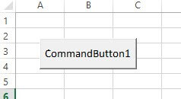](https://www.guru99.com/images/vba/062416_1207_VBAFunction1.jpg)

Set the following properties. The properties that we are setting

|  |  |  |  |
| --- | --- | --- | --- |
| **S/N** | **Control** | **Property** | **Value** |
| 1 | CommandButton1 | Name | btnDisplayFullName |
| 2 |  | Caption | Fullname Subroutine |

Your interface should now look as follows

[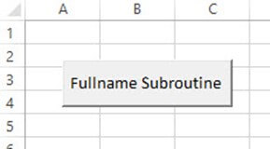](https://www.guru99.com/images/vba/062416_1207_VBAFunction2.jpg)

**Step 2)** Add subroutine

1. Press Alt + F11 to open the code window
2. Add the following subroutine

Private Sub displayFullName(ByVal firstName As String, ByVal lastName As String)

MsgBox firstName & " " & lastName

End Sub

**HERE in the code,**

|  |  |
| --- | --- |
| **Code** | **Actions** |
| * "Private Sub displayFullName(…)" | * It declares a private subroutine displayFullName that accepts two string parameters. |
| * "ByVal firstName As String, ByVal lastName As String" | * It declares two parameter variables firstName and lastName |
| * MsgBox firstName & " " & lastName" | * It calls the MsgBox built-in function to display a message box. It then passes the 'firstName' and 'lastName' variables as parameters. * The ampersand "&" is used to concatenate the two variables and add an empty space between them. |

**Step 3)** Calling the subroutine from the command button click event.

* Right click on the command button as shown in the image below. Select View Code.
* The code editor will open

[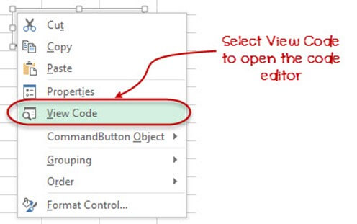](https://www.guru99.com/images/vba/062416_1207_VBAFunction3.jpg)

Add the following code in code editor for the click event of btnDisplayFullName command button.

Private Sub btnDisplayFullName_Click()

displayFullName "John", "Doe"

End Sub

Your code window should now look as follows

[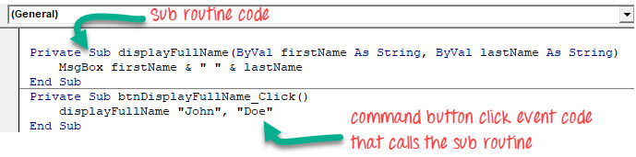](https://www.guru99.com/images/vba/062416_1207_VBAFunction4.jpg)

Save the changes and close the code window.

**Step 4) Testing the code**

On the developer toolbar put the design mode 'off'. As shown below.

[](https://www.guru99.com/images/vba/062416_1207_VBAFunction5.png)

**Step 5)** Click on the command button 'FullName Subroutine'.

You will get the following results

[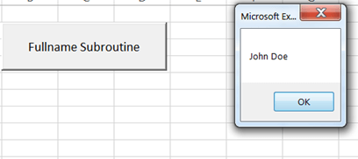](https://www.guru99.com/images/vba/062416_1207_VBAFunction6.png)

**Summary:**

* A subroutine is a piece of code that performs a specific task. A subroutine does not return a value after execution
* Subroutines offer code reusability
* Subroutines help break down large chunks of code into small manageable code.

# Excel VBA Function Tutorial: Return, Call, Examples

## What is a Function?

A function is a piece of code that performs a specific task and returns a result. Functions are mostly used to carry out repetitive tasks such as formatting data for output, performing calculations, etc.

Suppose you are developing a program that calculates interest on a loan. You can create a function that accepts the loan amount and the payback period. The function can then use the loan amount and payback period to calculate the interest and return the value.

**Why use functions**

The advantages of using functions are the same as the ones in the above section on why use subroutines.

**Rules of naming functions**

The rules for naming functions as the same as the ones in the above section on rules for naming subroutines.

#### VBA Syntax for declaring Function

Private Function myFunction (ByVal arg1 As Integer, ByVal arg2 As Integer)

myFunction = arg1 + arg2

End Function

**HERE in the syntax,**

|  |  |
| --- | --- |
| **Code** | **Action** |
| * "Private Function myFunction(…)" | * Here the keyword "Function" is used to declare a function named "myFunction" and start the body of the function. * The keyword 'Private' is used to specify the scope of the function |
| * "ByVal arg1 As Integer, ByVal arg2 As Integer" | * It declares two parameters of integer data type named 'arg1' and 'arg2.' |
| * myFunction = arg1 + arg2 | * evaluates the expression arg1 + arg2 and assigns the result to the name of the function. |
| * "End Function" | * "End Sub" is used to end the body of the function |

**Function demonstrated with Example:**

Functions are very similar to the subroutine. The major difference between a subroutine and a function is that the function returns a value when it is called. While a subroutine does not return a value, when it is called. Let's say you want to add two numbers. You can create a function that accepts two numbers and returns the sum of the numbers.

1. Create the user interface
2. Add the function
3. Write code for the command button
4. Test the code

**Step 1)**User interface

Add a command button to the worksheet as shown below

[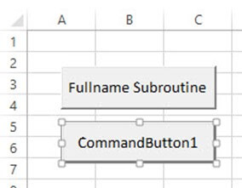](https://www.guru99.com/images/vba/062416_1207_VBAFunction7.jpg)

Set the following properties of CommanButton1 to the following.

|  |  |  |  |
| --- | --- | --- | --- |
| **S/N** | **Control** | **Property** | **Value** |
| 1 | CommandButton1 | Name | btnAddNumbers |
| 2 |  | Caption | Add Numbers Function |

Your interface should now appear as follows

[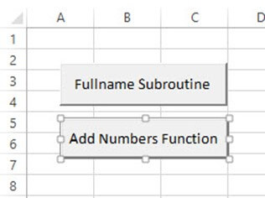](https://www.guru99.com/images/vba/062416_1207_VBAFunction8.jpg)

**Step 2)** Function code.

1. Press Alt + F11 to open the code window
2. Add the following code

Private Function addNumbers(ByVal firstNumber As Integer, ByVal secondNumber As Integer)

addNumbers = firstNumber + secondNumber

End Function

**HERE in the code,**

|  |  |
| --- | --- |
| **Code** | **Action** |
| * "Private Function addNumbers(…)" | * It declares a private function "addNumbers" that accepts two integer parameters. |
| * "ByVal firstNumber As Integer, ByVal secondNumber As Integer" | * It declares two parameter variables firstNumber and secondNumber |
| * "addNumbers = firstNumber + secondNumber" | * It adds the firstNumber and secondNumber values and assigns the sum to addNumbers. |

**Step 3) Write Code that calls the function**

1. Right click on btnAddNumbers_Click command button
2. Select View Code
3. Add the following code

Private Sub btnAddNumbersFunction_Click()

MsgBox addNumbers(2, 3)

End Sub

**HERE in the code,**

|  |  |
| --- | --- |
| **Code** | **Action** |
| **"MsgBox addNumbers(2,3)"** | * It calls the function addNumbers and passes in 2 and 3 as the parameters. The function returns the sum of the two numbers five (5) |

**Step 4)** Run the program, you will get the following results

[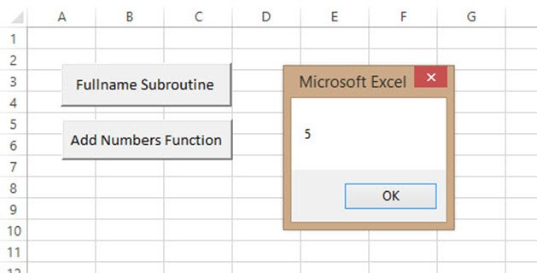](https://www.guru99.com/images/vba/062416_1207_VBAFunction9.jpg)

Download Excel containing above code

**Summary:**

* A function is a piece of code that performs a specific task. A function returns a value after execution.
* Both subroutines and functions offer code reusability
* Both subroutines and functions help break down large chunks of code into small manageable code.

# Excel VBA Range Object

## What is VBA Range?

The VBA Range Object represents a cell or multiple cells in your Excel worksheet. It is the most important object of Excel VBA. By using Excel VBA range object, you can refer to,

* A single cell
* A row or a column of cells
* A selection of cells
* A 3-D range

As we discussed in our previous tutorial, that VBA is used to record and run Macro. But how VBA identify what data from the sheet needs to be executed. This is where VBA Range Objects is useful.

In this tutorial, you will learn-

* [Introduction to Referencing Objects in VBA](https://www.guru99.com/vba-range-objects.html#1)
* [Refer to a Single cell using the Worksheet.Range Property](https://www.guru99.com/vba-range-objects.html#2)
* [Cell Property](https://www.guru99.com/vba-range-objects.html#3)
* [Range Offset property](https://www.guru99.com/vba-range-objects.html#4)

## Introduction to Referencing Objects in VBA

Referencing Excel's VBA Range Object and the Object Qualifier.

* **Object Qualifier**: This is used for referencing the object. It specifies the workbook or worksheet you are referring to.

To manipulate these cell values, **Properties** and **Methods** are used.

* **Property:** A property stores information about the object.
* **Method:** A method is an action of the object it will perform. Range object can perform actions like selected, copied, cleared, sorted, etc.

VBA follow object hierarchy pattern to refer object in Excel. You have to follow the following structure. Remember the .dot overhere connects the object at each of the different levels.

**Application.Workbooks.Worksheets.Range**

There are two main types of default objects.

## How to refer to Excel VBA Range Object using Range property

Range property can be applied in two different types of objects.

* Worksheet Objects
* Range Objects

Syntax for Range Property

1. The keyword "Range."
2. Parentheses that follow the keyword
3. Relevant Cell Range
4. Quotation (" ")

Application.Workbooks("Book1.xlsm").Worksheets("Sheet1").Range("A1")

When you refer Range object, as shown above, it is referred as **fully qualified reference**. You have told Excel exactly which range you want, what sheet and in what worksheet.

**Example**: MsgBox Worksheet("sheet1").Range("A1").Value

Using Range property, you can perform many tasks like,

* Refer to a Single cell using range property
* Refer to a Single cell using the Worksheet.Range Property
* Refer to an entire row or column
* Refer to merged cells using Worksheet.Range Property and many more

As such it will be too lengthy to cover all scenarios for range property. For scenarios mentioned above, we will demonstrate an example only for one. Refer to a Single cell using range property.

## Refer to a Single cell using the Worksheet.Range Property

To refer to a single cell, you have to refer to a single cell.

Syntax is simple **"Range("Cell")".**

Here, we will use ".Select" command to select the single cell from the sheet.

**Step 1)**In this step, open your excel.

[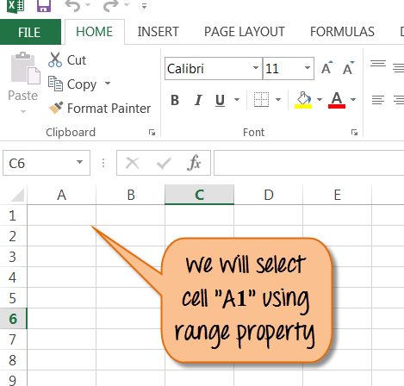](https://www.guru99.com/images/vba/062416_1236_VBARangeObj1.png)

**Step 2)** In this step,

* Click on [VBA Range Objects](https://www.guru99.com/images/vba/062416_1236_VBARangeObj2.png) button.
* It will open a window.
* Enter your program name here and click 'OK' button.
* It will take you to main Excel file, from top menu click on 'stop' record button to stop recording Macro.

[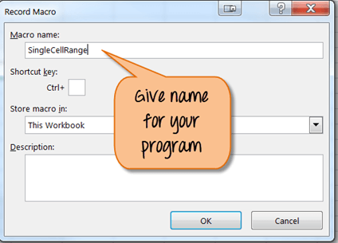](https://www.guru99.com/images/vba/062416_1236_VBARangeObj3.png)

**Step 3)** In next step,

* Click on Macro button [VBA Range Objects](https://www.guru99.com/images/vba/062416_1236_VBARangeObj4.png) from the top menu. It will open the window below.
* In this window, Click on the 'edit' button.

[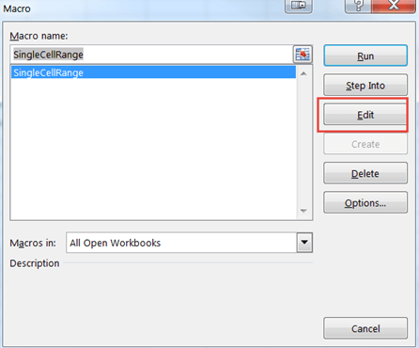](https://www.guru99.com/images/vba/062416_1236_VBARangeObj5.png)

**Step 4)** The above step will open VBA code editor for file name "Single Cell Range". Enter the code as shown below for selecting range "A1" from the excel.

[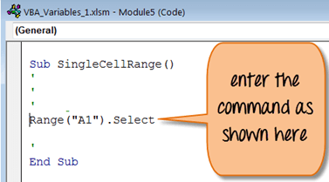](https://www.guru99.com/images/vba/062416_1236_VBARangeObj6.png)

**Step 5)** Now save the file [VBA Range Objects](https://www.guru99.com/images/vba/062416_1236_VBARangeObj7.png) and run the program as shown below.

[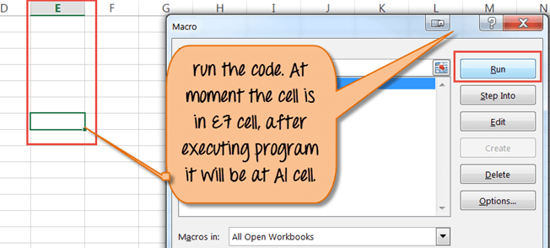](https://www.guru99.com/images/vba/062416_1236_VBARangeObj8.png)

**Step 6)** You will see Cell "A1" is selected after execution of the program.

[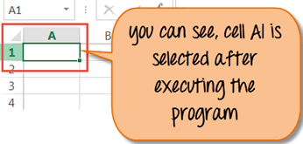](https://www.guru99.com/images/vba/062416_1236_VBARangeObj9.png)

Likewise, you can select a cell with a particular Name. For example, if you want to search cell with name "Guru99- VBA Tutorial". You have to run the command as shown below. It will select the cell with that name.

**Range("Guru99- VBA Tutorial").Select**

To apply other range object here is the code sample.

|  |  |
| --- | --- |
| **Range for selecting cell in Excel** | **Range declared** |
| For single Row | Range("1:1") |
| For single Column | Range("A: A") |
| For Contiguous Cells | Range("A1:C5") |
| For Non-Contiguous Cells | Range("A1:C5, F1:F5") |
| For Intersection of two ranges | Range("A1:C5 F1:F5")  (For intersection cell, remember there is no comma operator) |
| To merge Cell | Range("A1:C5")  ( To merge cell use "merge" command) |

## Cell Property

Similarly to the range, in VBA you can also you "Cell Property". The only difference is that it has an "item" property that you use to reference the cells on your spreadsheet. Cell property is useful in a programming loop.

For example,

Cells.item(Row, Column). Both the lines below refer to cell A1.

* Cells.item(1,1) OR
* Cells.item(1,"A")

## Range Offset property

Range offset property will select rows/columns away from its original position. On the basis of the range declared, cells are selected. See example below.

For example,

Range("A1").offset(Rowoffset:=1, Columnoffset:=1).Select

The result for this will cell B2. The offset property will move A1 cell to 1 column and 1 row away. You can change the value of rowoffset / columnoffset as per requirement. You can use a negative value (-1) to move cells backward.

Download Excel containing above code

**Summary**:

* The VBA Range Object represents a cell or multiple cells in your Excel worksheet
  + A single cell
  + A row or a column of cells
  + A selection of cells
  + A 3-D range
* To manipulate cell values, **Properties** and **Methods** are used
  + A property stores information about the object
  + A method is an action of the object it will perform like select, merge, sorted, etc.
* VBA follow object hierarchy pattern to refer object in Excel using .dot operator
* Range property can be applied in two different types of objects
  + Worksheet Objects
  + Range Objects

# Excel VBA Tutorial PDF

VBA stands for Visual Basic for Applications. It is a combination of the Microsoft's event-driven programming language Visual Basic with Microsoft Office Applications such as Microsoft Excel.

## Key Highlights of VBA Tutorial PDF are

* 85+ pages
* eBook Designed for beginners
* Beautifully annotated screenshots
* You will get lifetime access

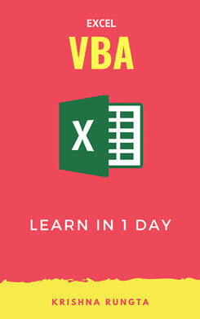

### Inside this PDF

1. Introduction to Macros in Excel
2. Creating your First Visual Basic for Applications (VBA) in Excel
3. VBA Data Types, Variables & Constant
4. VBA Arrays
5. VBA Excel Form Control & Activex Control
6. VBA Arithmetic Operators
7. VBA String Operators
8. VBA Comparison Operators
9. VBA Logical Operators
10. Excel VBA Call a Subroutine
11. Excel VBA Function Tutorial: Return, Call, Examples
12. VBA Range Objects